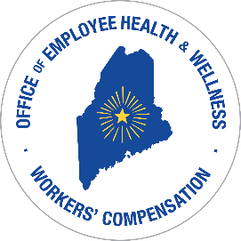
STATE OF MAINE
DEPARTMENT OF ADMINISTRATIVE & FINANCIAL SERVICES
Bureau of Human Resources
Division of Employee Health and Benefits and
Office of Workers’ Compensation
114 State House Station
Augusta, ME 04333-0114
Paul R. LePage, Governor
Alexander F. Porteous, Commissioner

NEW WORKERS’ COMPENSATION POLICY

COORDINATION OF BENEFITS

Effective February 4, 2018 our self-insured Workers’ Compensation Program will be taking

an offset if an employee chooses to use sick leave during a period of incapacity due to an injury.

The dollar value of the sick leave taken will be counted as earnings and will reduce and/or eliminate

the weekly workers’ compensation amount due to the employee. There will be no restorations of

sick leave.

If an employee plans on using their vacation/comp/personal leave time for their absence from work

due to a workers’ compensation injury, the Benefit Leave Option Form must be completed, signed

and returned promptly. If this form is not returned promptly indicating your option, then it will

be assumed that a weekly workers’ compensation check is desired and it will be mailed accordingly.

Any vacation/comp/personal leave time used will not be restored if the Benefit Leave Option Form

is not received indicating a restoration of time is requested in lieu of a workers’ compensation check.

If you have any questions regarding the coordination of benefits policy, please contact your

Workers’ Compensation Designee at your department and/or the Office of Workers’ Compensation

at (207) 624-7359. Thank you.

