|  |  |  |  |
| --- | --- | --- | --- |
| **Agency Name** |  | **Contact Name** |  |
| **Phone** |  | **Email** |  |
| **Mailing Address** |  | **City** |  |
| **State** |  | **Zip Code** |  |

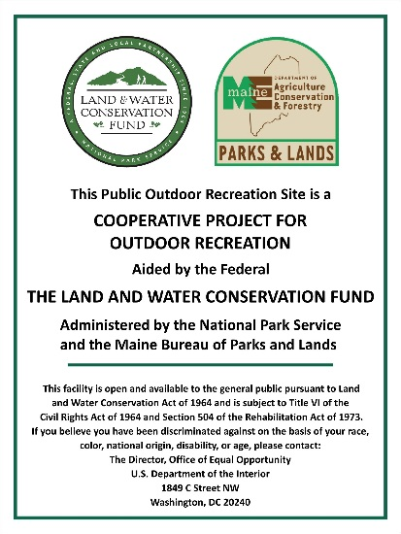

Signs need to be posted in prominent locations at each fund assisted site. Please order enough signs to assure compliance. In general, one sign is sufficient per project site. Some larger projects with multiple funded amenities should have one sign per distinct funded amenity. Some projects with multiple access points may benefit from more than one sign per site. Signs are 5-3/4 inches wide by 7-3/4 inches high.

Send your complete order form with payment in full to:

**Maine Bureau of Parks & Lands**

**Grants & Community Recreation Program**

**54 Independence Drive, SHS 124**

**Augusta, ME 04333-0124**

|  |  |  |  |  |
| --- | --- | --- | --- | --- |
| Item | Description | Quantity | Unit Price | Amount |
|
| **LWCF sign** | Required Signage |  | **$10.00** |  |
| **RTP sign** | Required Signage |  | **$10.00** |  |
|  |  |  | **Sub Total:** |  |
| (If tax exempt please include tax exempt number) | | | **Tax 5.5%:** |  |
| Make check out to “Treasurer State of Maine” | | | **Total Included:** |  |

