DEP Environmental Education Curricula
Lesson Plan
GRADE/LEVEL: High School
LESSON TITLE: Hazardous Wastes
Next Generation Science Standards
HS-ETS1-3 | HS-ETS1-3 | Evaluate a solution to a complex real-world problem based on prioritized criteria and trade-offs that account for a range of constraints, including cost, safety, reliability, and aesthetics as well as possible social, cultural, and environmental impacts.
 | Science and Engineering Practices | Evaluate a solution to a complex real-world problem, based on scientific knowledge, student-generated sources of evidence, prioritized criteria, and tradeoff considerations.
 | Disciplinary Core Ideas | When evaluating solutions, it is important to take into account a range of constraints, including cost, safety, reliability, and aesthetics, and to consider social, cultural, and environmental impacts.
 | Crosscutting Concepts | New technologies can have deep impacts on society and the environment, including some that were not anticipated. Analysis of costs and benefits is a critical aspect of decisions about technology.
Objectives
Objective 1: Students will discuss which characteristics make a waste hazardous.
Objective 2: Students will discuss several major regulations that are in place to control the generation, transportation, and disposal of hazardous and e-wastes.
Objective 3: Students will learn how to report a suspected oil spill or hazardous waste spill/storage.
Objective 4: Students will define e-waste and discuss known issues with its collection and recycling.
Vocabulary
 | Corrosive | Tending to cause corrosion, having acidic or erosive properties.
 | Hazard Ranking System | The Hazard Ranking System (HRS) is a scoring system used by the EPA to assess the relative threat associated with actual or potential releases of hazardous substances at sites.
 | Ignitable | Able to catch fire or set fire to; burn or cause to burn.
 | National Priority List | The National Priorities List (NPL) is the list of hazardous waste sites in the United States eligible for long-term remedial action (cleanup) financed under the federal Superfund program.
 | Potentially Responsible Party | Any individual or organization—including owners, operators, transporters or generators—potentially responsible for, or contributing to, a spill or other contamination at a Superfund site.
 | Reactive | Having a tendency to react chemically.
 | Toxic | Poisonous.
Background
Teacher Version  Selected Materials from …This is Superfund A Community Guide to EPA’s Superfund Program |  | Sources:  https://semspub.epa.gov/work/HQ/175197.pdf and as noted.
What are Hazardous Wastes?
Hazardous wastes are poisonous byproducts of manufacturing, farming, city septic systems, construction, automotive garages, laboratories, hospitals, and other industries. The waste may be liquid, solid, or sludge and contain chemicals, heavy metals, radiation, dangerous pathogens, or other toxins. Even households generate hazardous waste from items such as batteries, used computer equipment, and leftover paints or pesticides. (https://www.nationalgeographic.com/environment/global-warming/toxic-waste/).

The waste can harm humans, animals, and plants if they encounter these toxins buried in the ground, in stream runoff, in groundwater that supplies drinking water, or in floodwaters, as happened after Hurricane Katrina. Some toxins, such as mercury, persist in the environment and accumulate. Humans or animals often absorb them when they eat fish. (https://www.nationalgeographic.com/environment/global-warming/toxic-waste/)

The rules surrounding hazardous waste are overseen in the U.S. by the federal Environmental Protection Agency (EPA) as well as state departments of environmental protection (DEP). EPA requires that hazardous waste be handled with special precautions and be disposed of in designated facilities located throughout the United States, which charge for their services. Many towns have special collection days for household hazardous waste. (https://www.nationalgeographic.com/environment/global-warming/toxic-waste/)

They are a subset of solid wastes that contains either listed wastes (as defined by the EPA), or having hazardous characteristics as described below.

How are Hazardous Wastes Classified?

Characteristic Waste
- Corrosivity (pH ≤ 2 or ≥ 12.5)
- Ignitability – is the substance easily ignited?
- Reactivity – is the substance prone to sudden reactions?
- Toxicity - containing or being poisonous material especially when capable of causing death or serious debilitation
Listed wastes are wastes from common manufacturing and industrial processes, specific industries and can be generated from discarded commercial products. www.epa.gov
Self Listed are declared as hazardous by the companies that generate them.

The Resource Conservation and Recovery Act — commonly referred to as RCRA — is our nation’s primary law governing the disposal of solid and hazardous waste. Congress passed RCRA on October 21, 1976 to address the increasing problems the nation faced from our growing volume of municipal and industrial waste. RCRA, which amended the Solid Waste Disposal Act of 1965, set national goals for:
- Protecting human health and the environment from the potential hazards of waste disposal.
- Conserving energy and natural resources.
- Reducing the amount of waste generated.
- Ensuring that wastes are managed in an environmentally-sound manner.
(https://www.epa.gov/history/epa-history-resource-conservation-and-recovery-act)

HSWA - the Federal Hazardous and Solid Waste Amendments - are the 1984 amendments to RCRA that focused on waste minimization and phasing out land disposal of hazardous waste as well as corrective action for releases. Some of the other mandates of this law include increased enforcement authority for EPA, more stringent hazardous waste management standards, and a comprehensive underground storage tank program. (https://www.epa.gov/laws-regulations/summary-resource-conservation-and-recovery-act)

What is Superfund/Comprehensive Environmental Response, Compensation, and Liability Act (CERCLA)?
For a variety of reasons, hazardous commercial and industrial wastes have been mismanaged and may pose unacceptable risks to human health and the environment. This waste was dumped on the ground or in waterways, left out in the open, or otherwise improperly managed. As a result, thousands of hazardous waste sites were created throughout the United States. These hazardous waste sites commonly include manufacturing facilities, processing plants, landfills and mining sites.

In 1980, Congress established the CERCLA, as amended, in response to growing concerns over the health and environmental risks posed by hazardous waste sites. This law was enacted in the wake of the discovery of toxic waste dumps such as Love Canal and Valley of the Drums in the 1970s. CERCLA is informally called Superfund. The Superfund program is administered by EPA in cooperation with state and tribal governments. It allows EPA to clean up hazardous waste sites and to force responsible parties to perform cleanups or reimburse the government for cleanups led by EPA.

Discovering Superfund Sites
Superfund sites are “discovered” when the presence of hazardous waste is made known to EPA. The presence of contaminants is often reported by residents, local, state, tribal or federal agencies, or businesses. Sometimes these hazardous wastes are found by EPA during inspections or investigations into complaints.

National Response Center (NRC)
You can call NRC toll-free at 800-424-8802 to report potential releases of hazardous substances and oil 24-hours a day, seven days a week. You can report potential releases of hazardous substances and oil to the NRC as well as to your state, tribal and local authorities. The NRC is the national point of contact for reporting all oil, chemical, radiological, and biological releases into the environment anywhere in the United States and its territories.

Responsibility for Superfund Site Cleanup
Potentially Responsible Party (PRP): From the time the site is discovered, EPA tries to identify the generators and transporters of the hazardous waste and the owners and operators of a site. These people/companies/municipalities are considered PRP(s) under Superfund and are asked to conduct and/or pay for cleanup studies and activities. If the PRP(s) refuses to participate, EPA will clean up the site and sue the party or parties to recover costs.

Getting Involved
You and Your Community EPA’s Superfund Community Involvement Program provides individuals affected by hazardous waste sites with information and opportunities to participate as active partners in the decisions that affect the Superfund sites in their community. The community has a voice during all phases of the Superfund process, and plays an important role in assisting EPA with gathering information about the site. Your involvement is very important. You have the opportunity and the right to be engaged in, and to comment on the work being done at sites in your community

The National Priorities List
The National Priorities List (NPL) is a published list of hazardous waste sites in the country that are eligible for federal funding to pay for extensive, long-term cleanup actions under the Superfund remedial program.

How Do Sites Get On the NPL?
To evaluate the dangers posed by hazardous waste sites, EPA developed a scoring system called the Hazard Ranking System (HRS). EPA uses the information collected during the assessment phase of the Superfund process to score sites according to the danger they may pose to human health and the environment. Many of the sites that are reviewed do not meet the criteria for federal Superfund cleanup action. Some sites do not require any action, while others are referred to the states, other programs, other agencies, or individuals for cleanup or other action.
The Superfund Amendments and Reauthorization Act amended the Comprehensive Environmental Response, Compensation, and Liability Act of 1980 (CERCLA) on October 17, 1986. The Superfund Amendments and Reauthorization Act of 1986 (SARA) reflected EPA's experience in administering the complex Superfund program during its first six years and made several important changes and additions to the program. SARA:
- stressed the importance of permanent remedies and innovative treatment technologies in cleaning up hazardous waste sites;
- required Superfund actions to consider the standards and requirements found in other State and Federal environmental laws and regulations;
- provided new enforcement authorities and settlement tools;
- increased State involvement in every phase of the Superfund program;
- increased the focus on human health problems posed by hazardous waste sites;
- encouraged greater citizen participation in making decisions on how sites should be cleaned up; and
- increased the size of the trust fund to $8.5 billion.
SARA also required EPA to revise the Hazard Ranking System to ensure that it accurately assessed the relative degree of risk to human health and the environment posed by uncontrolled hazardous waste sites that may be placed on the National Priorities List (NPL). https://www.epa.gov/superfund/superfund-amendments-and-reauthorization-act-sara

e-Wastes

Electronic waste (or e-waste) describes discarded electrical or electronic devices. Used electronics which are destined for reuse, resale, salvage, recycling, or disposal are also considered e-waste. Since the invention of the iPhone, cell phones have become the top source of e-waste products because they are not made to last more than two years. (Source: https://en.wikipedia.org/wiki/Electronic_waste)

Electrical waste contains hazardous but also valuable and scarce materials. As of 2013, Apple has sold over 796 million iDevices (iPod, iPhone, iPad). In the United States, an estimated 70% of heavy metals in landfills comes from discarded electronics. (Source: https://en.wikipedia.org/wiki/Electronic_waste)

Crosscutting Concepts - New technologies can have deep impacts on society and the environment, including some that were not anticipated. Analysis of costs and benefits is a critical aspect of decisions about technology.

Discuss with students how the drive for “new and better” technology can have both benefits to society (more capable equipment, more affordable technology) and hazards to society (more waste generated, ethical considerations for treatment, storage, disposal, handing of wastes). Is making equipment less robust, and therefore often cheaper, worth dealing with a typically shorter lifespan and the resulting waste recycling and disposal issues?
Help ME Recycle Assignment |  |  | Materials taken from Source:  http://www.maine.gov/dep/gis/datamaps/brwm_recycling/
Go to the following site for more information regarding Maine Department of Environmental Protection’s site listed below to work on the following assignment.
Remind students to follow all school safety rules regarding going on to the internet.
Student Assignment – Help ME Recycle
- Go to the following site to complete this assignment: http://www.maine.gov/dep/gis/datamaps/brwm_recycling/
- Your screen will appear like the image below.
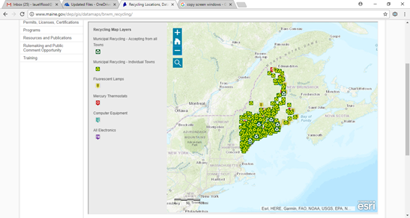
- What do the following icons signify?
__________________________
__________________________
__________________________

- Select the magnifying glass icon (shown by the arrow below) to reveal a search box.
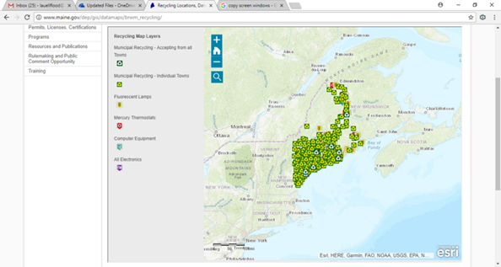
- The search box will appear. Type Portland, Maine in the search box.

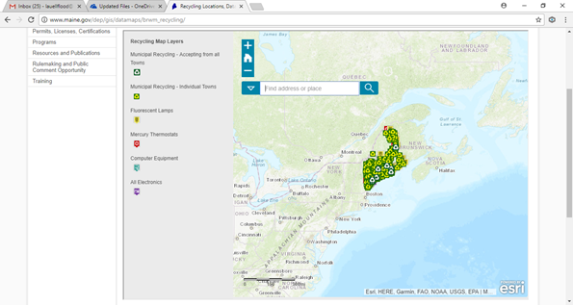
- The information box for Portland will pop up labeled as Search Results. (you may need to zoom in on the southern Maine area for the Search Results box to pop up and be visible.) Click on the icon near the side of the search results box.
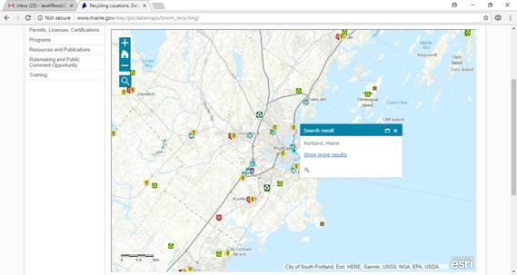

- What is the location name for this center? Portland Attended Donation Center - 1 Diamond St
- Does this center accept fluorescent lamps? No Computer Equipment? Yes Electronics? No
- Use this search process to provide information for the following towns (remember you may need to zoom in on the area around the town for the Search Results box to pop up):
  - Presque Isle, Maine – click on the following image near the search results box and answer the following question. What is the information available for this site? _____________________________________________________
  - Bangor, Maine – click on the following image near the search results box and answer the following questions. Res = residential, Bus = business
    - What is the location name for this center? Electronics End
    - Does this center accept fluorescent lamps? Res: Yes\ Bus: No Mercury thermostats? Res: No\ Bus: No Electronics? Res: No\ Bus: No
- What information can you find about the site located closest to your school? Answers May Vary
Teacher Prep
 | Advanced Preparation Steps &  Duration | - Read and consider associated background material and questions for discussion. (30 minutes)  - Review Hazardous Waste PowerPoint and Help ME Recycle web site (30 minutes)
Needed Materials
- Hazardous and e-waste Power Point
- Hazardous and e-waste Lesson Plan
- Internet connection
 | Duration of activities | 60 minutes
 | Safety notes | Follow school safety rules when accessing the internet.
Procedures for instruction
 |  | Introduce the class to the topic of hazardous and e-waste. |  | ~2 minutes
 |  | Introduce Hazardous and e-waste and discuss Power Point. Includes embedded fil Hazardous Waste (https://www.youtube.com/watch?v=E_ui1maDVgs) |  | ~20 minutes  (PowerPoint)
 |  | Discussion |  | ~10 minutes
Student workbook
 | Background Informational Sheet | Reading assignment prior to the demonstration day.
 | Vocabulary List | Available for clarification of terminology as students read their Background Informational Sheet and Demonstration Procedure

Student Background Information Sheet – Hazardous Waste
What are Hazardous Wastes?
Hazardous wastes are poisonous byproducts of manufacturing, farming, city septic systems, construction, automotive garages, laboratories, hospitals, and other industries. The waste may be liquid, solid, or sludge and contain chemicals, heavy metals, radiation, dangerous pathogens, or other toxins. Even households generate hazardous waste from items such as batteries, used computer equipment, and leftover paints or pesticides. (https://www.nationalgeographic.com/environment/global-warming/toxic-waste/).

The waste can harm humans, animals, and plants if they encounter these toxins buried in the ground, in stream runoff, in groundwater that supplies drinking water, or in floodwaters, as happened after Hurricane Katrina. (https://www.nationalgeographic.com/environment/global-warming/toxic-waste/)

The rules surrounding hazardous waste are overseen in the U.S. by the federal Environmental Protection Agency (EPA) as well as state departments of environmental protection. (https://www.nationalgeographic.com/environment/global-warming/toxic-waste/)

How are Hazardous Wastes Classified?
Characteristic Waste
• Corrosivity
• Ignitability
• Reactivity
• Toxicity
Listed wastes are wastes from common manufacturing and industrial processes, specific industries and can be generated from discarded commercial products. www.epa.gov
Self-Listed are declared as hazardous by the companies that generate them.

The Resource Conservation and Recovery Act — commonly referred to as RCRA — is our nation’s primary law governing the disposal of solid and hazardous waste. RCRA, which amended the Solid Waste Disposal Act of 1965, set national goals for:
• Protecting human health and the environment from the potential hazards of waste disposal.
• Conserving energy and natural resources.
• Reducing the amount of waste generated.
• Ensuring that wastes are managed in an environmentally-sound manner.
(https://www.epa.gov/history/epa-history-resource-conservation-and-recovery-act)

HSWA - the Federal Hazardous and Solid Waste Amendments - are the 1984 amendments to RCRA that focused on waste minimization and phasing out land disposal of hazardous waste as well as corrective action for releases. (https://www.epa.gov/laws-regulations/summary-resource-conservation-and-recovery-act)

What is Superfund/Comprehensive Environmental Response, Compensation, and Liability Act (CERCLA)?
For a variety of reasons, hazardous commercial and industrial wastes have been mismanaged and may pose unacceptable risks to human health and the environment. This waste was dumped on the ground or in waterways, left out in the open, or otherwise improperly managed. As a result, thousands of hazardous waste sites were created throughout the United States. These hazardous waste sites commonly include manufacturing facilities, processing plants, landfills and mining sites.

In 1980, Congress established the Comprehensive Environmental Response, Compensation, and Liability Act (CERCLA); CERCLA is informally called Superfund. The Superfund program is administered by EPA in cooperation with state and tribal governments. It allows EPA to clean up hazardous waste sites and to force responsible parties to perform cleanups or reimburse the government for cleanups led by EPA.

Discovering Superfund Sites
Superfund sites are “discovered” when the presence of hazardous waste is made known to EPA. The presence of contaminants is often reported by residents, local, state, tribal or federal agencies, or businesses. Sometimes these hazardous wastes are found by EPA during inspections or investigations into complaints.

National Response Center (NRC)
You can call NRC toll-free at 800-424-8802 to report potential releases of hazardous substances and oil 24-hours a day, seven days a week. You can report potential releases of hazardous substances and oil to the NRC as well as to your state, tribal and local authorities. The NRC is the national point of contact for reporting all oil, chemical, radiological, and biological releases into the environment anywhere in the United States and its territories.

Responsibility for Superfund Site Cleanup
Potentially Responsible Party (PRP): From the time the site is discovered, EPA tries to identify the generators and transporters of the hazardous waste and the owners and operators of a site. These people/companies/municipalities are considered PRP(s) under Superfund and are asked to conduct and/or pay for cleanup studies and activities. If the PRP(s) refuses to participate, EPA will clean up the site and sue the party or parties to recover costs.

Getting Involved
You and Your Community EPA’s Superfund Community Involvement Program provides individuals affected by hazardous waste sites with information and opportunities to participate as active partners in the decisions that affect the Superfund sites in their community. The community has a voice during all phases of the Superfund process, and plays an important role in assisting EPA with gathering information about the site. Your involvement is very important. You have the opportunity and the right to be engaged in, and to comment on the work being done at sites in your community.

The National Priorities List
The National Priorities List (NPL) is a published list of hazardous waste sites in the country that are eligible for federal funding to pay for extensive, long-term cleanup actions under the Superfund remedial program.

How Do Sites Get On the NPL?
To evaluate the dangers posed by hazardous waste sites, EPA developed a scoring system called the Hazard Ranking System (HRS). EPA uses the information collected during the assessment phase of the Superfund process to score sites according to the danger they may pose to human health and the environment.

The Superfund Amendments and Reauthorization Act amended the Comprehensive Environmental Response, Compensation, and Liability Act of 1980 (CERCLA) on October 17, 1986. The Superfund Amendments and Reauthorization Act of 1986 (SARA) reflected EPA's experience in administering the complex Superfund program during its first six years and made several important changes and additions to the program.

SARA:
- stressed the importance of permanent remedies and innovative treatment technologies in cleaning up hazardous waste sites;
- required Superfund actions to consider the standards and requirements found in other State and Federal environmental laws and regulations;
- provided new enforcement authorities and settlement tools;
- increased State involvement in every phase of the Superfund program;
- increased the focus on human health problems posed by hazardous waste sites;
- encouraged greater citizen participation in making decisions on how sites should be cleaned up; and
- increased the size of the trust fund to $8.5 billion.
SARA also required EPA to revise the Hazard Ranking System to ensure that it accurately assessed the relative degree of risk to human health and the environment posed by uncontrolled hazardous waste sites that may be placed on the National Priorities List (NPL). https://www.epa.gov/superfund/superfund-amendments-and-reauthorization-act-sara

e-Wastes

Electronic waste (or e-waste) describes discarded electrical or electronic devices. Used electronics which are destined for reuse, resale, salvage, recycling, or disposal are also considered e-waste. Since the invention of the iPhone, cell phones have become the top source of e-waste products because they are not made to last more than two years. (Source: https://en.wikipedia.org/wiki/Electronic_waste)

Electrical waste contains hazardous but also valuable and scarce materials. As of 2013, Apple has sold over 796 million iDevices (iPod, iPhone, iPad). In the United States, an estimated 70% of heavy metals in landfills comes from discarded electronics. (Source: https://en.wikipedia.org/wiki/Electronic_waste)

Student Vocabulary List – Hazardous Waste
 | Corrosive | Tending to cause corrosion, having acidic or erosive properties.
 | Hazard Ranking System | The Hazard Ranking System (HRS) is a scoring system used by EPA to assess the relative threat associated with actual or potential releases of hazardous substances at sites.
 | Ignitable | Able to catch fire or set fire to; burn or cause to burn.
 | National Priority List | The National Priorities List (NPL) is the list of hazardous waste sites in the United States eligible for long-term remedial action (cleanup) financed under the federal Superfund program
 | Potentially Responsible Party | Any individual or organization—including owners, operators, transporters or generators—potentially responsible for, or contributing to, a spill or other contamination at a Superfund site.
 | Reactive | Having a tendency to react chemically.
 | Toxic | Poisonous

Student Assignment – Help ME Recycle
- Go to the following site to complete this assignment: http://www.maine.gov/dep/gis/datamaps/brwm_recycling/
- Your screen will appear like the image below.
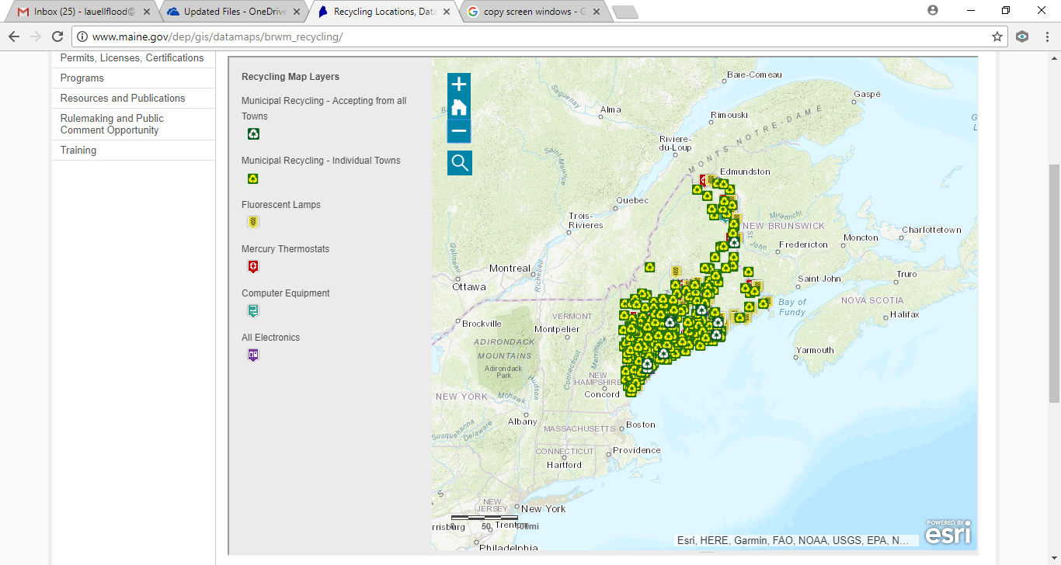
- What do the following icons signify?
  - __________________________
  - __________________________
  - __________________________
- Select the magnifying glass icon (shown by the arrow below) to reveal a search box.
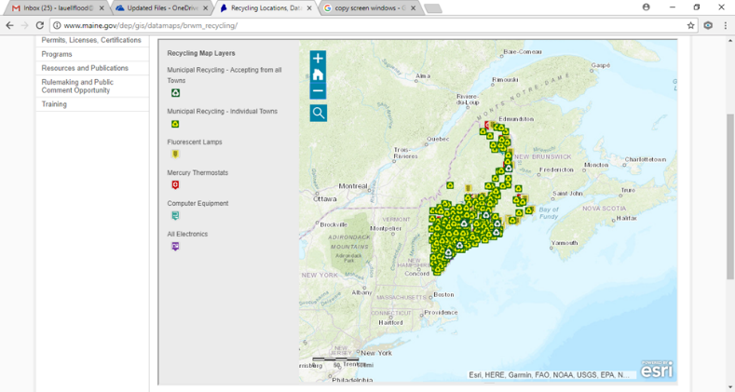
- The search box will appear. Type Portland, Maine in the search box.
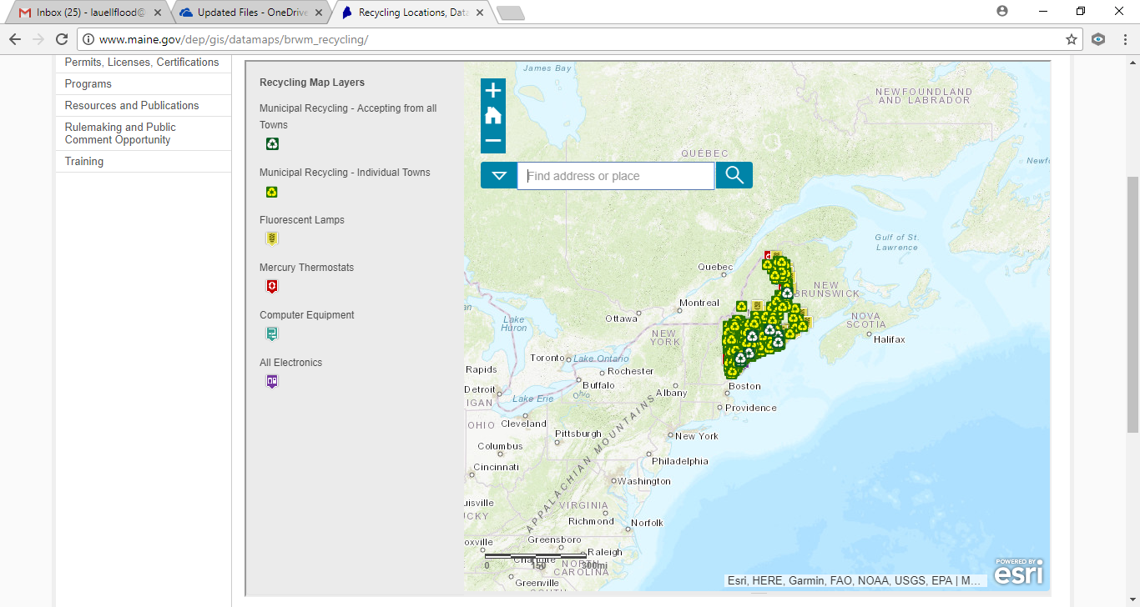
- The information box for Portland will pop up labeled as Search Results. (you may need to zoom in on the southern Maine area for the Search Results box to pop up and be visible.) Click on the icon near the side of the search results box.

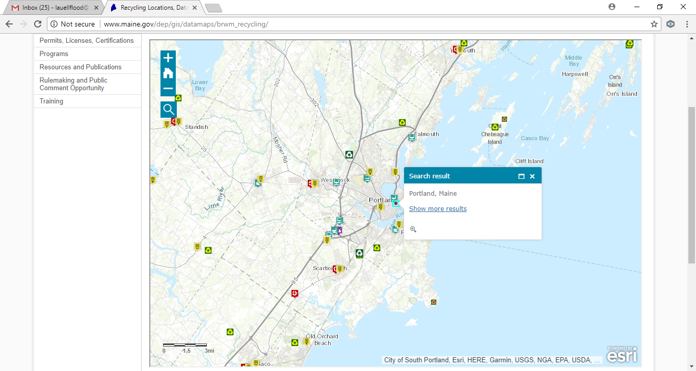
- What is the location name for this center? ______________________________
- Does this center accept fluorescent lamps? ___ Computer Equipment? ____ Electronics? ____
- Use this search process to provide information for the following towns (remember you may need to zoom in on the area around the town for the Search Results box to pop up):
  - Presque Isle, Maine – click on the following image near the search results box and answer the following question. What is the information available for this site? _____________________________________________________
  - Bangor, Maine – click on the following image near the search results box and answer the following questions.
    - What is the location name for this center? _______________
    - Does this center accept fluorescent lamps? _____________ Mercury thermostats? ___________ Electronics? _____________
- What information can you find about the site located closest to your school?
Site: ________________________________________________________________________________________________________________________________________________________________________________________________________________________________________________________________________________

Project Assessment
Project Title: ___________________________________________________________________________
Instructor/School/Grade: _______________________/______________________/_________________
Instructor Contact Information: ________________________________________________________________
Date assigned: _____________ Number of Students Participating ____________
The following questions are intended to help us understand your feelings regarding the presentation and materials. Your sincerity in answering these questions is appreciated. Please feel free to use the space at the end of the form for any additional comments that you may have. This form has been left in Microsoft Word format so that you may fill it in electronically. Please fill out the form completely and email your assessment to david.madore@maine.gov.
Ranking System
1 ~ Excellent / Strongly agree
2 ~ Good – Above average / Moderately agree
3 ~ Average – ok / Neutral in agree or disagree
4 ~ Poor – below average / Moderately disagree
4 ~ Very poor – not acceptable / Strongly disagree
NA / not applicable
Please continue on the second page…
1 | 2 | 3 | 4 | 5 | NA | Questions
 |  |  |  |  |  | Course Content
 |  |  |  |  |  | - Value of course content to you.
 |  |  |  |  |  | - Importance of course content given your teaching topic.
 |  |  |  |  |  | - Overall rating of course content.
 |  |  |  |  |  | - Ease of implementing materials into daily lessons.
 |  |  |  |  |  | Materials/Project
 |  |  |  |  |  | - Movie (if applicable) was easy to present.
 |  |  |  |  |  | - Student worksheet was useful and easy to follow.
 |  |  |  |  |  | - Student project stimulated thinking & conversation.
 |  |  |  |  |  | - The project put ideas across effectively.
 |  |  |  |  |  | - Teacher materials were useful and easy to follow.
 |  |  |  |  |  | - The method of material presentation encouraged students feel free to ask questions, disagree, express ideas, etc.
 |  |  |  |  |  | Self-Evaluation (Instructor)
 |  |  |  |  |  | - What was your level of knowledge concerning this topic prior to this presentation?
Please share any recommendations you feel would be helpful.

Thank you for providing your feedback!
Please email your assessment to david.madore@maine.gov.

