Influenza: What You Can Do At Home

Influenza (Flu) is a very contagious respiratory illness caused by influenza viruses. People with flu are most contagious in the first 3-4 days after illness begins. People with the flu should stay home until 24 hours after their fever breaks.

What You Can Do:

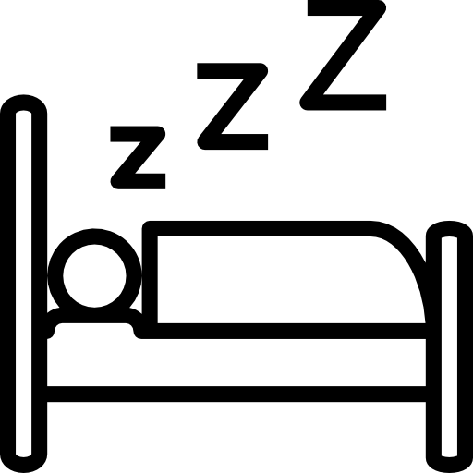

Get Plenty of Rest
Drink Water and Clear Fluids
Take Medicine for Fever and Sore Throat

Children should not be given aspirin to help with fevers or sore throats.

Prevent Spreading the Flu:

Avoid Contact with Others
Wash Your Hands Often
Cover Coughs and Sneezes

Talk to your doctor if you think you have the flu. Antiviral drugs may be a treatment option and work best when they are started within 2 days of getting sick.

Updated October 2018 Icons from www.flaticon.com

