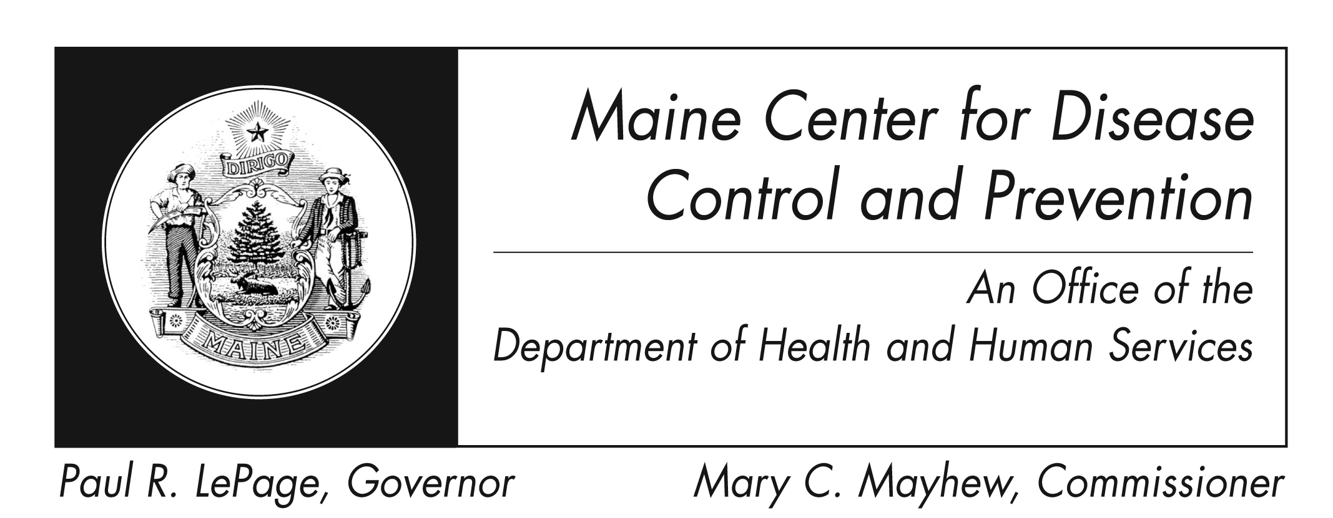Diphtheria
Fact Sheet

What is diphtheria?
Diphtheria is a disease caused by certain types of Corynebacterium diphtheriae bacteria that make toxins.

How is it spread?
It is spread from person to person by droplets from the nose or throat of someone with the disease. Handling objects soiled with the bacteria can sometimes spread the disease. It can also be spread by consuming raw milk.

What are the symptoms?
Early symptoms include malaise, sore throat, loss of appetite, and low fever. A sticky white or gray membrane forms on the tonsils, or in the throat or nose. Other symptoms may include hoarseness, barking cough, or a skin rash.

How soon do symptoms appear?
Symptoms often occur after 2-7 days but can be up to 10 days later.

Are there complications?
Neck swelling or a large membrane can cut off air supply. Abnormal heart rhythms can occur and lead to heart failure. Nerves may become inflamed and lead to paralysis and respiratory failure. Death occurs in 5%-10% of those infected.

How long is an infected person able to spread the disease?
A person who is not treated can spread the disease for 14 days or less, and rarely more than 4 weeks. Infected people without symptoms, or carriers, may spread bacteria for 6 months or more without treatment.

What is the treatment?
People with disease of the nose or throat must be treated with antitoxin. Federal CDC keeps this medicine at special sites around the country. If given in time, antitoxin can prevent serious disease. Antibiotics are used to kill the bacteria and reduce spread.

How can I prevent it?
- Vaccine is the best way to prevent this disease. A few types of child and adult vaccines are offered.
- People who travel to countries where the disease is common should also get vaccine.
- Wash your hands with soap and water after contact with skin sores.
- Healthcare staff must wear gloves and a mask to care for patients with diphtheria of the nose or throat. Anyone taking care of a person with skin sores must wear gloves and a gown.
- Wear gloves and a gown to handle all objects soiled by droplets from the nose, throat, or skin of the patient.

Where can I get more information?
For more information contact your healthcare provider or local health center. You can also contact the Maine Center for Disease Control and Prevention by calling 1-800-821-5821 or check the federal Centers for Disease Control and Prevention website - http://www.cdc.gov.

