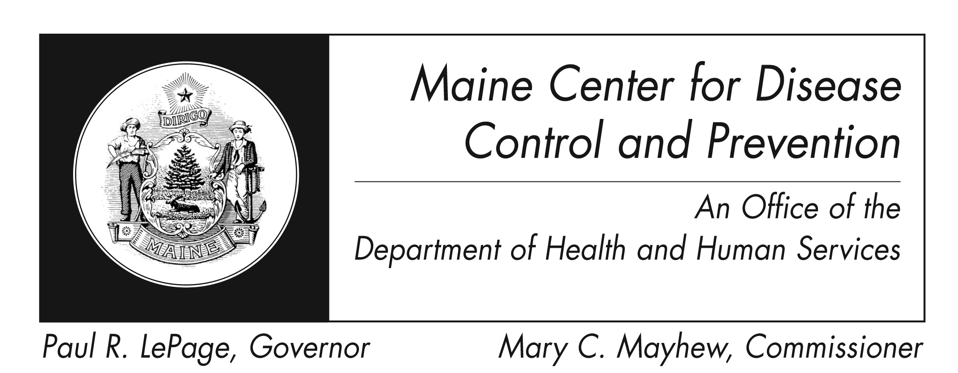
Varicella (Chickenpox)
Fact Sheet

What is Varicella?

It is an infection caused by the varicella zoster virus.

Who can get varicella?

Anyone who is unvaccinated, not adequately vaccinated or not immune from previous varicella infection can get varicella.

What are the symptoms of varicella?

The most common symptoms are a skin rash concentrated on the face, scalp, and trunk. Most infected individuals have a fever, which develops just before rash appears.

Are there complications of varicella?
Yes, bacterial infection of the skin, swelling of the brain, and pneumonia can occur. Adolescents and adults are more at risk for severe disease.

How soon do symptoms appear?

Symptoms typically appear 14-16 days after infection, but this period can range from 10-21 days after infection.

How is varicella spread?

Varicella is spread by coughing and sneezing, direct contact, and aerosolization of the virus from skin lesions. Surfaces of items like toys, can also spread the virus if someone who is sick touches them without washing their hands, and someone else then touches the same surface and then rubs their eyes, mouth, or nose.

How long is an infected person able to spread the disease?

An infected person can spread the disease up to 5 days before starting symptoms, but more commonly is only infectious 1-2 days prior to onset of rash. The infected person remains contagious until all lesions are crusted (usually 5 days after start of symptoms).

What is the treatment for varicella?
Infected persons, who do not have additional health conditions will not need specific treatment.
Do not use aspirin or products containing aspirin to relive your child’s fever, as this has been known to cause Reye’s syndrome, a potentially fatal disease affecting all organs, but most seriously affecting the liver and brain. Use only non-aspirin medications.

Persons whose immune systems have been compromised from disease or medication should contact their doctor immediately if they are exposed to or develop varicella. If you are pregnant and are either exposed to or develop varicella, you should immediately discuss prevention and treatment options with your doctor.

How do I protect myself and my family?

Varicella vaccine is the best prevention. Washing hands well and often with soap and teaching children to do the same is also of vital importance. Eating utensils should not be shared and surfaces that are frequently touched (toys, doorknobs, tables, counters, etc) should also be regularly cleaned with soap and water or with cleaning wipes.

Where can I get more information?
Your healthcare provider or local health center will have additional information and you can also contact the Maine Center for Disease Control and Prevention by calling 1-800-821-5821. The federal Centers for Disease Control and Prevention website (http://www.cdc.gov) is another excellent source of health information.

