TO: Maine Immunization Providers

FROM: Maine Immunization Program

SUBJECT: Influenza 2012-2013 Recommendations

DATE: September 20, 2012

The flu season is upon us and the annual influenza vaccination is the most effective method for preventing influenza virus infection and its complications.

Key Reminders:

* Routine annual influenza vaccination is recommended for all persons ≥ 6 months of age.
* The CDC recommends that influenza vaccination begin as soon as the flu vaccine becomes available.
* CDC recommends a yearly flu vaccine as the first and most important step in protecting against flu.
* While there are many different flu viruses, the flu vaccine protects against the three viruses that research suggests will be most common this season.
* The 2012-2013 flu vaccine will protect against an influenza A (H1N1) virus, an influenza A (H3N2) virus and an influenza B virus.
* Vaccination of high-risk people is especially important to decrease their risk of severe flu illness.
* Vaccination is important for health care workers, and other people who live with or care for high-risk people to keep from spreading the flu to high-risk people.
* Please see Attachment A for algorithm for children who may require 2nd dose of influenza vaccine.
* Please see Attachment B for guidance on influenza vaccination of persons with history of egg allergy.

Sincerely,



Tonya Philbrick, BS, NCMA

Director, Maine Immunization Program

**Attachment A**

**2012-2013 Influenza 2nd dose Recommendations**

* Children who are aged 6 months through 8 years need only 1 dose of vaccine in 2012-2013 if they received a total of 2 or more doses of seasonal vaccine since July 1, 2010.
* Children who did not receive a total of 2 or more doses since July 1, 2010, require 2 doses in 2012-2013.
* If a child aged 6 months through 8 years is known to have received at least 2 influenza vaccines during any previous season, and at least 1 dose of a 2009 (H1N1)-containing vaccine, then the child needs only 1 dose for 2012-2013.
* Children aged 6 months through 8 years need only 1 dose of vaccine in 2012-13 if they have received any of the following:
* 2 or more doses of seasonal influenza vaccine since July 1, 2010; or
* 2 or more doses of seasonal vaccine before July 1, 2010, and 1 or more doses of monovalent 2009 (H1N1) vaccine; or
* 1 or more doses of seasonal vaccine before July 1, 2010, and 1 or more doses of seasonal influenza vaccine since July 1, 2010.

**Influenza 2012-2013 2nd dose Recommendations**

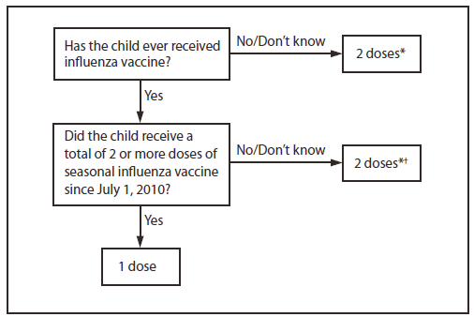

* Doses should be administered at least 4 weeks apart.

† For simplicity, this algorithm takes into consideration only doses of seasonal influenza vaccine received since

July 1, 2010. As an alternative approach in settings where vaccination history from before July 1, 2010, is available,

if a child aged 6 months through 8 years is known to have received at least 2 seasonal influenza vaccines during any previous season, and at least 1 dose of a 2009(H1N1)-containing vaccine (i.e., either 2010–11 or 2011–12 seasonal vaccine or the monovalent 2009[H1N1] vaccine), then the child needs only 1 dose for 2012–13. Using this approach, children aged 6 months through 8 years need only 1 dose of vaccine in 2012–13 if they have received any of the following:

1) 2 or more doses of seasonal influenza vaccine since July 1, 2010

2) 2 or more doses of seasonal influenza vaccine before July 1, 2010, and 1 or more doses of monovalent

2009(H1N1) vaccine; or

3) 1 or more doses of seasonal influenza vaccine before July 1, 2010, and 1 or more doses of seasonal influenza

vaccine since July 1, 2010. Children for whom one of these conditions is not met require 2 doses in 2012–2013.

For further information, please visit:

[www.cdc.gov/mmwr/preview/mmwrhtml/mm6132a3.htm?s_cid=mm6132a3_e](http://www.cdc.gov/mmwr/preview/mmwrhtml/mm6132a3.htm?s_cid=mm6132a3_e)

If you have any questions, please call the Maine Immunization Program at 207-287-3746 or 1-800-867-4775.

**Attachment B**

**Recommendations for Influenza Vaccination of Persons with a History of Egg Allergy**

All currently available influenza vaccines are prepared by means of inoculation of virus into chicken eggs. The use of influenza vaccines for persons with a history of egg allergy has been reviewed recently by ACIP ([*16*](http://www.cdc.gov/mmwr/preview/mmwrhtml/mm6033a3.htm) -http://www.cdc.gov/mmwr/preview/mmwrhtml/mm6033a3.htm). For the 2011–12 influenza season, ACIP recommended that persons with egg allergy who report only hives after egg exposure should receive TIV, with several additional safety measures.

As with all vaccines, please remember that they should be administered in settings in which personnel and equipment for rapid recognition and treatment of anaphylaxis are available. ACIP recommends that all vaccination providers be familiar with the office emergency plan.

**Vaccine administration to persons with a history of egg allergy**

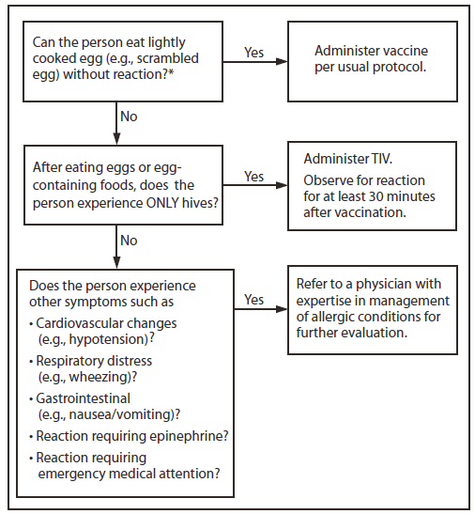

For further information, please visit:

[www.cdc.gov/mmwr/preview/mmwrhtml/mm6132a3.htm?s_cid=mm6132a3_e](http://www.cdc.gov/mmwr/preview/mmwrhtml/mm6132a3.htm?s_cid=mm6132a3_e)

If you have any questions, please call the Maine Immunization Program at 207-287-3746 or 1-800-867-4775.