

## ImmPact

Maine’s Immunization Information System

Maine Immunization Program

286 Water Street. 9th floor

Augusta, Maine 04333

ImmPact Support Desk: 1-800 906-8754

Fax: 207-287-8127

ImmPact Support Email: [immpact.support@maine.gov](mailto:immpact.support@maine.gov)

TTY Users call Maine Relay 711

Entering Administered Doses

Log-in at <https://portal.maine.gov/wir>

Enter:

1. Organization Code
2. Username
3. Password
4. 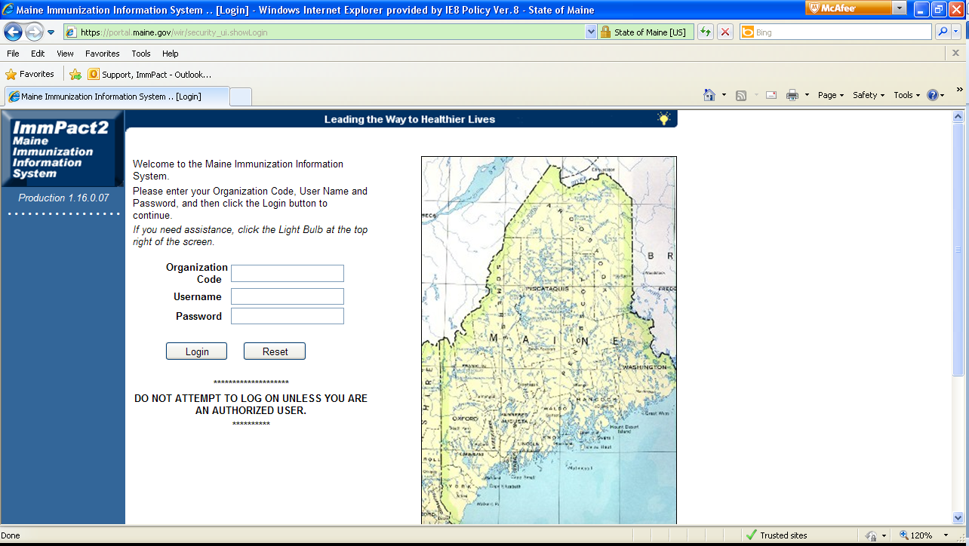Click Login

**3.**

**2.**

**1.**

1. Read all required announcements marked with the red triangle Warn! as well as any other announcements that may pertain to your site

**4.**

*Ensure that all data entry is complete prior to reconcilation

(Example : If inventory has been reconciled between the date that dose was given and the day it was entered, the dose will not draw down from the inventory)

1. 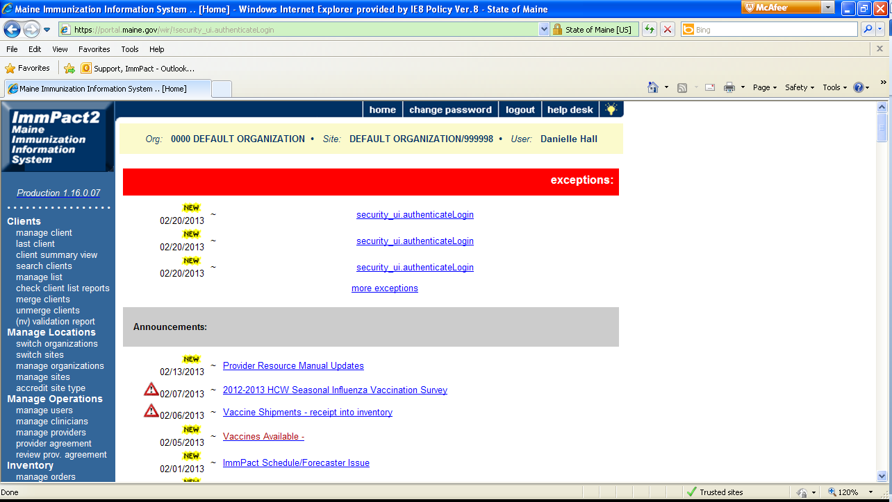Click manage client under the Clients heading

**6.**

**5.**

1. Enter the first three letters of the client’s last name that is being searched
2. Enter the first three letters of the client’s first name that is being searched
3. Click Find
4. Select appropriate client record by selecting the blue link

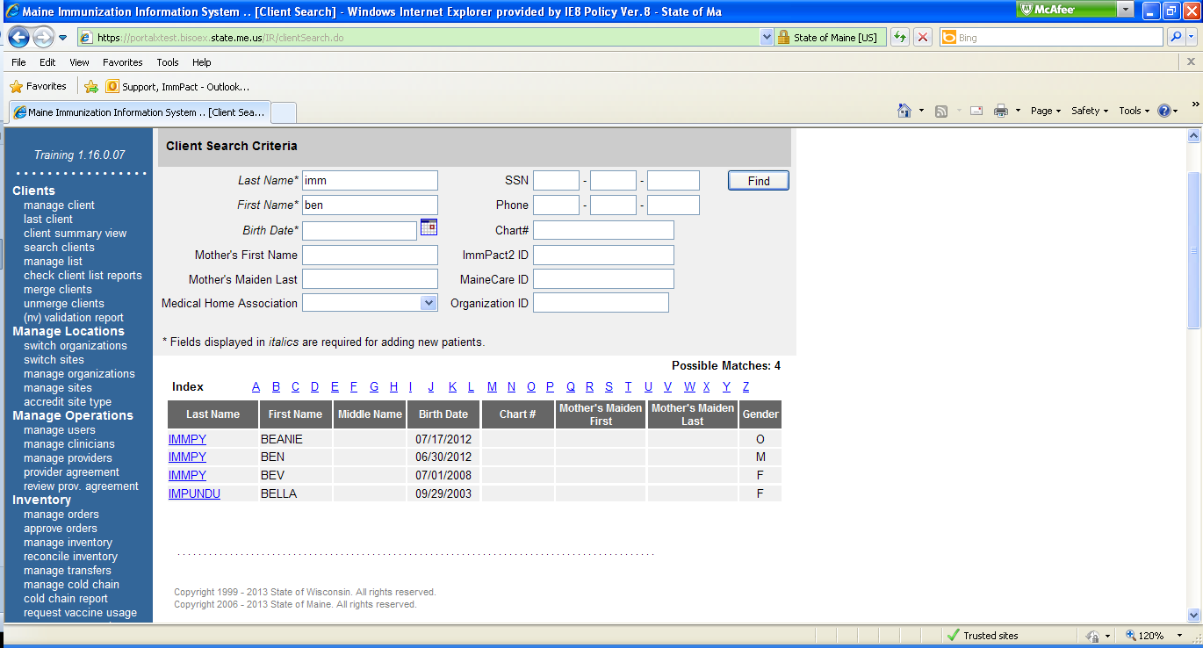*If the client is in the system and there are no similar matches to the search ImmPact will go directly to the client record

**9.**

**8.**

**7.**

1. Ensure that it is the correct client record and verify that the information is correct in the Personal Information section. All fields in blue and with an * are required

**10.**

1. Click Save once all the information has been verified
2. Click Record Immunization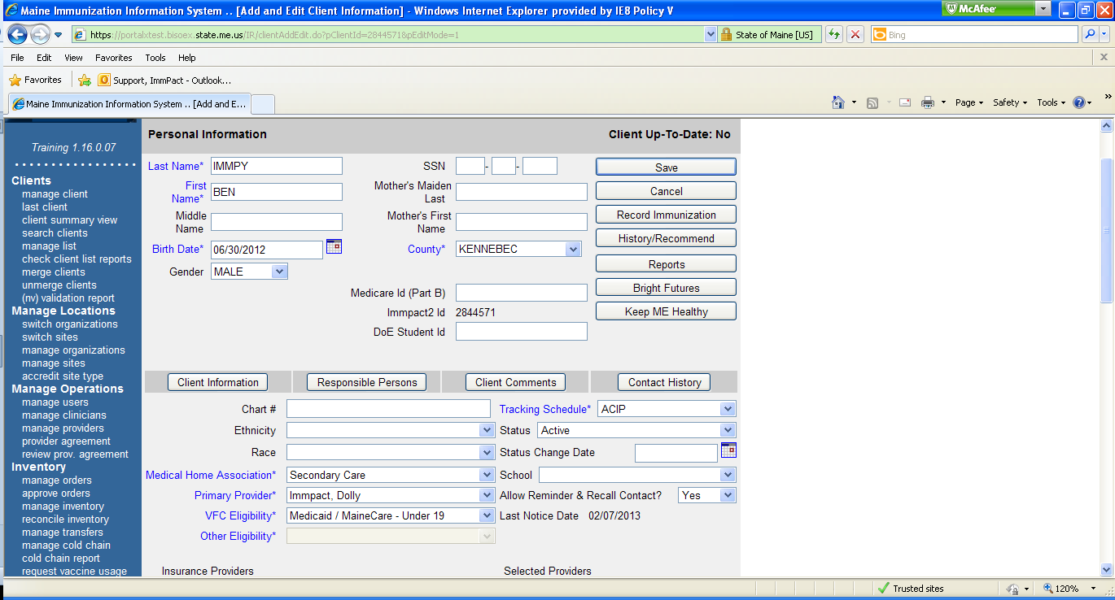

**12.**

**13.**

**11.**

1. 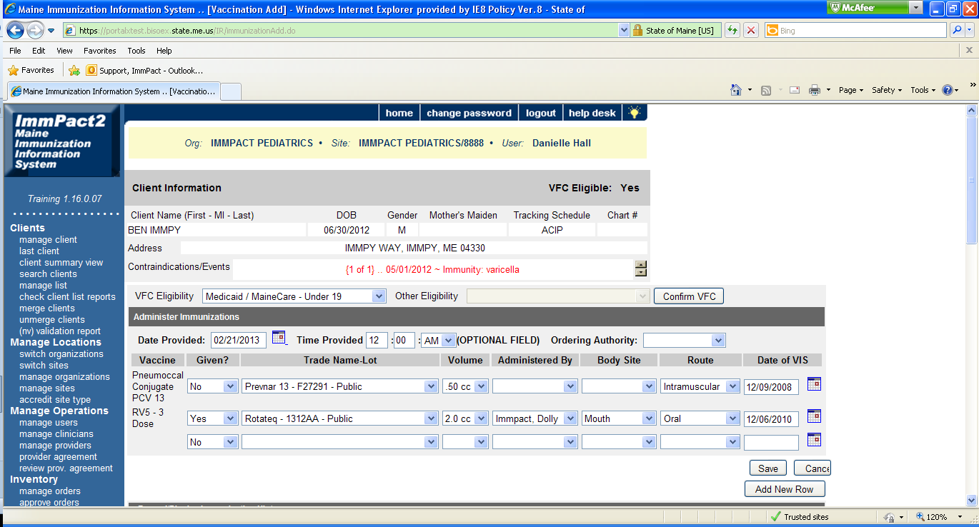Select the VFC Eligibility from the dropdown and Confirm VFC

**17.**

**16.**

**15.**

**14.**

1. In the date provided box enter the date the dose was given

a. You may update the Time Provided (Optional)

b. You may update the Ordering Authority (Optional)

1. Select
2. Indicate Given (Yes)
3. Trade name-lot
4. Volume
5. Adminstered by
6. Body site
7. Route
8. Date of VIS (This should be the publication date of the Vaccine Information Statement (VIS) provided to the client)
9. Click Save
10. 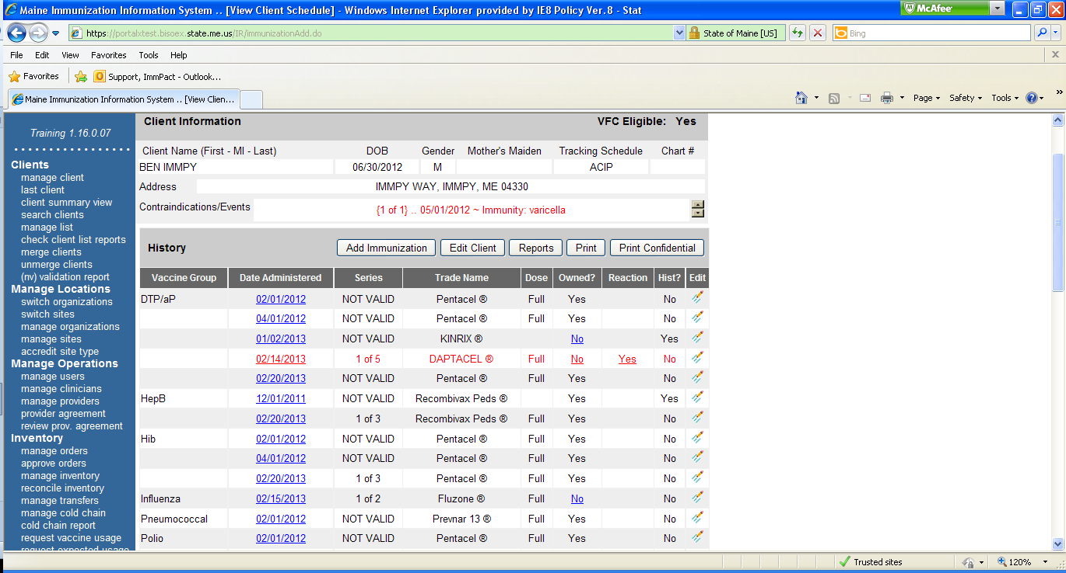After successfully saving, ImmPact will redirect to the Client information on the History/Recommend page for review of the immunization that was just added

**18.**

1. Ensure that the record was saved as intended with the correct date, vaccine and dose amount

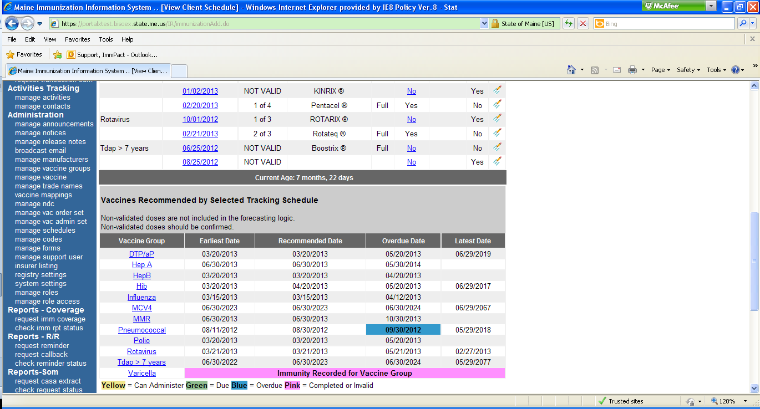

**19.**

**20.**

1. The tracking schedule will provide the next guidance when the next doses are recommended
2. The Vaccines Recommended by Selected Tracking Schedule section will provide guidance for when the next doses are recommended as well as any vaccines the client is overdue for. Please also use other immunization resources such as Pink Book, ACIP Schedule and package inserts.