Synergy Mass Delete Attendance Tool
- In the top right, set your focus to the current school year and school you wish to delete from:

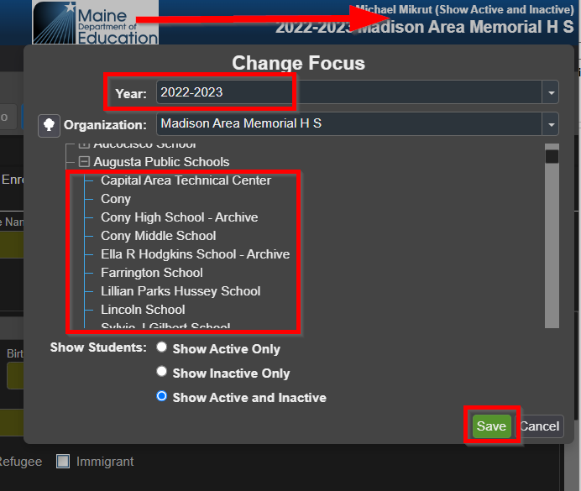

- Navigate to the ‘Mass Delete Attendance’ screen:
  - Quick Launch:
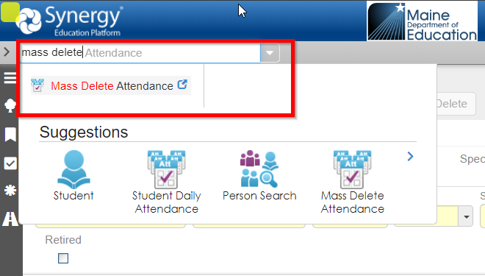

  - PAD Tree: Synergy SIS > Attendance > Mass Delete Attendance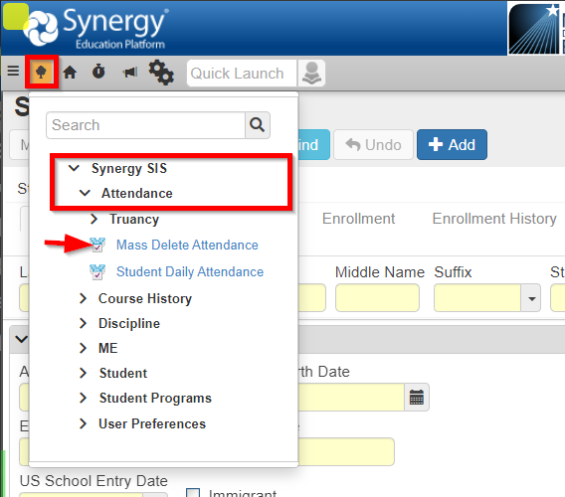

To Delete attendance for a currently enrolled student:
- Click the ‘Chooser’ button towards the bottom to pull up a ‘Student Find’ window:
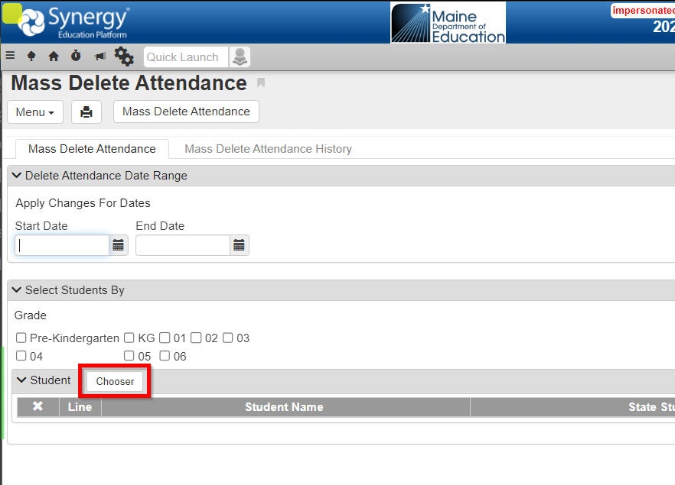
- Enter the State Student ID number for the student(s) you wish to delete attendance for. You may enter as many as you like here. The Chooser uses two columns “Find Result” and “Selected Items” in case you don’t know the ID number of the student. Clicking the Line number of a record moves it from one column to the other. Once your student(s) are under “Selected Items”, hit ‘Select’:
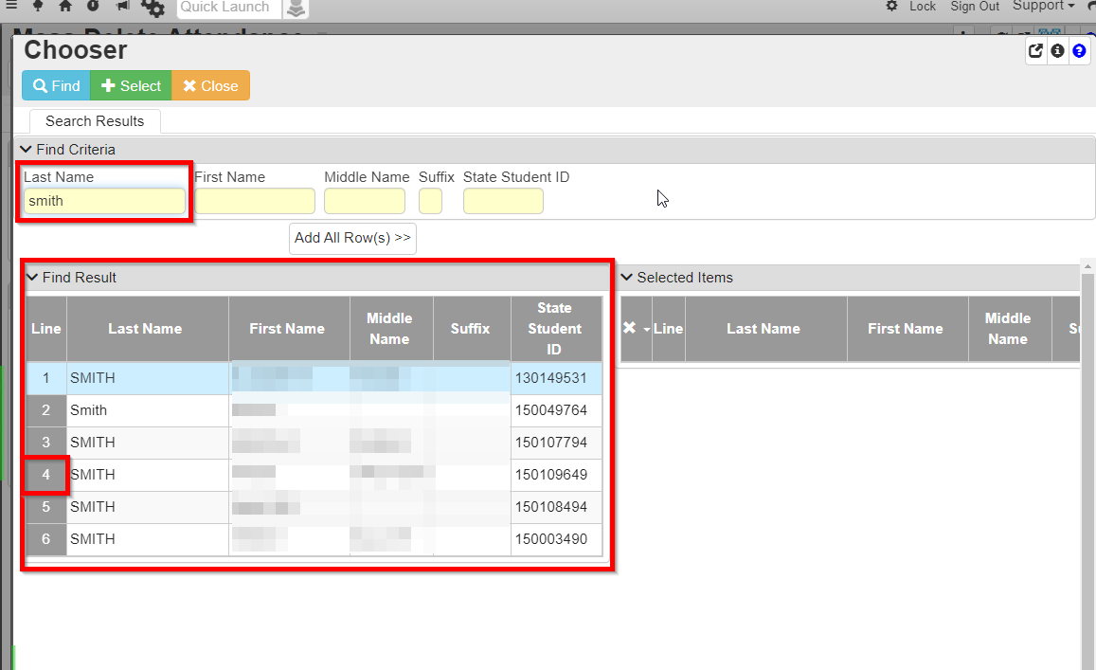
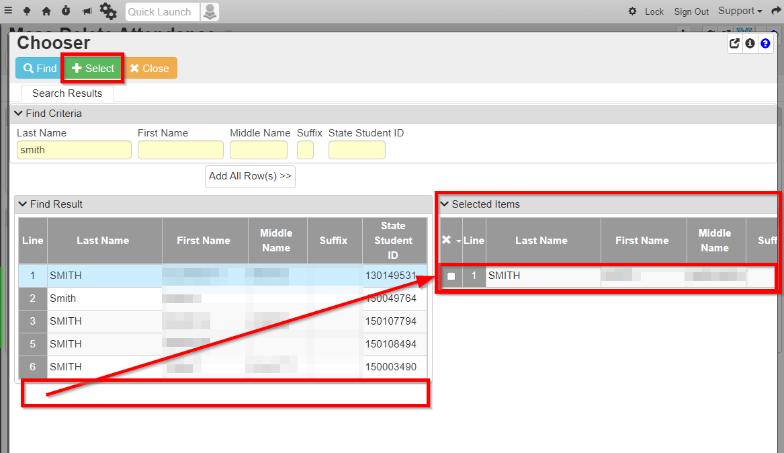

- The chosen student(s) will show in the grid on the main screen, and now you may specify a date range to delete.
  - Leaving the Date fields blank will delete ALL attendance for the student at the chosen school.
  - Choosing the same Start Date and End Date will delete just that single day.
  - Using a span of different days will delete the selected days and everything in-between.
    - Click the ‘Mass Delete Attendance’ button to perform the action.
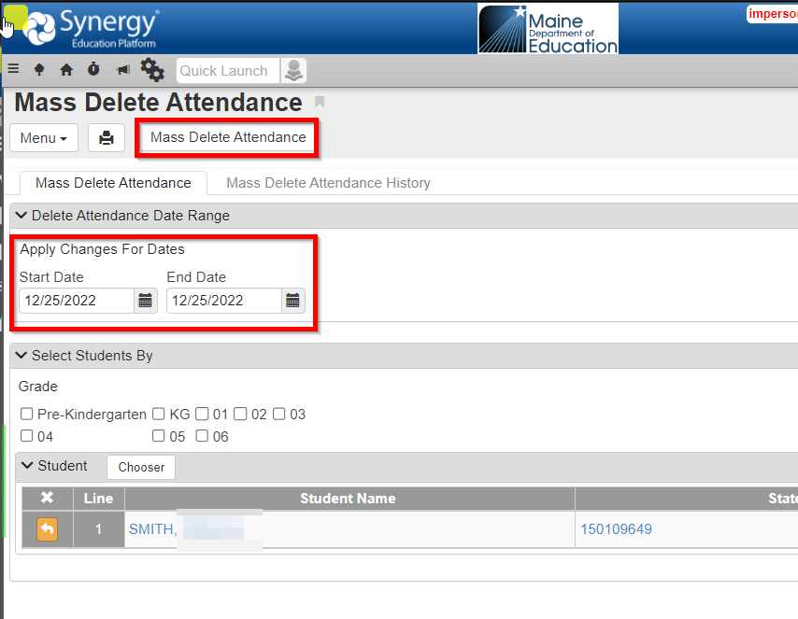

To Delete attendance for ALL Students at a School:

- To remove attendance for all Students at a school, you would not select any students with the Chooser.
  - Checking a grade will delete the specified days for all students in that Grade.
  - Leaving both the Student Chooser and Grades un-selected will delete the attendance from ALL Students at the school.
  - Leaving everything blank is not advised, as this will delete all attendance from all students.
