1. | Identify Your Purpose
2. | Choose A Picture Book | It might be new, it might be known.
3. | Select A Thinking Routine | A known routine will allow for participants to have an increased capacity for engagement.
4. | Share Communication Strategies | How will ideas be shared? (With partners, small groups, post-it notes, through drawing, rhythm, movement, etc.)
5. | Share The Book, Routine & Ideas | Archive the ideas to return to in the future, especially when noticing and naming positive social and emotional actions in your learning space.
6. | Reflect On Your Purpose | You might use the tool on the MDOE’s website, “After Reading Educator Reflection”
7. | Reflect On What Surfaced | What did you observe? What did you learn?
8. | Identify Your Next Purpose

Thinking Template:
1. | Identify Your Purpose | Our purpose in reading this book is to…
2. | Choose A Picture Book | We will read…
3. | Select A Thinking Routine | We will use the routine…
4. | Share Communication Strategies | Ideas will be shared through…
5. | Share The Book, Routine & Ideas | We will document our thinking by…
6. | Reflect On Your Purpose | I had hoped that we…what I noticed was that we…
7. | Reflect On What Surfaced | As I zoom out, I noticed that…
8. | Identify Your Next Purpose | Next, we will …

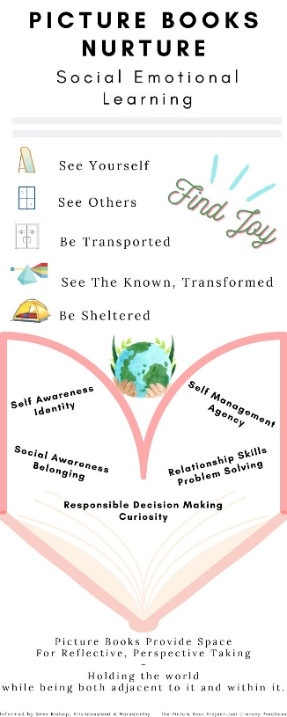
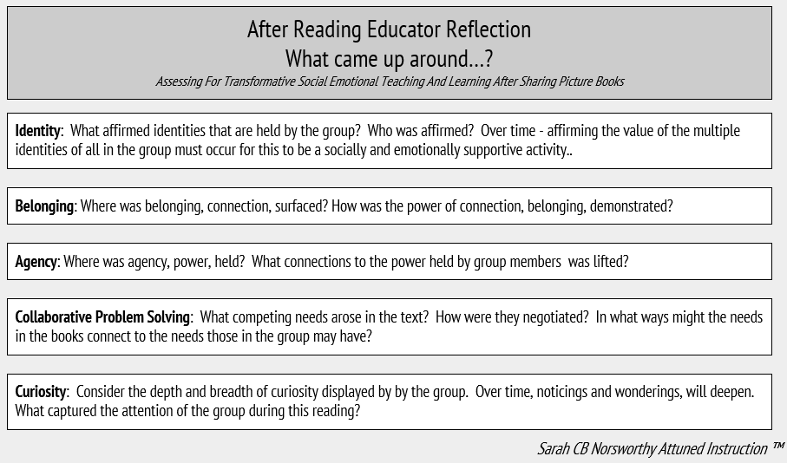

These tools are available on the Maine Department of Education’s Social Emotional Learning Implementation’s website.

