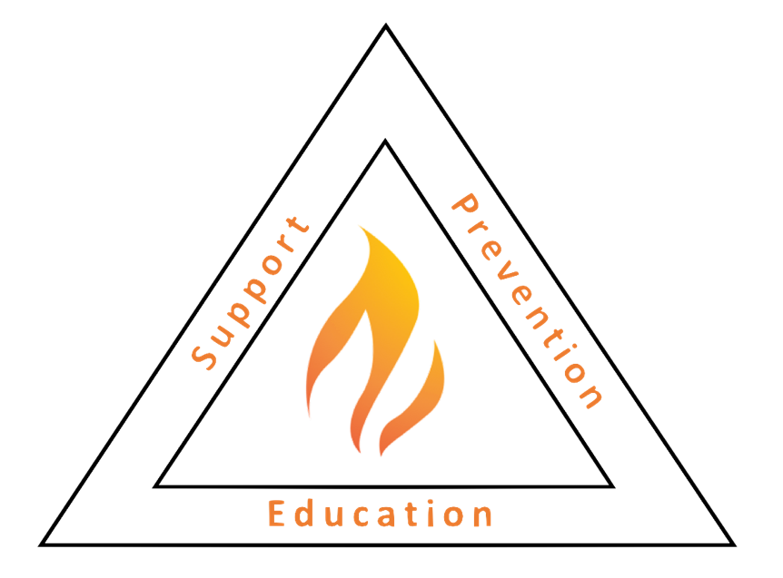
Address
Phone:
Email:

____________ Youth Fire Safety Program Manual

Directive 2410

SUBJ: YOUTH FIRE SAFETY INTERVENTION PROGRAM MANUAL

Reference: (a) FEMA Youth Firesetting Prevention & Intervention Manual.
(b) Maine Office of State Fire Marshal Juvenile Fire Safety & Intervention Protocol.
(c) Standard on Fire and Life Safety Educator, Public Information Officer,
Youth Firesetter Intervention Specialist and Youth Firesetter Program Manager Professional Qualification/NFPA 1035.
(d) ____________________________ Job Descriptions.

Attachment: (1) Referral Process Flow Chart.
(2) Program Logo
(3) Program Graduation Certificate (Form 2410/1)
(4) Stakeholder Memorandum of Agreement

1.0 Mission Statement: To protect the community from the dangers of youth firesetting while reducing fire-related tragedies through collaboration, assessment, intervention, and education.

2.0 Program Overview: The ______________ Youth Fire Safety Program is a partnership between local public and private partners who are working together for the safety of _____________communities.

The ______________ Youth Fire Safety Program provides educational programs that are designed for youth who demonstrate unsafe behavior related to fire or firesetting behaviors. The program is intended for youth ages 5-17 and addresses concerns related to the dangers of fire along with prevention strategies. The program strives to individualize each educational opportunity and is provided free of charge to all participants.

The program utilizes a nationally recognized screening process that aids staff in identifying the educational needs of the child, while also considering additional supports that might benefit the youth or family. If indicated by the intake process, the youth will receive education in the areas of fire behavior, fire prevention, burns management, and decision making. However, variations are made to address the youth’s needs and supervision recommendations. The youth’s fire safety knowledge retention is assessed using a pre and post-test before and after the educational intervention. The program staff will then make any additional recommendations and/ or referrals at the time of graduation. A follow-up survey is disseminated to parents/guardians at six- and one-year intervals.

While it is known that fire safety education is an effective means of reducing fire setting behaviors, further referrals will be made if continued firesetting behaviors are recognized by the program staff.

3.0 Organizational Goals:

COLLABORATION

To develop a collaborative of youth fire safety stakeholders such as, but not limited to, families, school departments, fire departments, law enforcement agencies.

To develop and sustain local and regional youth fire safety stakeholder collaborations and formalize such collaboration through memorandums of agreement.

ASSESSMENT

To provide standardized assessment tools for intervention team member use in identifying potential risk of continued fire activity.

To train a cadre of Youth Firesetter Intervention Specialists (YFIS).

To develop a youth fire safety intervention resource network.

DATA COLLECTION

To collect and analyze youth firesetter data.
To maintain a central repository for youth referred to the program.
To store, secure, safeguard and utilize such data by using generally accepted methods and following applicable Federal, State, and Local guidelines.

YOUTH FIRE SAFETY AWARENESS EDUCATION

To inform stakeholders of the scope and severity of youth fire interest and /or setting problem.

To inform stakeholders of the existence and capability of the youth fire safety resource network.

To provide educational resources for use by stakeholders.

YOUTH FIRE SAFETY INTERVENTION

To provide standardized education materials in fire safety, legal aspects, and behavioral health resources to youth firesetters and their family members.

To refer youth firesetters and their family to appropriate community resources.

4.0) Employee Training, Qualifications: Employees of this program will be trained, certified, and qualified to NFPA Standard 1035, National Fire Academy standards and/or requirements of the Maine Office of State Fire Marshal Office, or Maine Fire Service Institute.
Qualifications and certification requirements shall be provided in applicable job descriptions. (See Reference (d)).

5.0) Standard Operating Guidelines: The Program Manager shall develop the necessary operating guidelines, job aids, checklists, etc. for the efficient operation of this program.

Standard Operating Guideline 3411

Subject: PROGRAM INTAKE PROCEDURES

Reference: (a) Directive 2410/______________ Youth Fire Safety Program Manual

Forms: 3411/1) Authorization to Interview.
3411/2) Release of Liability.
3411/3) Authorization(s) of Release.
3411/4) Fire Safety Agreement.
3411/5) Parent Checklist.
3411/6) Parent Interview.
3411/7) Youth Interview.
3411/8) Screening Report.
3411/9) American Red Cross Smoke Alarm Form.

1,0) Purpose. This directive is designed to provide program staff a standardized procedure for conducting an intake process with a youth that has demonstrated an interest in fire or has been involved with firesetting behaviors.

2.0) Definitions: Youth Firesetting Information Repository & Evaluation System (YFIRES): A confidential online database that allows de-identified documentation of youth firesetting events on a national scale. YFIRES is used to collect de-identified data for fire prevention efforts throughout the State of Maine at the direction of the Maine Office of State Fire Marshal. www.YFIRES.com

3.0) Procedure: A referral is received from a referral source that may include fire departments, police departments, schools, behavioral health, and/or parents/guardians. This receipt of the referral form initiates the intake process.

Once program staff determines a youth is appropriate for a youth fire safety program, the information from the referral form is entered into the YFIRES database.

The prospective youth/family is contacted via phone to set up an intake date and time. The program strives to schedule the intake date within 7 days of the referral.

Once a mutually scheduled time and date are established, the location is confirmed by both parties. The intake is preferably done within the home environment, though alterations are made based on extenuating circumstances i.e., safety concerns.

The program staff sends a reminder within 24 hours prior to the scheduled intake meeting to confirm the details with the youth/family.

On the day of the intake meeting, program staff prepare an intake packet, smoke alarm resources, and confirm appropriate dress.

The program staff proceed to the mutually agreed meeting location with appropriate identification.

Once at the mutually agreed meeting location, program staff forms a rapport with youth/family through appropriate introductions. The intake process is explained to both youth and family. An authorization to interview form is completed prior to any further discussion.

Program staff complete authorization to interview / release of liability, authorization of release (s), fire safety agreement, parent checklist, parent interview, child/youth interview, and screening report.

Once the documents are completed, scores from both the youth and parent interviews are reviewed to determine the next programmatic steps.

The home environment is assessed for any obvious safety concerns and appropriate notifications are completed.

The home is confirmed to have operating smoke alarms, if not program staff install smoke alarms in partnership with the American Red Cross smoke alarm program with the appropriate documentation completed.

The program staff makes appropriate referrals in concert with the youth/family.

The program staff reviews documentation and makes appropriate contact to person (s) and/or agencies identified by the authorization of release form.

Once notifications have been made and resources gathered for education, the youth/family are contacted to set up a mutually agreed date and time to complete education.

The scheduling of education completes the intake process.

Standard Operating Guideline 3412

Subject: CLIENT EDUCATION

Reference: (a) Directive 2410/______________ Youth Fire Safety Program Manual

Forms Required
3412/1) Fire safety knowledge pre/posttest- levels I, II & III
3412/2) Fire behavior workbook
3412/3) Fire prevention workbook
3412/4) Burns & decision-making workbook
3412/5) Fire safety & intervention objectives form

1.0 Purpose.

This SOG is designed to provide program staff a standardized procedure for guiding education with a youth who has experimented or demonstrated interest in firesetting. These objectives act to guide education, but each educational interaction is tailored to the meet physical, cognitive, behavioral, and emotional needs of a youth and family

The program education is completed utilizing the framework provided by the National Fire Academy Youth Firesetting Prevention & Intervention Programs. The education is adapted to fit both the youth and family needs in collaboration with program supervision. The educational outline below is intended to address a generalized pathway and can be adapted to fit the needs of the youth, family, or program. The fire safety educational intervention is separated into four parts: fire behavior, fire prevention, burns management, and decision making. The presentation of the intervention is adjusted based on the youth / family needs, though the intervention is frequently delivered in two separate sessions. The information below is provided to outline common objectives, though content is adjusted to meet the physical, cognitive, behavioral, and emotional needs of the youth / family. All educational objectives are documented utilizing the Fire Safety & Intervention Objectives Form.

2.0) Procedure:

The youth is provided a pre-test at the first educational intervention to establish a baseline fire safety knowledge. This score is documented on the Fire Safety & Intervention Objectives Form.

The educational program is presented in two-sessions, though often tailored to meet the needs of the youth or family.

The program staff utilizes slides, worksheets, videos, and hands-on activities to meet the objectives outlined by the Fire Safety & Intervention Objectives Form.

The youth completes the fire safety workbooks during or following the in-class portion of the program.

The youth and family are required to complete a fire safety exit drill in the home prior to the completion of the program.

Following completion of the fire education modules, a post-test is administered to determine retention and application of fire safety education.

A certificate of completion is issued to the youth upon successfully completing the objectives of the fire safety program.

Fire Behavior Module

Youth demonstrates an understanding of the fire tetrahedron
Youth demonstrates an understanding of a chain reaction
Youth demonstrates an understanding of combustion
Youth demonstrates an understanding of the product of combustion
Youth demonstrates an understanding of the contents and characteristics of smoke
Youth demonstrates an understanding of the effects of smoke on the body
Youth demonstrates an understanding of fire speed and progression
Youth demonstrates an understanding of the dangers of matches and lighters

Fire Prevention Module

Youth demonstrates an understanding of classes of fire
Youth demonstrates an understanding of the dangers of flammable liquids
Youth demonstrates an understanding of types of extinguishers
Youth demonstrates an understanding of smoke alarm importance
Youth demonstrates an understanding of smoke alarm maintenance and testing
Youth demonstrates an understanding of exit drills in the home
Youth demonstrates an understanding of two ways out of room
Youth demonstrates an understanding of the importance of closing the door on fire
Youth demonstrates an understanding of safe uses of fire
Youth demonstrates an understanding of generalized home hazards

Burns Module

Youth demonstrates an understanding of the anatomy of the skin
Youth demonstrates an understanding of sources of burns
Youth demonstrates an understanding of types of burns
Youth demonstrates an understanding of the rules of 9
Youth demonstrates an understanding of burn treatment

Decision-Making Module

Youth demonstrates a basic understanding of arson
Youth demonstrates an understanding of curiosity fire setting
Youth demonstrates an understanding of anger fire setting
Youth demonstrates an understanding of boredom fire setting
Youth demonstrates an understanding of peer pressure fire setting
Youth demonstrates a basic understanding of diversion techniques
Youth demonstrates an understanding of the consequences of firesetting behavior
Youth demonstrates an understanding of restitution

Standard Operating Guideline 3413

Subject: PROGRAM DOCUMENTATION

Reference: a) Directive 2410/______________ Youth Fire Safety Program Manual.
b) Maine Local Government Record Retention Schedule 21 (August 2018).
c) MSRA Title 15 ss 3308/Juvenile Case Records.

Forms:
3413/1) Fire Safety & Intervention Objectives Form
3413/2) Youth Fire Safety & Intervention Contact Form
3413/3) Youth Fire Safety & Intervention Follow-up Form

1.0) Purpose. This directive is designed to provide program staff with a standardized procedure for documentation of interactions with youths and families.

2.) Definitions: Youth Firesetting Information Repository & Evaluation System (YFIRES): A confidential online database that allows deidentified documentation of youth firesetting events on a national scale. YFIRES is used to collect de-identified data for fire prevention efforts throughout the State of Maine at the direction of the Maine Office of State Fire Marshal. www.YFIRES.com

3.0) Procedure:

The program documentation is divided into electronic and paper files. This
documentation is retained within YFIRES and the ______________ Youth Fire Safety Program office. All files are kept in a secured manner with appropriate passwords and keys. The procedure defines how data is collected and disseminated within the confines of the ______________ Youth Fire Safety Program.

All information obtained through the intake, education, and follow-up processes is documented using both an electronic and paper format. Information obtained is confidential and documented in accordance with program policies and procedures.

Any information obtained from youth or family is kept confidential, excluding mandatory reporting requirements or information being shared with other providers only if the appropriate release of information form has been completed.

Information is provided for the sole purposes of ongoing fire prevention efforts on both a local and national level. This sharing of information is in accordance with the directive from the Maine Office of State Fire Marshal.

The Program staff will strive to document case information as soon as possible in most cases.

4.0) Records & Records Retention

4.1) Personal Identifiable Information (PII): Personal information on the youth and their family (i.e., name, age, gender, date of birth, town, parent/guardian information, address, fire setting behaviors, fire education attendance, etc.) is gathered from the intake and screening documents and entered into YFIRES. At the direction of the Maine Office of State Fire Marshal, YFIRES is used to help track children who have a history of fire setting and for statistical purposes.

4.2) Records Location: The physical records are kept at the ________________ in a locked container within the ______________ Youth Fire Safety Program Office. Records are only to be accessed by program staff as authorized by staff.
Electronic records are stored in the YFIRES online database. YFIRES system access is granted via the YFIRES administrator, as authorized by program staff

4.3) Record Retention: Records are maintained as required by References (b) and (c). Series 21.15 of Reference (b), records of juveniles who have started fires, and of the steps taken to prevent recurrence must be maintained until the former juvenile is 23 years old. These records are confidential, as required by Reference (c).

Standard Operating Guideline 3414

Subject: CLIENT FOLLOW UP

Reference: a) Directive 2410/______________ Youth Fire Safety Program Manual.

Forms:
3413/3) Youth Fire Safety & Intervention Follow-up Form

1.0) Purpose. This directive is designed to provide program staff a standardized procedure for conducting post-education follow up with youths and families.

The follow-up procedure is intended to outline a common pathway within the ______________ Youth Fire Safety Program. The ______________ Youth Fire Safety Program follow-up schedule is divided into 6-month and 1-year intervals. The youth/family is eligible to receive a program follow-up after successful completion of the _______________ Youth Fire & Safety Program educational intervention. The procedure is defined below.

2.0) Procedure:

The program staff identified follow-up.

The program staff compile standardized follow-up letter and survey

The follow-up letter and survey are sent with a self-addressed stamped envelope to the identified youth/family.

The program staff document the follow-up event within YFIRES.

All completed survey responses are entered into YFIRES.

The returned survey response is then filed with the youth/family information on file.

Standard Operating Guideline 3415

Subject: CLIENT COMMUNICATION

Reference: a) Directive 2410/______________ Youth Fire Safety Program Manual.

Forms:
3413/2) Youth Fire Safety & Intervention Contact Form

1.0) Purpose. This directive is designed to provide program staff with a standardized procedure for communication interactions with youths and families.

2.0) Procedure:

It is understood that communication is an essential part of the fire safety intervention strategy, though care must be used in information discussed, disseminated, and documented to ensure accuracy and transparency. The procedure defines pearls that should be adhered to protect all parties involved in the communications. This procedure will discuss the mediums of phone, fax, text, and email communications. All forms of communication will require a signed release form completed by a parent or guardian prior to the dissemination of information. It is recommended that during the intake process that the best means of contact be identified by both the program’s staff and the youth’s parent or guardian.

2.1) Telephone: Program staff should ensure that all phone conversations are brief and address only program concerns related to the specific fire intervention or strategy.

Voicemails are to be left with the least amount of identifiable information, at no time will the youth’s name or date of birth be identified within a voicemail.

Program staff should ensure that all voicemails include the program staff members’ contact information to allow for proper return contact.

2.2) Facsimile (FAX): All faxes will include a completed fax cover sheet to include an intended receiver, return contact information, and de-identified reason for the fax.

Program staff should ensure that faxes are sent to the appropriate recipient by verifying the fax number and specific contact.

It is a recommended practice that following fax, the sender confirms via phone, email, or text that the fax was received by the recipient.

2.3)Text Messaging: Program staff should ensure that all text conversations are brief and address only program concerns related to the specific fire intervention or strategy.

Text messages are to be sent with the least amount of identifiable information, at no time will the youth’s name or date of birth be identified within a text message.

As the text is primarily utilized by program families, it is recommended that clear boundaries around text messaging be discussed during the intake process

At no time is a text to be directly sent to a youth.

2.4) Electronic Mail: Program staff should ensure that all emails are brief and address only program concerns related to the specific fire intervention or strategy.

Email messages are to be sent with the least amount of identifiable information, at no time will the youth’s name or date of birth be identified within an email message.

As email is often utilized by program families, it is recommended that clear boundaries around emails be discussed during the intake process

Standard Operating Guideline 3416

Subject: CLIENT ASSESSMENT and SUPERVISION

Reference: a) Directive 2410/______________ Youth Fire Safety Program Manual.

1.0) Purpose. This directive is designed to provide program staff with a standardized procedure for the use of interagency networking to increase the effectiveness of fire safety interventions.

2.0) Definitions:

2.1) Interagency Network: A group of professionals or agencies, not limited to public safety, behavioral health, education, and health care providers that form informal or formal collaborative relationships.

2.2) Supervision: An oversight agency and/or person(s) that is designed to give greater perspective to ongoing case management and program development. Ideally, this agency and/or person (s) should have a background in systems-based assessment and interventional pathways.

3.0) Procedure: The program employs interagency networking as required by the needs of youth, family, or program. These relationships are developed through partnerships that enhance how the assessment, education, and follow-up are delivered within the context of the fire safety intervention. The program utilizes two forms of interagency collaboration, those being continuous and case specific.
3.1) Case Specific: The program staff will utilize the obtained intake information from a youth/family and collaborate with agencies that will enhance the delivery and effectiveness of the fire safety education and intervention. This type of collaboration exists on a case-by-case basis, though partnerships are regularly cultivated and maintained by program staff.
3.2) Continuous: The goal of ongoing supervision is to maintain a continuous relationship with an agency and/or person (s) that provides insights and recommendations on case management and programmatic direction. The program staff will meet regularly with the agency and/or person (s) who are willing to fill this invaluable role. The goal of these meetings is to review de-identified cases and discuss potential systems-related concerns while identifying community resources to aid the youth or family.

Standard Operating Guideline 3417

Subject: PROGRAM REPORTING

Reference: a) Directive 2410/______________ Youth Fire Safety Program Manual.

1.0) Purpose. This SOG is designed to provide program staff with a standardized procedure for the reporting of program achievements, needs, and challenges on a quarterly basis.

2.0) Procedure: The quarterly report is intended to inform fire officials and staff of the program’s accomplishments within a defined period. The quarterly report is completed by program staff to determine progress and effectiveness.

2.1) Report: The quarterly report shall contain pertinent information covering these topics:
- Program Interventions: Number of clients entering the program, number of clients’ graduating from the program.
- Referral Sources.
- Communities Served
- Program Achievements & Goals.
- Outreach & Collaborative Efforts & Accomplishments.
- Needs Assessment: Personnel/Staff, Training, Material, Financial.

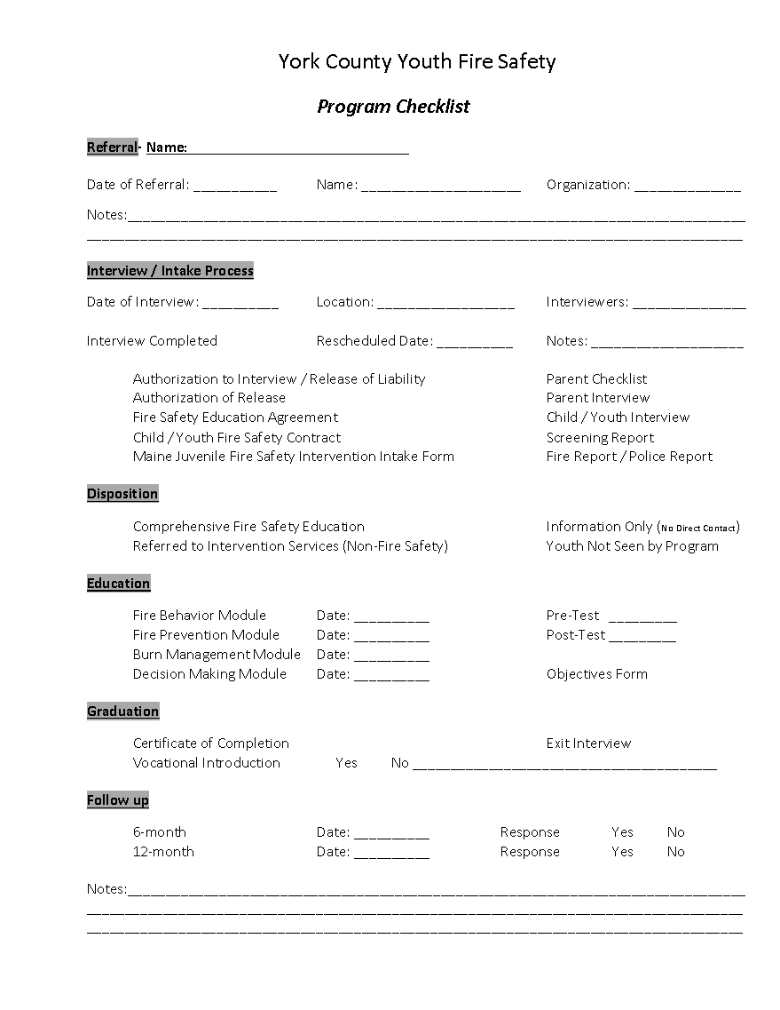
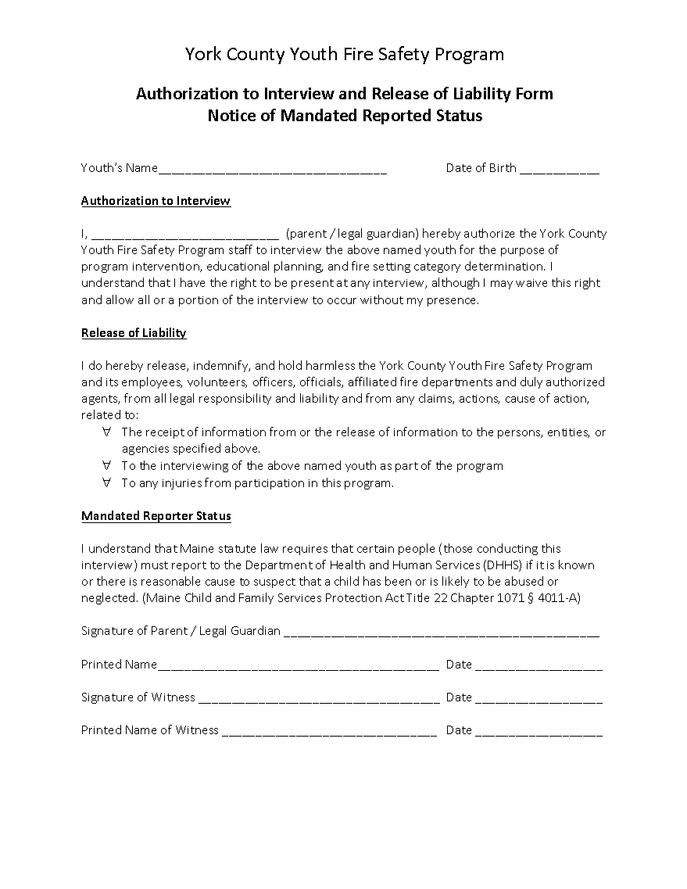
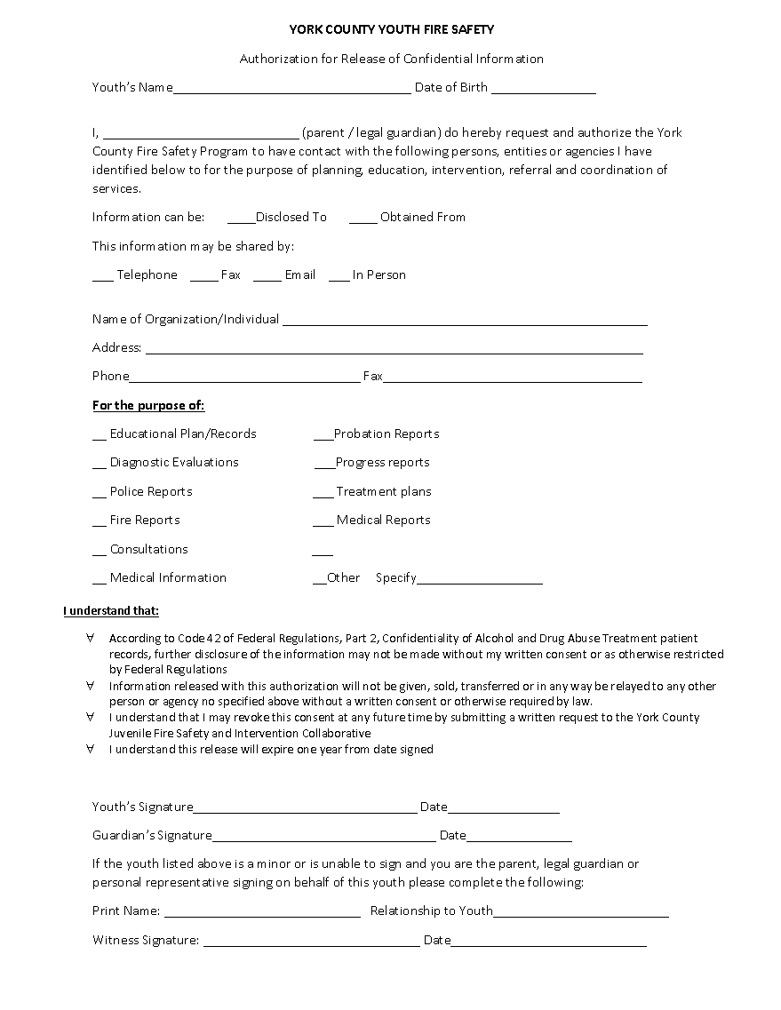
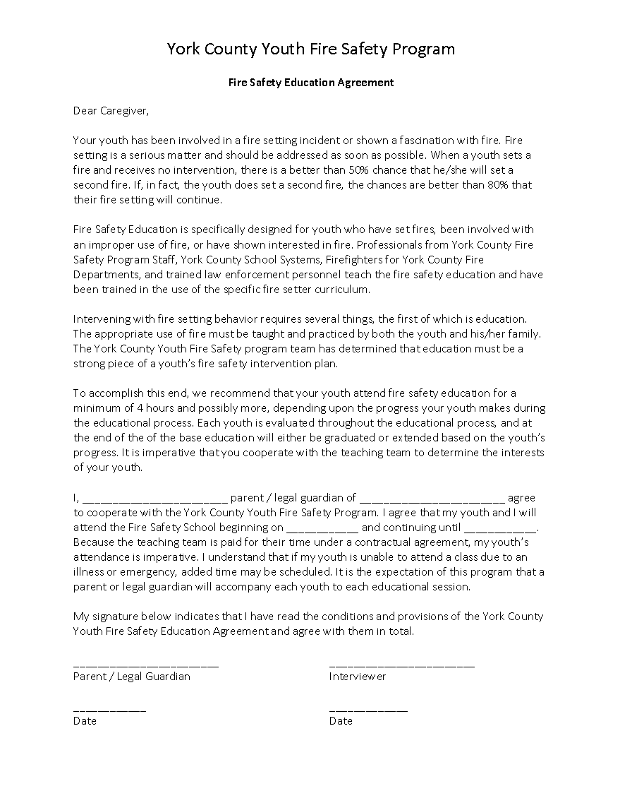
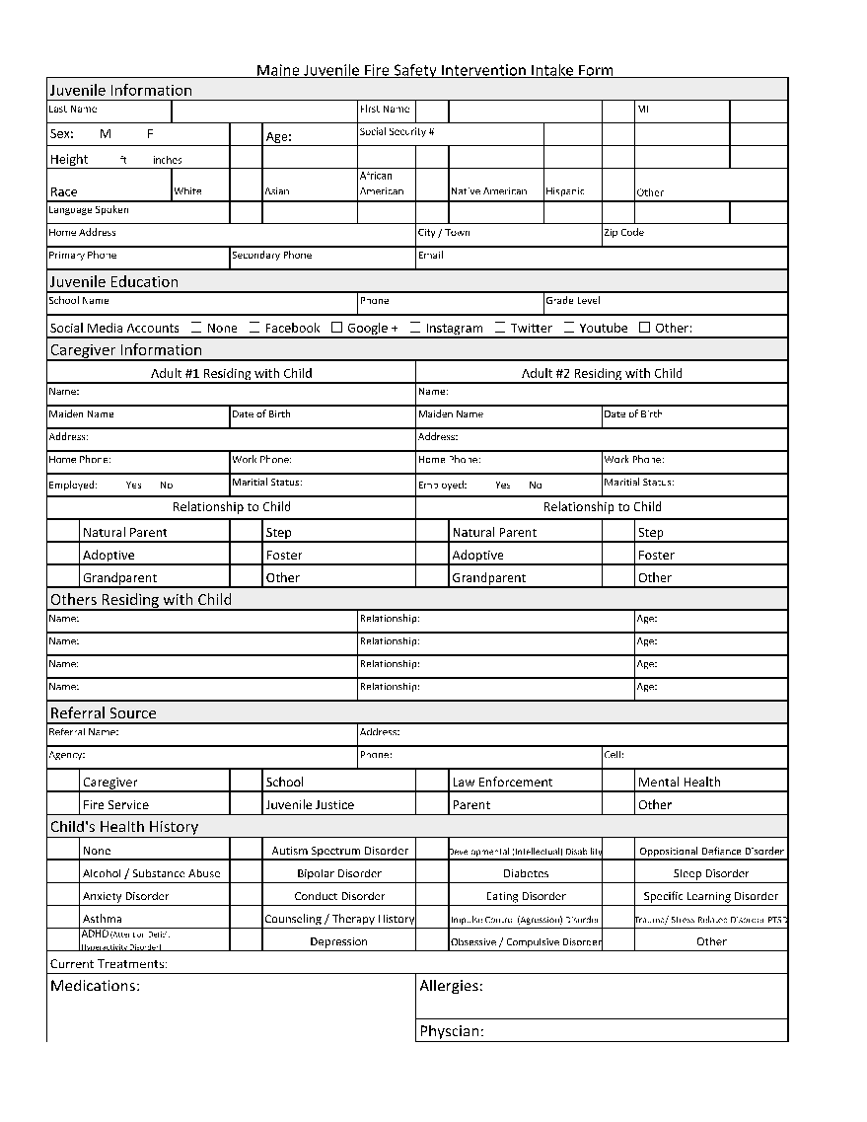
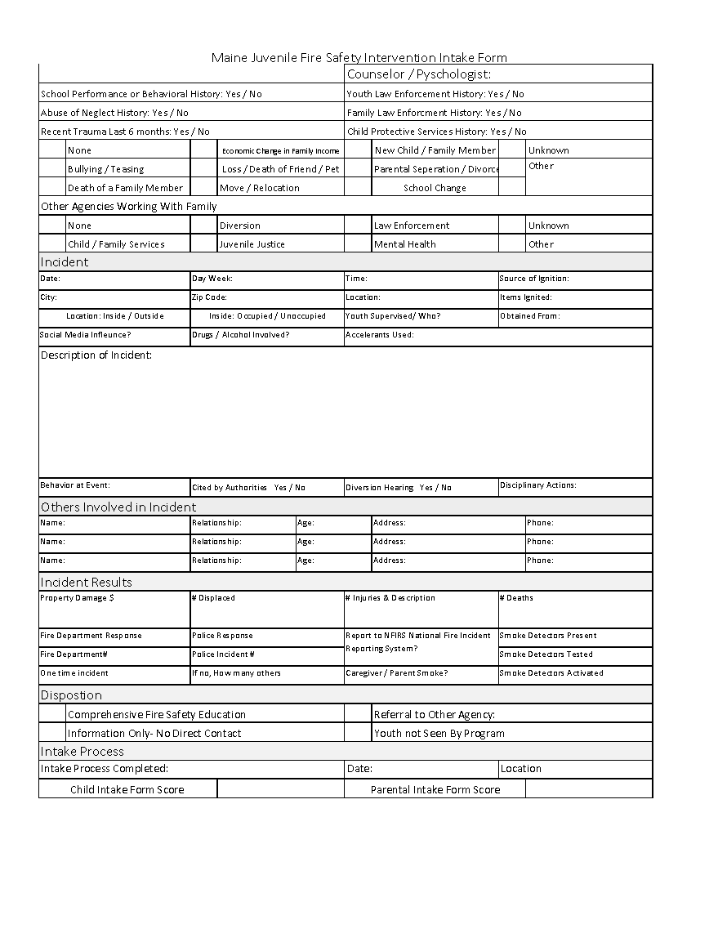
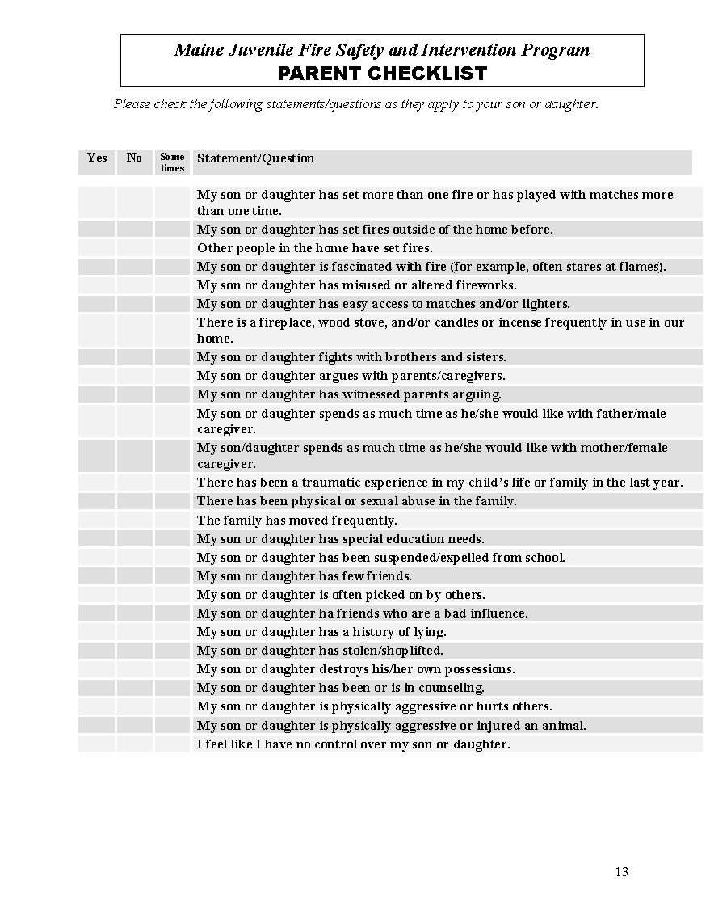
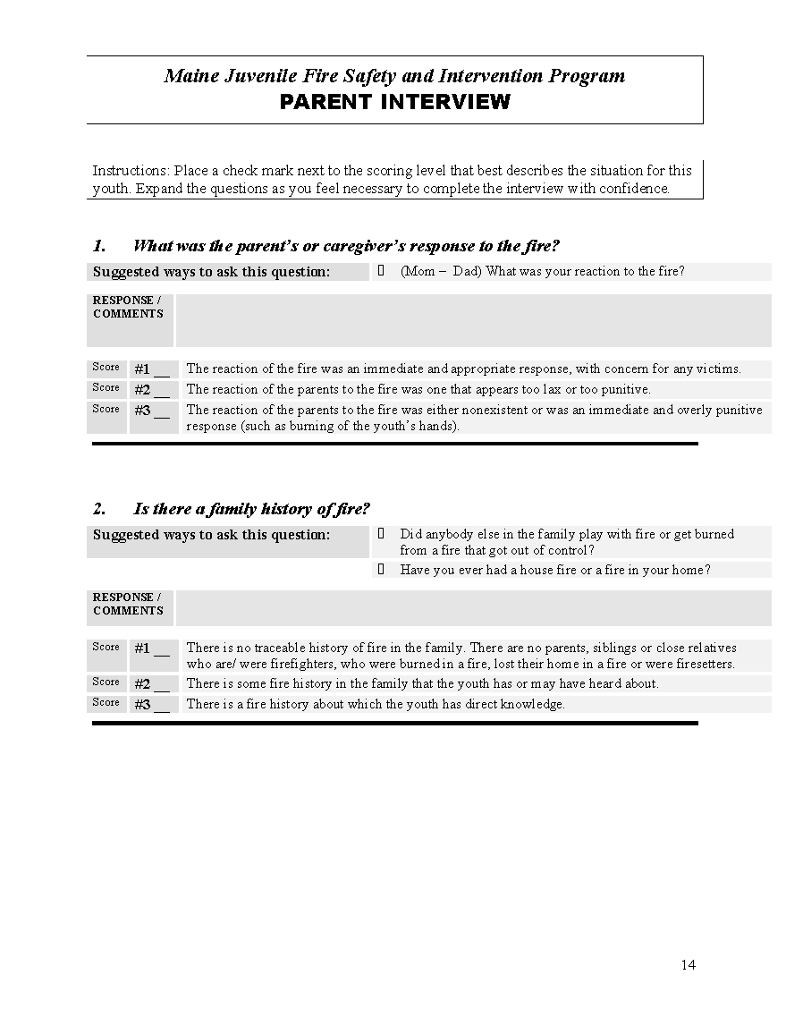
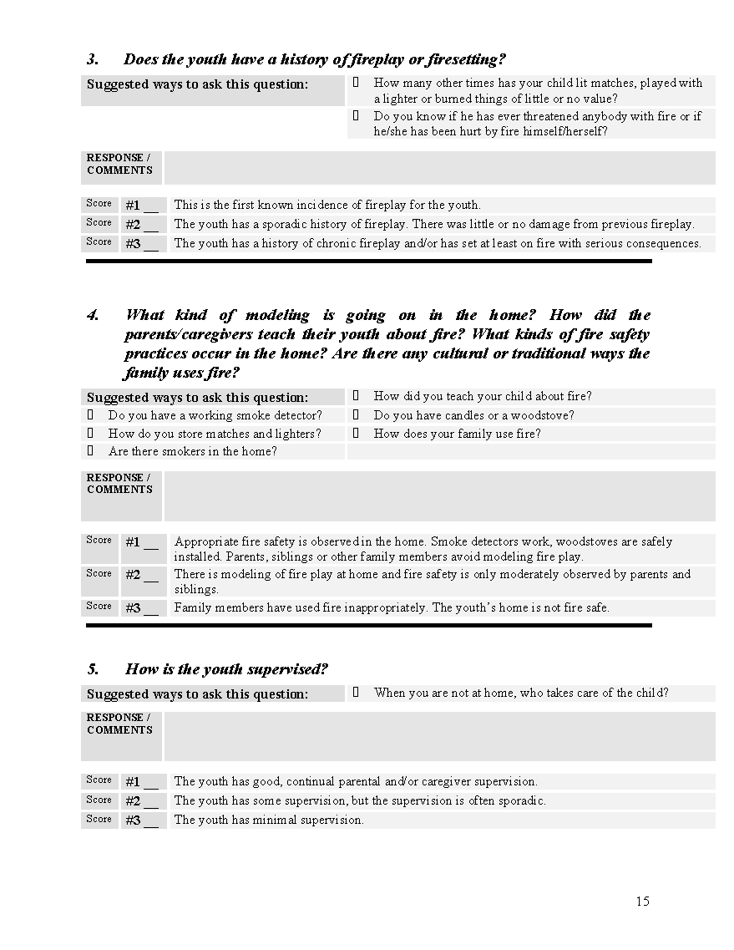
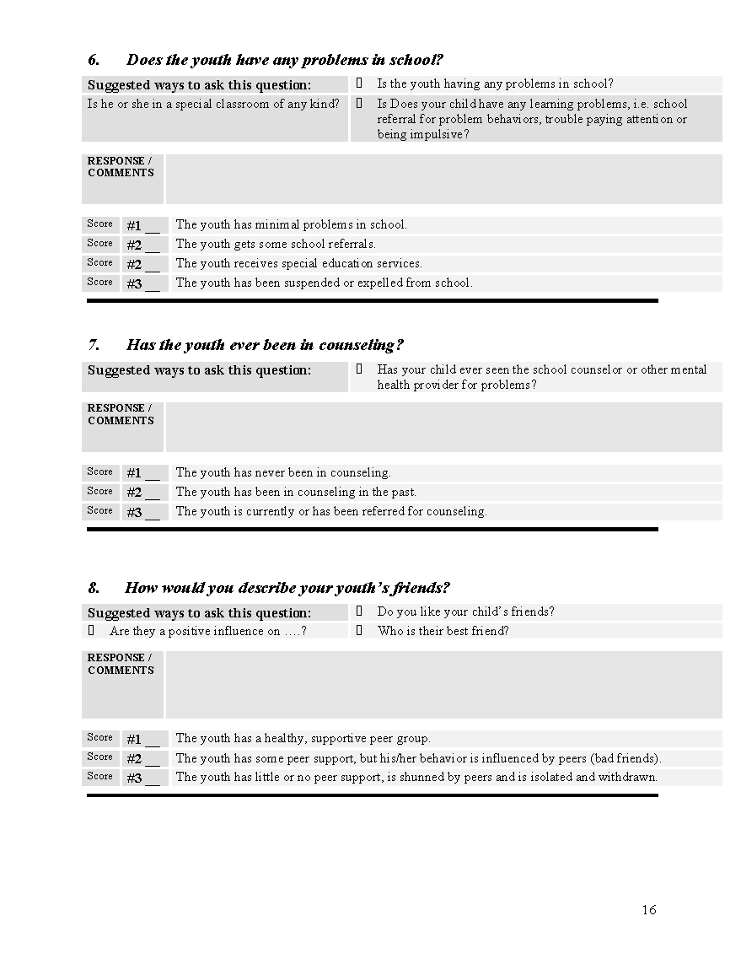
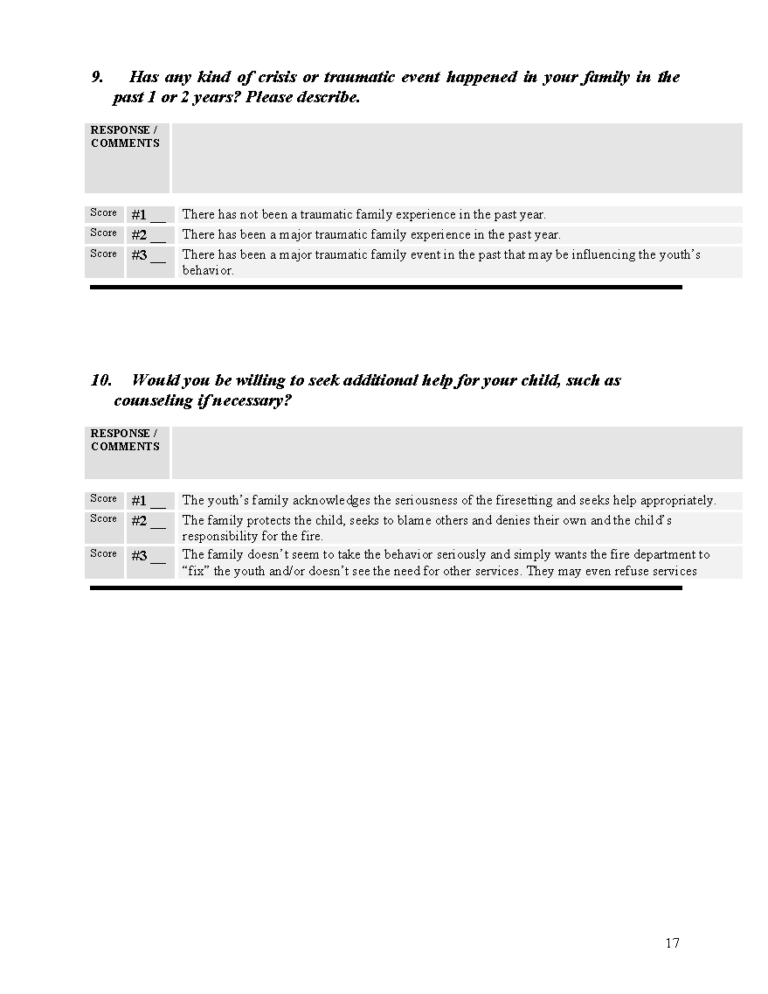
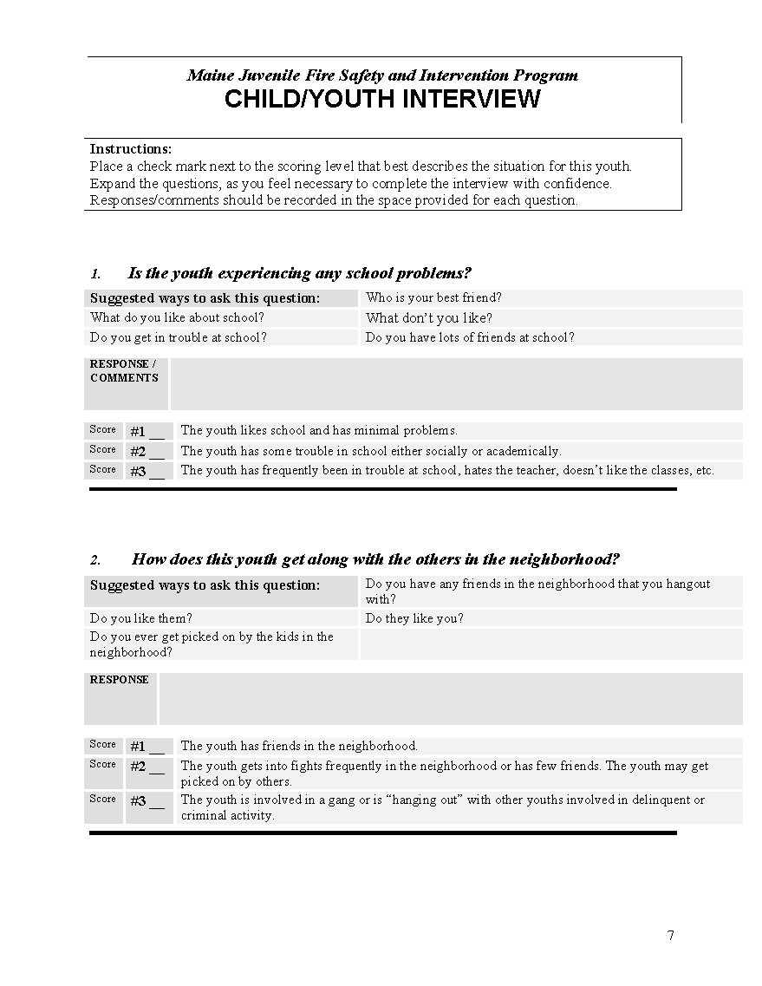
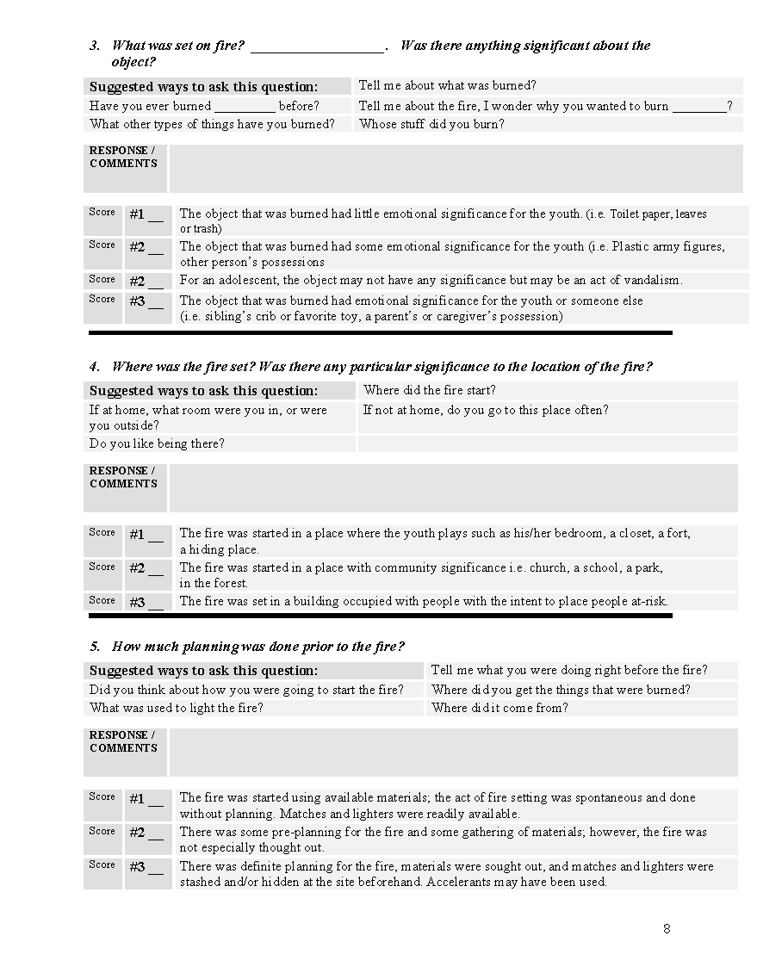
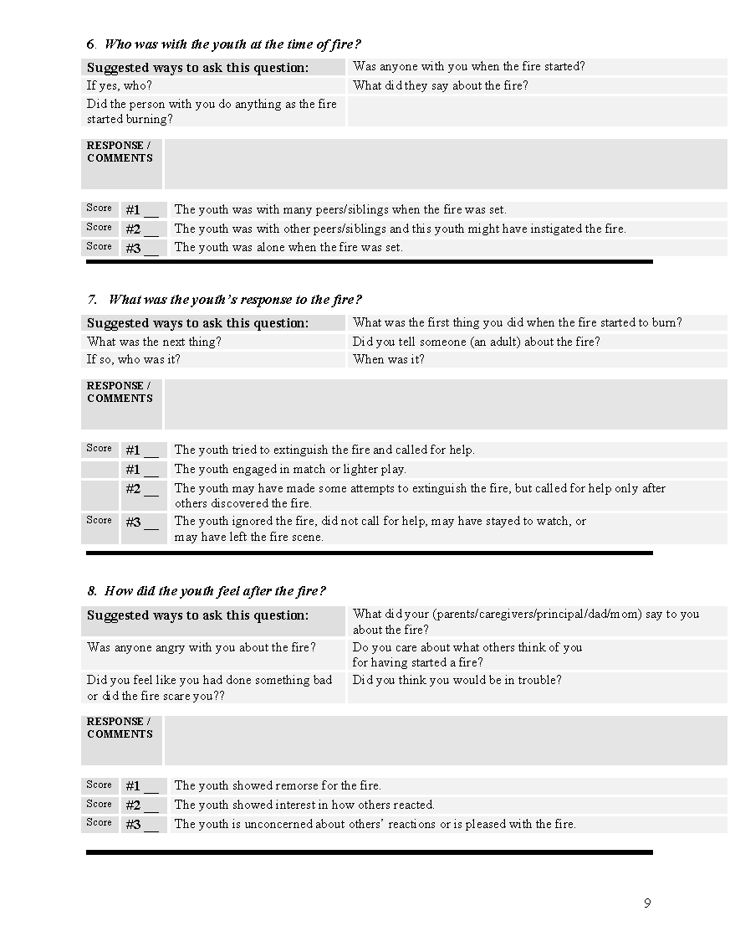
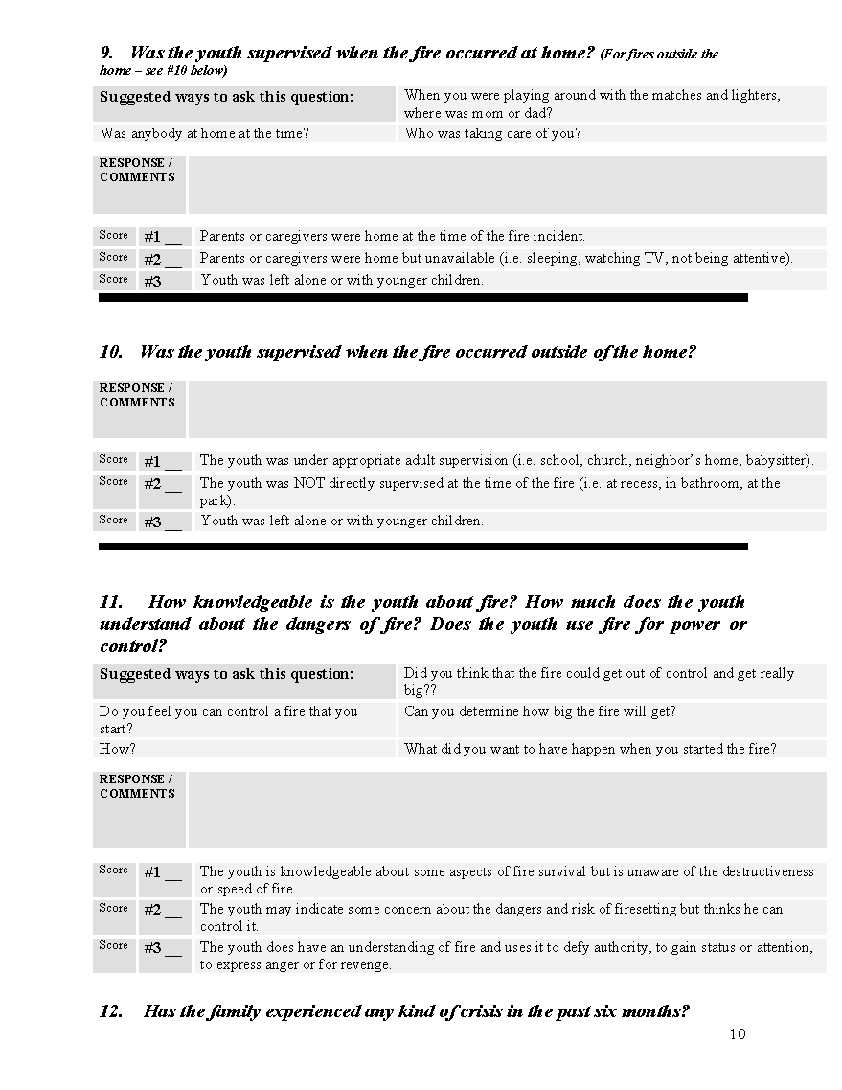
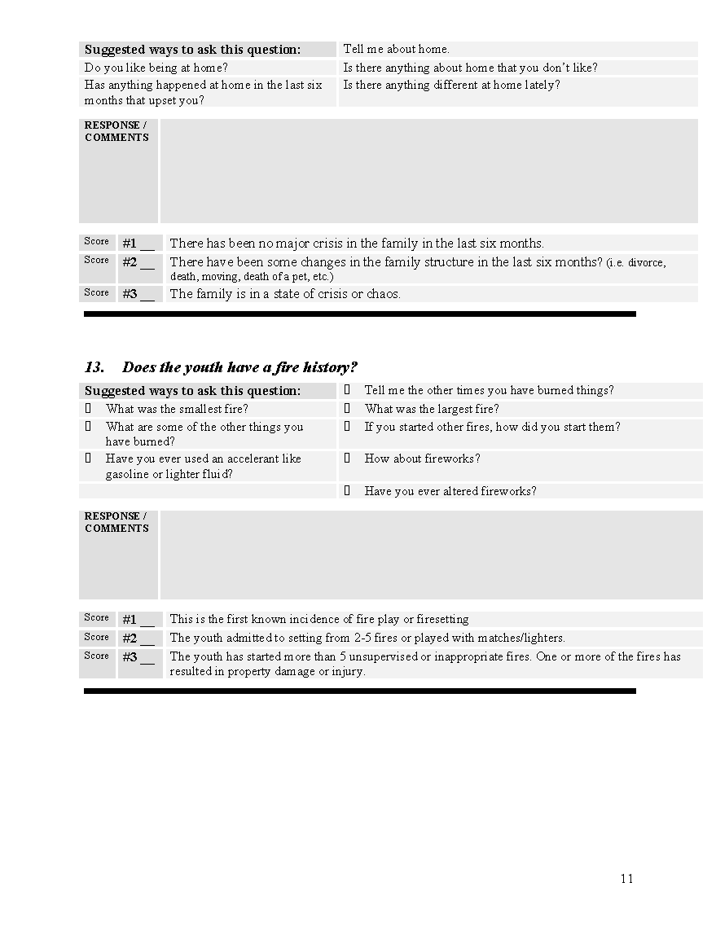
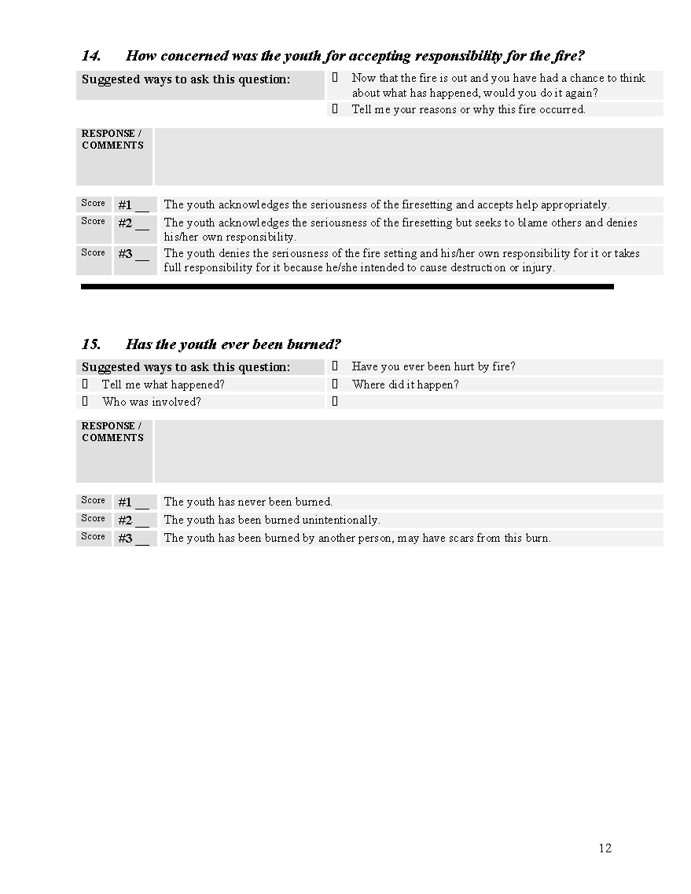
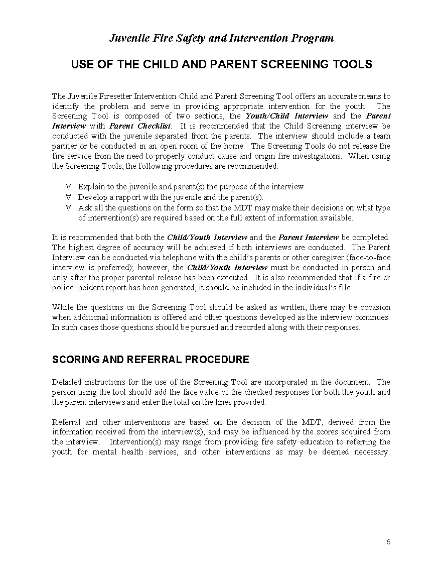
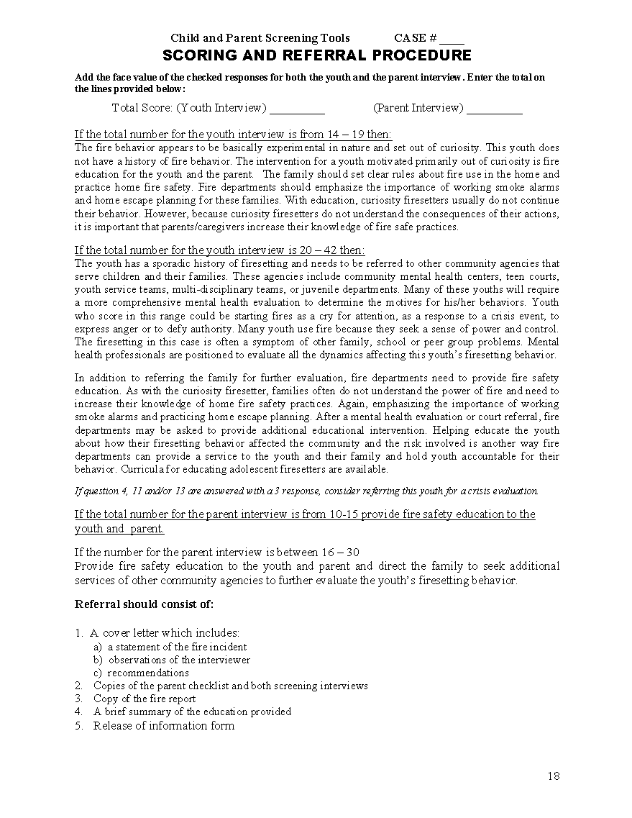
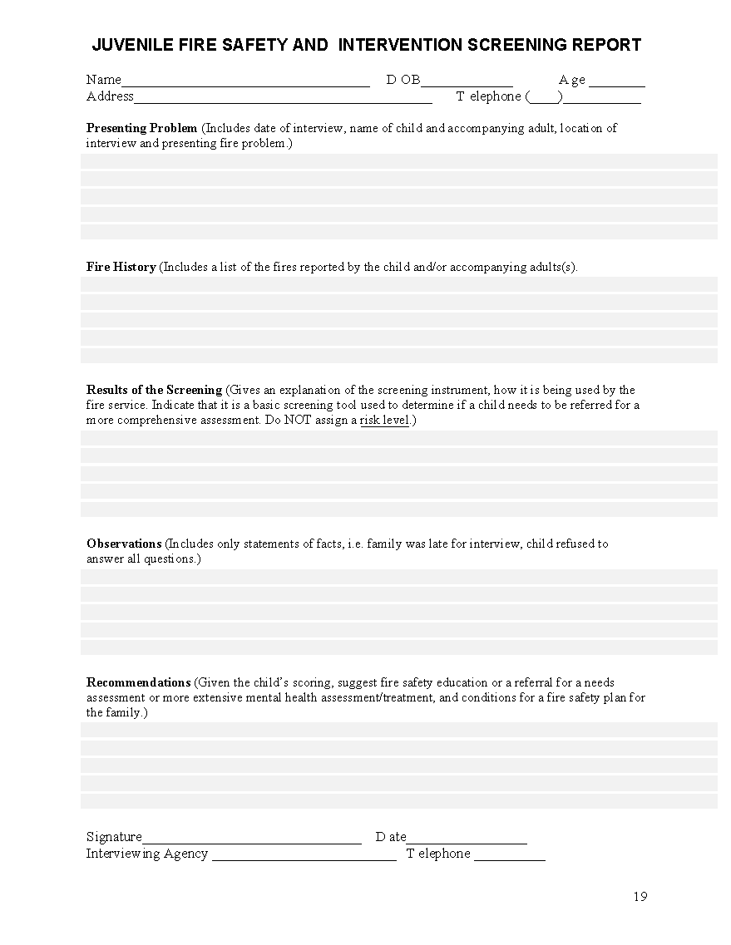

Appendix (1) To Directive 2410

REFERRAL PROCESS FLOW CHART

Appendix (2) to Directive 2410

YFSP Logo

Appendix (3) To Directive 2410

GRADUATE CERTIFICATE

