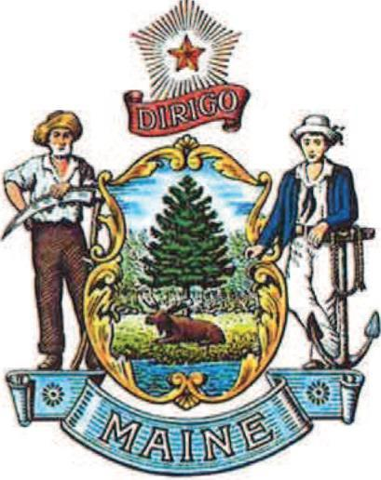
Maine Fire Protection Services Commission
52 State House Station
Augusta, Maine 04333-0052

Chief Daniel S Brooks
Chair

The Maine Fire Protection Services Commission, also known as the “Fire Commission” was established to review issues relative to the fire service and provide feedback to the Legislature on these issues, as well as pertinent bills during Legislative sessions. The Commission is comprised of 23 members representing the fire service, state agencies and includes two Senators and three Representatives. During the First Session of the 131st Legislature the Fire Commission developed, promoted and/or supported several important pieces of legislation that created funding for many important fire service initiatives. We appreciate your support in enacting:
LD 1280 An Act to Invest in Maine’s Fire Service Training Facilities
LD 588 An Act to Promote Public Safety and Retain Essential First Responders by Funding the Length of Service Awards Program
LD 516 An Act to Reduce Cancer Among Firefighters by Providing Grants for Safety Equipment
Additionally, we support a carry over bill from the first session:
LD1857 An Act to Create the Public Safety Health and Wellness Reimbursement Fund to Benefit Public Safety Workers and Volunteers – This bill provides additional medical screening for firefighters and other public safety officials who are at a higher risk of heart disease, cancer and mental health issues.

The Fire Commission looks forward to working with Legislators on this bill and we will continue to be an asset to Legislators and the Fire Service in general by initiating, providing insight, and lobbying for important legislation that affects the fire service in the State of Maine.

