Board of Trustees
MAINE CRIMINAL JUSTICE ACADEMY

ELECTRONIC SPEED MEASUREMENT DEVICE INSTRUCTOR CERTIFICATION

Specification S-9

Purpose:

To establish certification requirements for instructors who will train law enforcement officers in the use of Electronic Speed Measurement Devices (ESMD).

Requirements:

A. The applicant must:
1. Be a Maine certified full-time law enforcement officer or a full-time law enforcement officer certified in another state or jurisdiction, or
2. Be Maine part time certified officer having previously met the training standards of and worked as a full-time law enforcement officer, or
3. Be a member of the Maine Criminal Justice Academy Staff who will perform instructional duties for the Academy and is assigned by the Director.
4. Have attained MCJA Instructor Certification or have successfully completed the Methods of Instruction (or equivalent) course.
5. Attend the ESMD Instructor Development course, which consists of classroom instruction and field training using the model curriculum developed by the NHTSA (National Highway Traffic Safety Administration) and IPTM (Institute of Police Technology and Management), as approved by the Director.
6. Successfully complete the ESMD Instructor Development course by:
  - Passing the ESMD Instructor examination with a score of at least 80%.
  - Demonstrating proficiency in setting up and checking unit accuracy (internal and external) according to manufacturer guidelines with 100% accuracy for both RADAR (Radio Detecting And Ranging) and LIDAR (Light Detection And Ranging) units.
  - Demonstrating proficiency in conducting visual estimates of speed, verified for both RADAR and LIDAR, to the following standards:
1. Conducting ten visual speed estimates, while stationary, with an average deviation of no greater than five miles per hour of the true speed as measured by use of RADAR.
2. Conducting ten visual speed estimates, while moving, with an average deviation of no greater than five miles per hour of the true speed as measured by use of RADAR.
3. Conduct ten target acquisitions (which include visual speed estimates) and speed measurements with an average deviation of no greater than five miles per hour of the true speed as measured by use of LIDAR.

7. Conduct training in strict accordance with the MCJA curriculum on ESMD operation.
8. In addition to the above requirements, to remain certified as an MCJA ESMD Instructor, ESMD instructors must:
a. Instruct and/or assist in instructing at least one MCJA approved ESMD Operation or ESMD Instructor Development course in a 2-year period, or
b. Assist with practical application training in ESMD Operation for at least one BLETP class in a 2-year period.

Certification:

A. Following successful completion of the training requirements, the candidate can apply for ESMD Instructor certification on approved MCJA forms submitted with required documentation to the Academy.

B. The application and supporting documentation are to be reviewed by the Academy Staff for compliance with certification standards and, if approved, the Director will issue the certification.

C. The applicant may appeal the Academy Staff’s findings to the Director.

D. ESMD Instructors who maintain employment as full-time or part-time law enforcement officer and/or a member of the Maine Criminal Justice Academy Staff who will perform instructional duties for the Academy may apply for renewal of certificates every two years by submission of an approved MCJA form (and supporting materials, if necessary) documenting the following:
1. The ESMD Instructor has assisted in instruction of one MCJA approved ESMD Operators Course within the previous 2 years, or
2. The ESMD Instructor assisted with the practical application training for ESMD operation for at least one BLETP class in the previous 2 years.

E. ESMD Instructors who fail to comply with certification requirements outlined in section 4 (above) will have their certification suspended by the Director pending completion of requirements delineated in this specification -- Requirements, section A. 8. 1 or 2 (above).

Adopted: 01/10/2014
Amended: 11/08/2019
Review Date: 11/08/2022

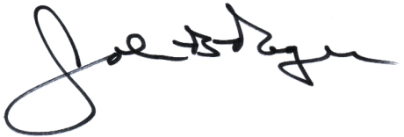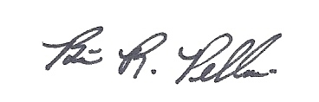
____________________________ __________________________
John B. Rogers, Director Brian R. Pellerin, Chair
Maine Criminal Justice Academy MCJA Board of Trustees

