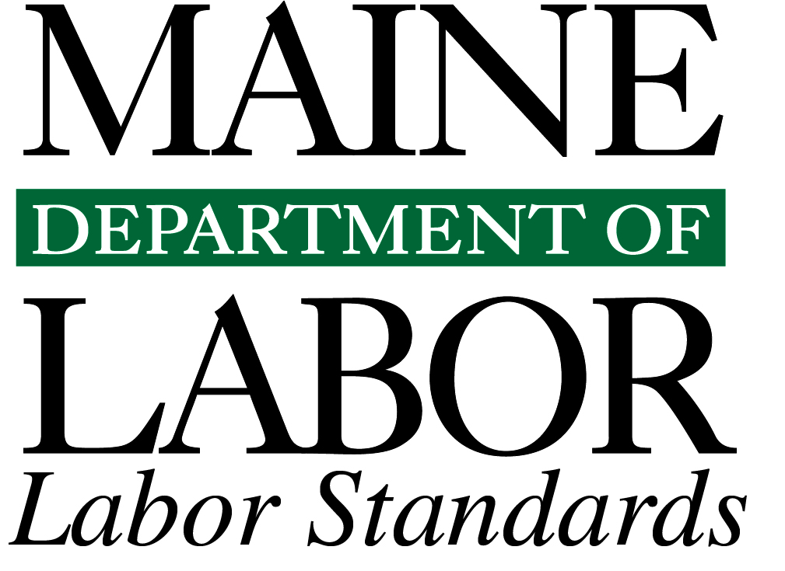
Injuries Incurred by Maine’s EMTs, EMT/Firefighters and Paramedics
Due to Lifting, Transporting or
Assisting Injured or Ill Persons
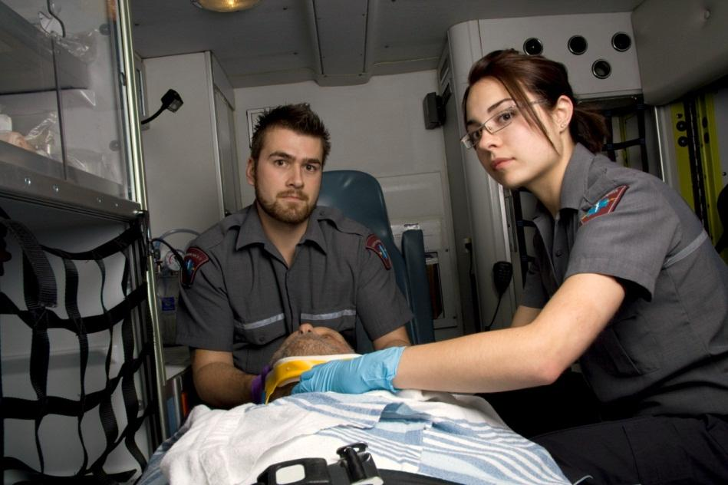
Maine’s 2012 Injury Experience

October 2013
Injuries Incurred by Maine’s EMTS, EMT/Firefighters and Paramedics Due to Lifting, Transporting or
Assisting Injured or Ill Persons in 2012

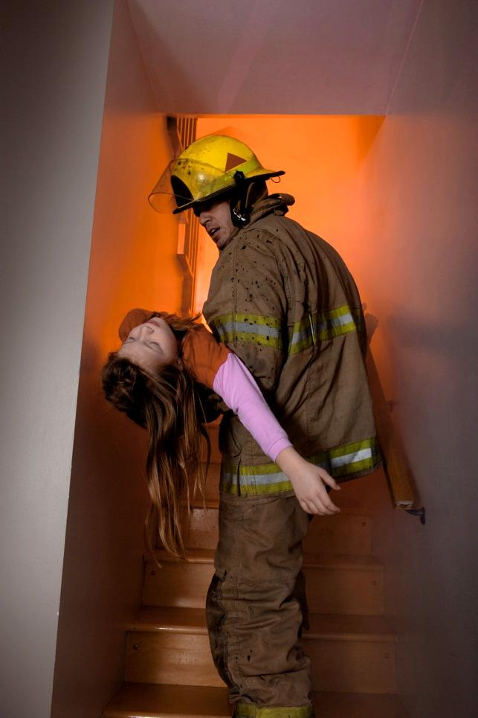

Introduction
This report presents 2012 data pertaining to injuries incurred by Maine’s emergency medical technicians (EMTs), EMT/firefighters and paramedics where a significant number of similar injury events were recorded. Research and data analysis resulted in findings that 35 percent of injury events were due to overexertion while lifting, transporting or assisting injured or ill persons. Findings also show that sprain and strain injuries accounted for 93.6 percent of the overexertion injuries and that the back was the body part injured most often, accounting for 44.7 percent of the cases. These injuries occurred with and without the use of mobility or lift assistance equipment.

Methodology
Data used for this report was extracted from the 2012 First Reports of Injury submitted to the Workers’ Compensation Board¹ by Maine employers on behalf of injured EMTs, EMT/firefighters and paramedics. A review of the case narratives submitted with the First Reports of Injury was conducted to determine what type(s) of incidents contributed to the injury of the workers. Analysis was then conducted on the types of injuries incurred and the body parts most affected by these injury incidents.

The Data
Figure 1 presents data regarding the types of activities being performed by EMTs, EMT/firefighters and paramedics at the time of the injury incidents. Forty-seven injuries (35 percent of all 134 injuries submitted by this worker category) involved lifting, transporting or assisting injured or ill persons. Thirty-four of the 47 injuries resulted from lifting injured or ill persons. Injuries caused by assisting the injured or ill in movement accounted for 12 injuries. One injury involved the independent motion of the worker while providing assistance to an injured person.

Other injuries reported by EMTs, EMT/firefighters and paramedics covered a broad range of events, including slips, trips and falls, exposure to smoke/fumes, other overexertion injuries, heat exhaustion, post-traumatic stress disorder, injuries caused by being struck by materials and vehicles, and so on. The numbers of these other types of injury incidents are relatively small when compared to those for lifting, transporting or assisting injured or ill persons.

Figure 2 presents the nature of the injuries incurred by EMTs, EMT/firefighters and paramedics from lifting, transporting or assisting injured or ill persons. Thirty-eight injuries (80.8 percent) were strains, six (12.8 percent) were sprains and three (6.4 percent) were other injuries. Strain and sprain natures of injury are typically associated with heavy lifting and hand transporting.

Figure 3 presents data on the body parts injured by EMTs, EMT/firefighters and paramedics, predominantly by strains and sprains while lifting, transporting or assisting the injured or ill. The body part most affected was the back/lower back, accounting for 21 (44.7 percent) of the injury incidents. Combined injuries to the shoulders (six instances), multiple body parts (six instances) and the knees (five instances) accounted for 36.2 percent of the overexertion injuries.

Conclusions
The risk of EMTs, EMT/firefighters and paramedics being injured due to lifting, transporting or assisting injured or ill persons is high when compared to other types of events causing injury to workers in this occupational category. These injury incidents overridingly resulted in sprains and strains, with the largest number, twenty-one, affecting the back.

A University of Maryland, Baltimore (UMBC) 1998 to 2002 retrospective study² of occupational injuries incurred by EMS workers in two urban agencies concluded that, “The injury rates for EMS workers are higher than rates reported by the federal Department of Labor for any industry in 2000.” It also found that, “Sprains, strains, and tears” was the leading category of injury and “the back was the body part most often injured.” Maine’s injury data for EMTs, EMT/firefighters and paramedics is consistent with both of these findings on leading injury categories and the back being the body part most often injured.
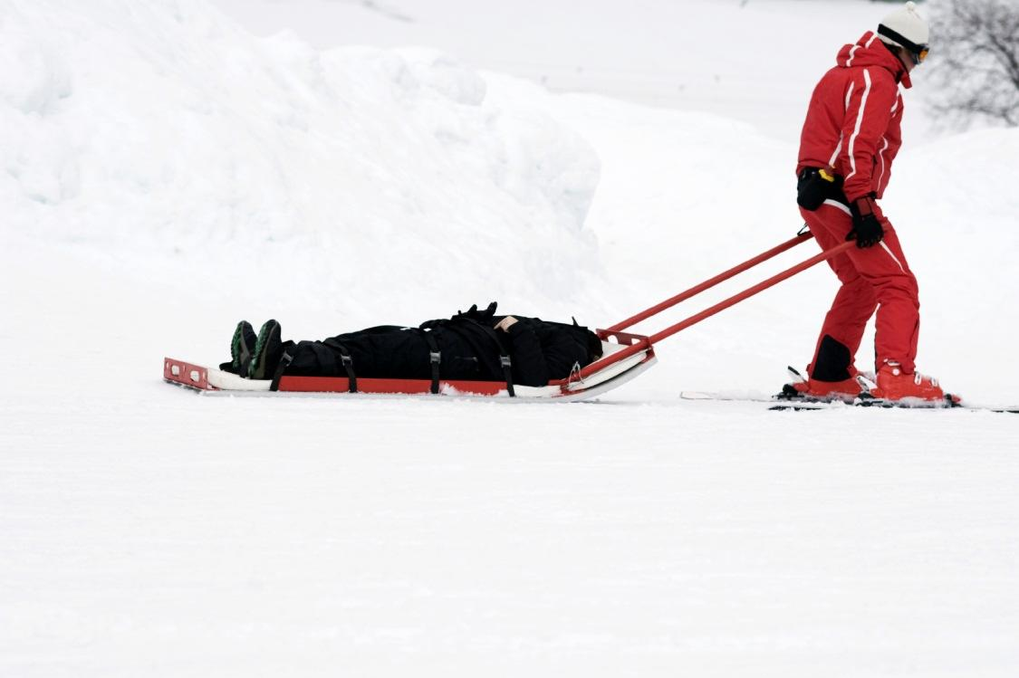

Recommendations
SafetyWorks! of the Maine Department of Labor enforces safety regulations for employers in the State of Maine. In order to reduce EMT, EMT/firefighter and paramedic overexertion back injuries and other sprains and strains, SafetyWorks! recommends the following initiatives: 1) institute a Health & Wellness program to include regular exercise and stretch breaks multiple times daily; 2) consider job rotation and implementing procedures to monitor staff who have early symptoms of sprains and strains; 3) use powered stretcher lifts to aid patient-lifting whenever possible; and 4) require additional staff lifting resources for special situations or high-risk patient lifts.

References
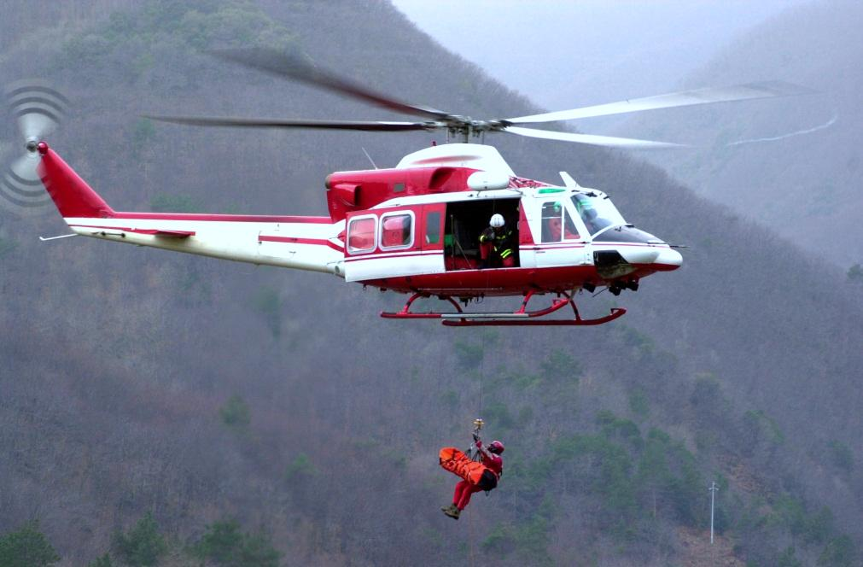
- Maine Workers’ Compensation Board. Selected 2012 Employer’s First Reports of Occupational Injury or Disease.
- “Occupational injuries among emergency medical services personnel.” Maquire, B.J., Hunting, K.L., Smith, G.S, Department of Emergency Health Services, University of Maryland, published in Prehospital Emergency Care, 2005 Oct–Dec; 9(4):405–11.

Research for this report was prepared by Barbara A. Spillane
Research and Statistics Unit, Division of Technical Services
Bureau of Labor Standards
Maine State Department of Labor

For more information on fatal occupational injuries, contact
Barbara A. Spillane, 207-623-7905
TTY users call Maine Relay 711.

Maine Department of Labor provides equal opportunity in employment and programs.
Auxiliary aids and services are available to individuals with disabilities upon request.

