How To Training
for
CMS Case File – Active Party and Notification List Tab
You will be able to view an official listing of interested entities in the Case. The tab is divided into two categories:

Notification List - all members interested in the Case.

Active Party List – Notification List members elevated to an Active Party by the authorized user assigned to the Case.

View and Manage Notification List

Objective:

- View Active Party and Notification Lists

Step | Action
Logged in External Registered User from the Case File Screen
- Click on the Active Party and Notification List tab
- Default view will display Active Party List

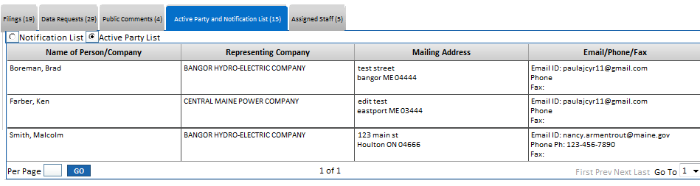

- Select Notification List Radio Button to view interesting members
