How To Training
For
CMS Case File – Filings Tab

Adjudicatory and Non-Adjudicatory Cases
When the Case File Screen is accessed, the default view is the Filings tab which contains a listing of filings/issuances associated with a specific case. This screen is available to External Users (Registered and Public).

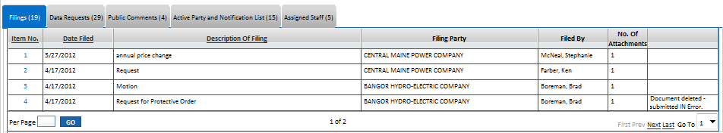

Objective:

- View Filed/Issued Documents

Step | Action
 | From the Home Page , Click on Case File Case Files on the access menu list
Case Search will be displayed
- Enter Case Number in Text Box
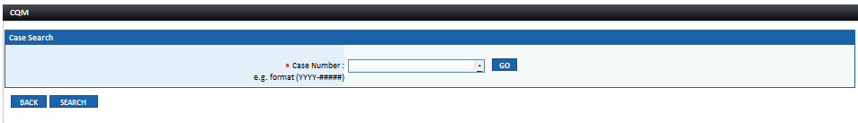
- Click on GO Button to display specified Case File.

- OR –

If user does not know case number:

- Click on Search Button, enter known search criteria
- Click on Search Button
- Search result will display all cases matching entered parameters
- Click on Case Number hyperlink to be navigated to the Case File Screen for the specified case.

By default the Filings tab will be selected and the grid will display all filings and issuances in the grid with the following columns:

- Item No.
- Date Filed
- Description of Filing
- Filing Party
- Filed By
- No. of Attachment(s)
- If a filing has been rejected the last column will display the following: Document deleted – submitted in Error

 | - Click on Back Button to navigated to the previous screen
- Click on Item No. link for the filing to view filing details and attachment(s)

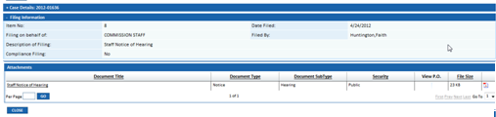

Filing Information will be displayed in the first section:
- Item No.
- Filing on Behalf of
- Description of Filing
- Compliance Filing (Yes/No)
- Date Filed
- Filed By

Attachments Sections will display with the following columns:
- Document Title (hyperlink)
- Document Type
- Document Subtype
- Security
- View P.O.
- File Size
- Software Designator Icon

In the Attachments Grid:

- Click on Document Title link to view attachment
- Document will open second pop-up window that will display the public document
- Document can also be saved use users computer
- Confidential Document access will be based on security measures in place (Clerk of the Commission, Assigned Staff and Staff Users who have been granted access by Clerk of the Commission)
- Close the document once it has been viewed

 | - Click on Close Button to close the Filing Information pop-up window

