How To Training
for
CMS Case File – Public Comments Tab
When External Users (Registered and Public) submit public comments they are displayed under the Public Comments tab on the Case File Screen. The Clerk is authorized to manage the comments. Comments can be managed from the Case File Screen or from the Clerk’s Inbox Public Comments Queue.
.
Step | Action
 | From the Home Page Click on Case File Case Files on the access menu list
Case Search will be displayed
- Enter Case Number in Text Box
- Click on GO Button to display specified Case File.

- OR -
If user does not know case number:

- Click on Search Button, enter known search criteria
- Click on Search Button
- Search result will display all cases matching entered parameters
- Click on Case Number hyperlink to be navigated to the Case File Screen for the specified case.

By default the Filings tab will be selected and the grid will display all Commission filings and issuances.

- Click on Public Comments tab
- Public Comment grid will be displayed

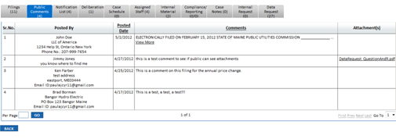

Public Comments grid will be displayed with the following columns:

- Sr. No.
- Posted By
- Posted Date
- Comments
- Attachments (click on hyperlink to view attachment, if included)
- Back Button will navigate user to the Home Page

