How To Training
for
Data Requests – View/Search
Authorized Users will be able to Search/View Data Request Questions and Responses with security measures in place.

Searching /Viewing of Confidential DR Question or DR Response attachments will be controlled by Protective Orders.

View/Search

Objective:

- Search and View

Step | Action
 | From the Home Page Click on Data Requests/Responses View/Search on the access menu list
Search DR Questions and Responses Screen
- Enter known search criteria and click on Search Button
- User will also be able to Full Text Search Questions, Responses and Attachments
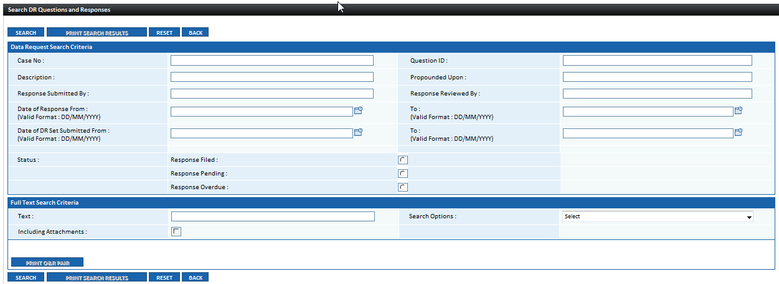

Search Results will be displayed in a grid at the bottom of the screen
- Click on View to display contents of item in grid
- Following functionality is available:
  - Print Q & R Pair Button
  - Print Search Results Button

