How To Training
for
Projects / Reports
Reports/Projects are a collection of documents that are stored in the CMS application as a matter of convenience. Reports/Projects will be submitted and monitored in the application based on tracking numbers and report/project types. The Report/Project related submissions will include the set of activities for filing the reports/projects online.

The security status of the Reports/Projects Types will be predetermined and flagged as either public or confidential by the Clerk of the Commission as well as assigned Staff.

Submit Project/Report

Objective:
- Submit Project/Report
- Searching for a Document
Step | Action
From the Home Page
- Click on Project/Report Files from the Access Menu
- From the Submenu, click on Submit Project/Report
- Enter Required Information and click on Attach Document Button to attach document
- Click on Submit Button

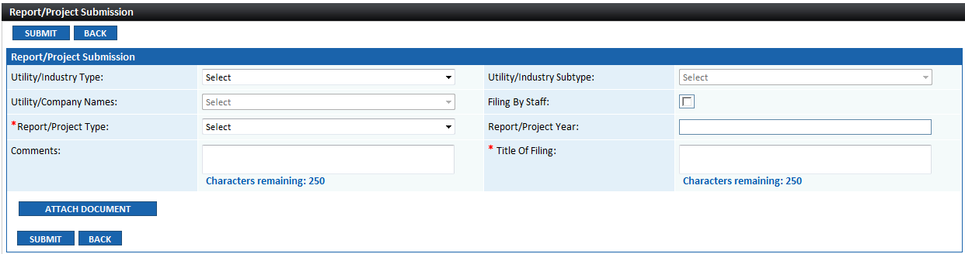
On Submit the following will occur

- Tracking number will be generated (format LLLL-YYYY-#####, where LLLL is the unique 4-digit code designated for the Report/Project Type).
- Email notifications of project/report filing will be sent to Assigned Staff and Clerk of the Commission per workflow business rules

- Submission will be available on the Public and External Registered User websites unless the Report/Project has been flagged as confidential by the Clerk of the Commission.
- If flagged as confidential, the submission will only be available for viewing by the submitter, the Commissioners, Clerk of the Commission and the staff assigned to the Report/Project

Supplement Project/Report

Objective:
- Supplement Project/Report
Step | Action
From the Home Page
- Click on Project/Report Files from the Access Menu
- From the Submenu, click on Supplement Project/Report
- Enter Tracking Number in the Project/Report Search Screen
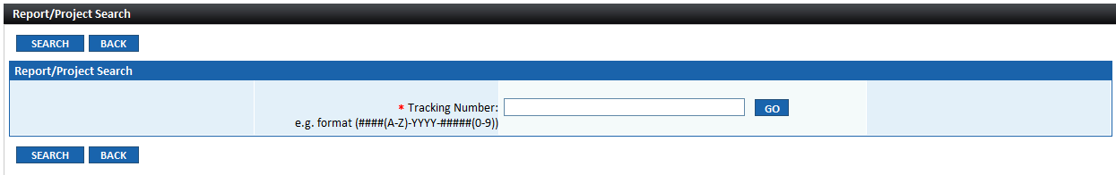
- Click on GO Button
- OR -
If user does not know tracking number:

- Click on Search Button, enter known search criteria
- Click on Search Button
- Search result will display all Projects/Reports matching entered parameters
- Note Tracking Number and go the Step 1 to continue

- Project/Report Supplemental Submission Screen will display
  - Tracking Number, Report/Project Type and Report/Project Year
  - Report/Project details will be displayed in next section

- Enter Required Information in the Supplemental Submission Section
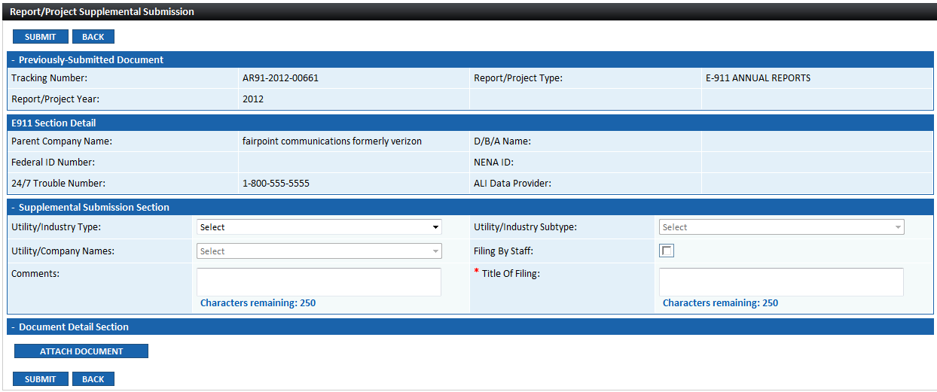
- Click on Attach Document Button to attach document
- Click on Submit Button
On Submit the following will occur

- Submission will be appended to the existing Project/Report file.
- Email notifications of project/report filing will be sent to Assigned Staff and Clerk of the Commission per workflow business rules

- Submission will be available on the Public and External Registered User websites unless the Report/Project has been flagged as confidential by the Clerk of the Commission.
- If flagged as confidential, the submission will only be available for viewing by the submitter, the Commissioners, Clerk of the Commission and the staff assigned to the Report/Project

View /Search

Objective:
- View Search Project/Report
Step | Action
From the Home Page
- Click on Project/Report Files from the Access Menu
- From the Submenu, click on View/Search
Report/Project Submission Search Screen will be displayed
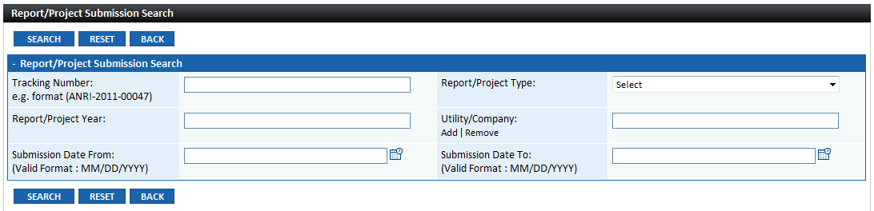
- Enter known search criteria and click on Click on Search Button

- Search Result grid will be displayed at the bottom of the screen
  - Tracking Number
  - Report/Project Type
  - Utility Company Name
  - Report/Project Year
  - Title of Filing
  - Submission Date
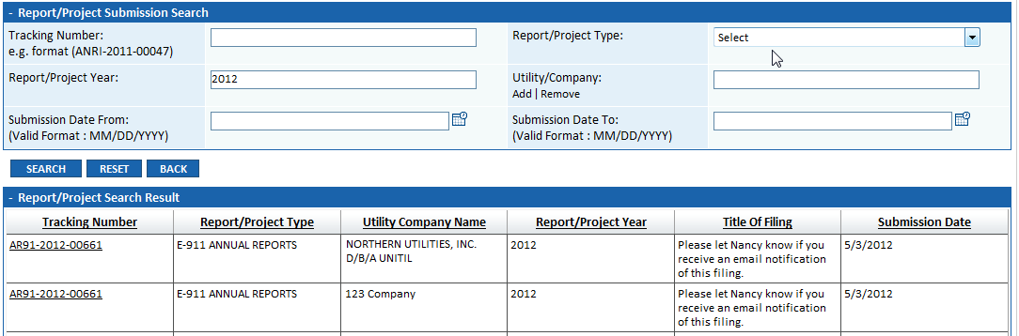

- Clicking on Tracking Number hyperlink will display
  - Submission details
  - Attached Document(s) details
  - Click on File Name hyperlink to view attachment
