How To Training
for
CMS Case File – Data Requests Tab
Data Request tab provides the ability for Internal and External Registered Users to view DR Questions and Responses which have been propounded for the case. By default the screen will display by Sets. User can select Radio Button to view by Question.

DR Sets may be submitted by the Commission Staff assigned to the Case and by External Registered Users. Such DR Sets may be directed to Commission Staff, Company/Organization represented by Active Parties, Company/Organization represented by Notification List members, any individual in contact list and any individual/company/organization not in the application.

Confidential DR Question or DR Response attachments must be associated with a protective order existing in a Case filing with the same security and functionality as is in place for case filings.

Step | Action
 | From the Home Page Click on Case File Case Files on the access menu list
Case Search will be displayed
- Enter Case Number in Text Box
- Click on GO Button to display specified Case File.
- OR -
If user does not know case number:

- Click on Search Button, enter known search criteria
- Click on Search Button
- Search result will display all cases matching entered parameters
- Click on Case Number hyperlink to be navigated to the Case File Screen for the specified case.

By default the Filings tab will be selected and that grid will display all Commission filings and issuances.

- Click on Data Requests tab
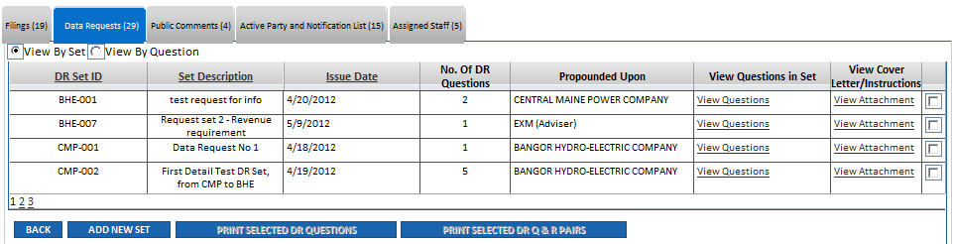

The View by Set default grid will displayed with the following columns:
- Set ID – number assigned by system with prefix denoting what company/agency/user created the Set.
- Set Description – text entered by creator of Set
- Issue Date –Date Set was submitted
- No. Of DR Questions – in Set
- Propounded Upon – Company/agency/person to whom the Set questions are directed for response.
- View Questions in Set
- View Cover Letter/Instructions – optionally included by creator of Set
- Print Checkbox - more than one can be selected for print in a formatted report
- Buttons for authorized users: Add New Set, Print Selected DR Questions, Print Selected DR Q&R Pairs and Back

Step | Action
- Click on View By Question Radio Button to view questions
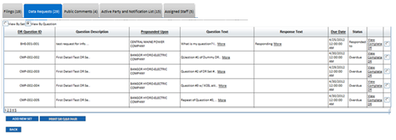
The grid will displayed with the following columns:
- DR Question ID - number assigned by system that is prefix denoting what company/agency/user created the Set - the Set number - the Question number.
- Question Description – defaults to Set description unless creator of question has edited the question description
- Propounded Upon - Company/agency/person to whom the Set questions are directed for response
- Question Text
- Response Text – will be filled in once the question has been responded to.
- Due Date – date by which the question creator wishes to see a response
- Status – Pending, Overdue, or Responded to
- View Complete DR (hyperlink) – takes you to View screen
- Print Checkbox – more than one can be selected for print in a formatted report

- Attachments – Hyperlink that opens a pop-up window listing any attachments associated to the question
- Buttons for authorized users: Add New Set, Print DR Q&R Pair and Back

