IGOVERN™ Complaint and Quality Management System

Deliverable Name: External Registered User Training Manual

Date- May 21, 2012

Introduction

Overview
Case Management System enables the Register External Users and Authorized Internal Staff to submit case filings electronically. Users can submit case filings for legal proceedings before the MPUC.

Purpose
The purpose of this document is to provide general information and instruction to External Registered Users regarding use of the iGOVERN™ CQM Application.

Conventions
Following table presents list of icons and its purpose that are used throughout the application for performing various actions.
ICON | Name | Convention
 | Button | Click on a button to perform an action. The button text describes the action that will occur upon clicking the button.  Submit button enables the user to submit information, which is stored in a repository.
 | Button | User can select this button to attach documents. On clicking this button, a new window will be opened for the user to browse and attach the document.
 | Button | User can select this button to reload page. All data previously captured on the page and not saved by user is cleared from all fields.
 | Button | User can select this button to go back to the previous page.  Note: Do not use the back button on your browser window. If you want to go back to the previous screen, use the Back button in the application itself.
 | Button | User can select this button to search for any information.
 | Button | User can select this button to clear all the information entered by the user for extraction of information from the application.
 | Button | After entering specific criteria (e.g., Case Number) upon clicking on this button, user will be navigated as per entered criteria (e.g., Case File).
 | Button | User can select this button to delete information.
 | Check Box / Checklist | Users can select one or more items from a list by checking the checkboxes.
 | Drop Down List Box | Control that displays a current setting, but can be opened to display a list of choices.
Add | Link | Click/select hyperlink to invoke a new page or a process. The text of the hyperlink will describe the action that will be invoked, e.g., Add, Remove etc.
 | Page Size | User will be able to change screen to display a specific number of rows by entering a number up to 100 in the text box.
 | Paging | Select number from list box to navigate to the page number chosen.
 | Paging Links | Click on hyperlinks to navigate to First, Last, Next or Last page of information being displayed.
 | Calendar | Click on icon to view the calendar look-up and select a date.
 | Radio Button | Select one of the radio buttons in a group to designate the desired option, e.g., view Notification List or Active Party List, Check-In/Out selected Document, etc.
 | Text Box | The purpose of text box is to allow the user to input text information to be used by the program. Enter data in a defined area on the page by typing in the text box.
 | Help | Click on the icon to display online help document in a pop-up window.
 | About | Click on the icon to display information about the application
 | Home | Click on the icon to navigate to the Home Page
 | Logout | Click on the icon to logout of the application
 | Mandatory Fields | All the mandatory (required) entry fields are prefixed with a red asterisk.
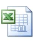 | Software Designator | Microsoft Excel Software
 | Software Designator | Microsoft Word Software and Rich Text Format (RTF)
 | Software Designator | Adobe Portable Document Format (PDF)
 | Security Icon | Image to designate a confidential document
 | Error | Error in the application.
 | Info | Displays information.
 | Expand | By clicking on plus (+) sign to the left of a Section Title, contents of the section will be expanded for viewing additional details.
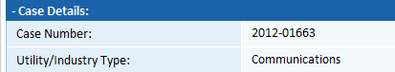 | Collapse | To collapse details displayed in a section, click on minus (-) sign to hide the contents of the section.

Acronyms
Abbreviations/ Acronym | Description
CQM | Complaint and Quality Management
CMS | Case Management System

System Features

Login to CQM
Step | Action
From the Public User Home Page, click on Sign in or Register hyperlink
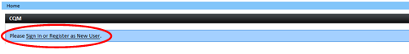
- When clicked, user will be navigated to External Registered User Login Screen

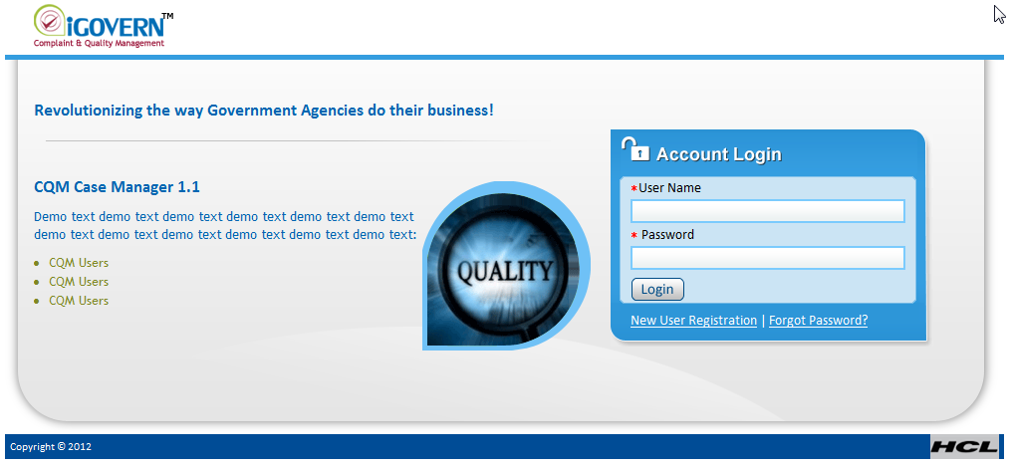
Login Page

Step | Action
- If already registered, enter User Name, Password and click on Login Button
- Forget Password? Click on link at the bottom of the Account Login Box and Enter User ID text box and click Submit Button
- If you need additional assistance, please contact Help Desk @ 207-287-3831

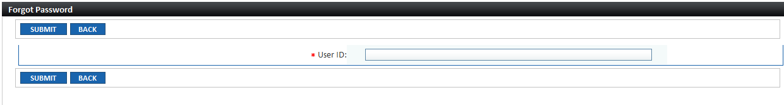

- To register for the first time, click on New User Registration hyperlink the User Registration Form will be displayed
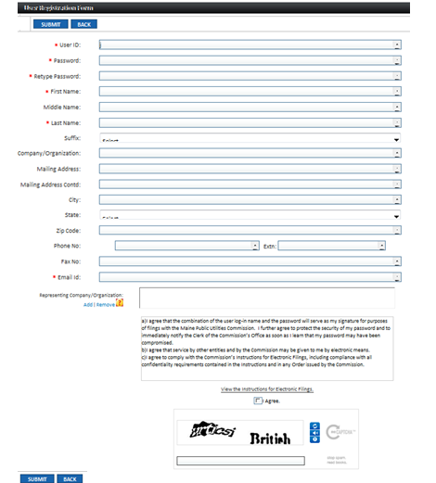

Step | Action
- At a minimum, enter all mandatory details which are designated by a red asterisk ( * ) as listed below:
  - User ID (minimum of 8 characters)
  - Password (minimum of 8 characters, one capital letter and one special character)
  - Re-enter Password
  - First Name
  - Last Name
  - Email Address

Do you represent Companies and/or Organizations? If so, provide representative information:

- Under the Representative of Company/Organization label, click on “Add” to include entities that you represent

By default, Search Result grid displayed on the screen will list of all utilities/companies
- User may filter the results by selecting Utility/Industry Type, Subtype, Utility/Company Name or by entering Code
- After specifying search criteria, click on Search Button
From the Company/Organization Results Grid:
- Select checkbox(es) for the utilities/companies represented and click on Select Button

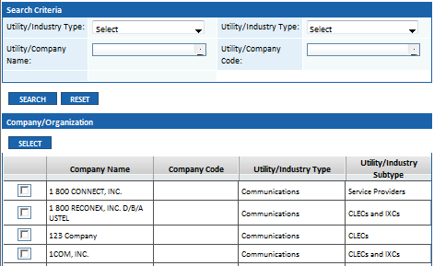
- After reviewing the Instructions for Electronic Filings select the checkbox if you agree
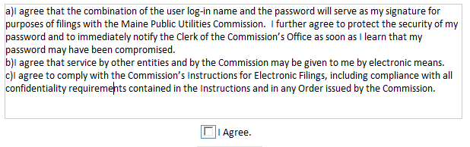

- Enter characters in text box for challenge-response test
- If you cannot clearly distinguish characters, click on to display new set of characters.
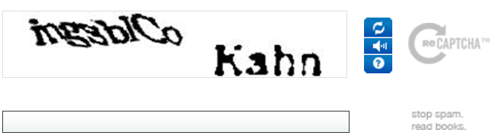
 | - Click on Submit Button
Message will be displayed:

- A message has been sent to the email address provided by you. To confirm your registration, you will need to click on the link provided in the email message that has been sent to you. Thank you.
- Go to your Email Account and check your email account for a message from CQM Administrator
- Note: Be sure to check your Junk Mail for this message
- Follow instructions in the email

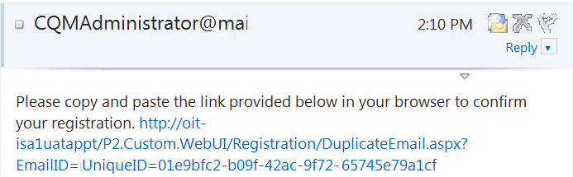

- Click on here hyperlink to confirm your registration and you will be navigated to the screen posted below

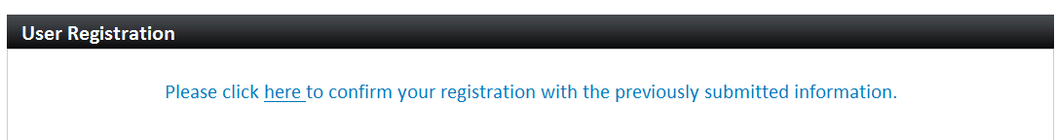
 | User is logged into the CQM Application and Home Page is displayed

Home Page – External Registered User

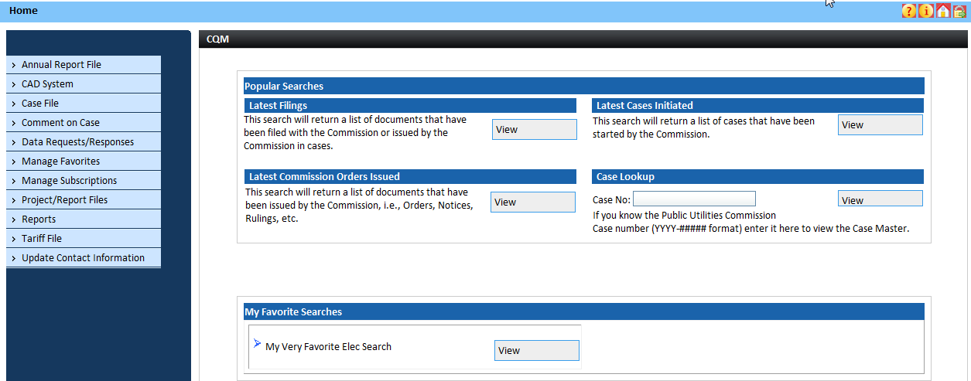

External Registered User Home Page

External Registered User Home Page in CQM displays the following information:
- Common Buttons are displayed under the Application Header.
Icon | Icon Name | Description
 | Help | Click on the icon to display online help document in a pop-up window.
 | About | Click on the icon to display information about the application.
 | Home | Click on the icon to navigate to the Home Page.
 | Logout | Click on the icon to logout of the application.

Application Level Access Menu displays buttons for the functions available to the External Registered Users. By clicking on a hyperlink, user will be navigated the specified system modules. For instance, if you are filing in a case, click on Case Filing link and, after entering Case Number, the Case Filing Screen will be displayed.
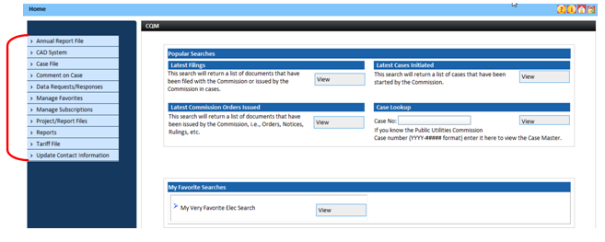
External Registered User Home Page

Popular Searches displays the following:
Latest Filings – The search will return a list of documents that have been filed with the Commission or Issued by the Commission in cases within the last 30 days.
Step | Action
From the External Registered User Home Page, click on Latest Filings View Button
- When clicked, the Latest Filings pop-up window will display filings submitted within the last 30 days.

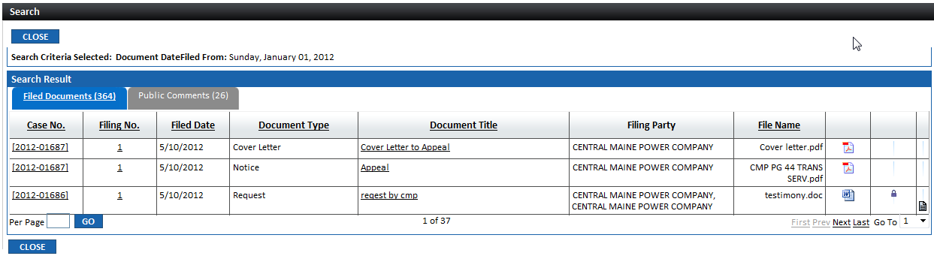

- Click on the Case No. hyperlink to be navigated to the Case File for the selected case
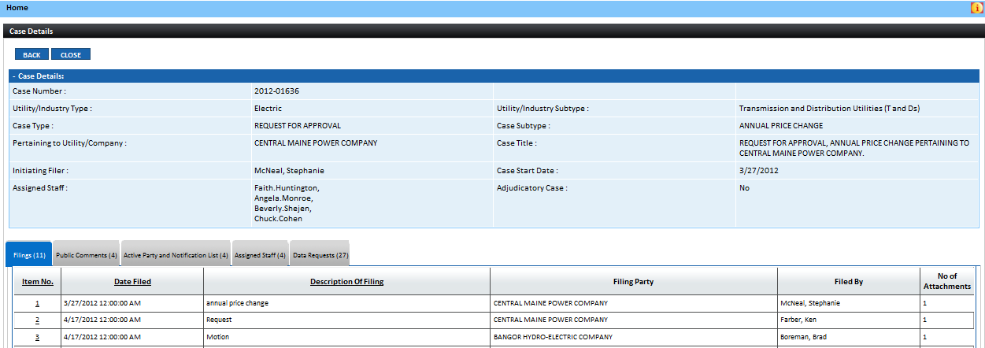
- Click on Document Title hyperlink to view filing

- Click on Filing No. hyperlink to view pop-up window containing filing information will be displayed
- In Attachments section, click on Document Title hyperlink to view filing.
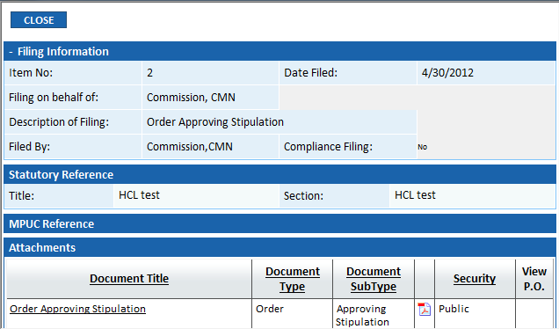

- Latest Cases Initiated – The search will return a list of cases that have been initiated by the Commission or an External User within the last 30 days.
Step | Action
From the External Registered User Home Page, click on Latest Cases Initiated View Button
- When clicked, the pop-up window will display Latest Cases Initiated within the last 30 days.

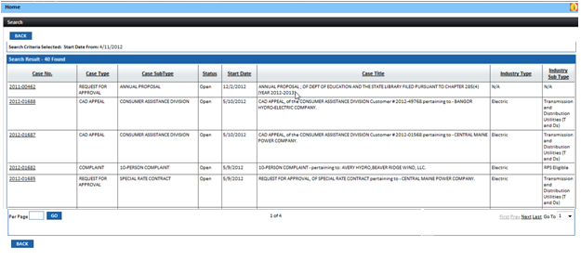

 | - Click on the Case No. hyperlink to be navigated to the Case File for the selected case

- Latest Commission Orders Issued – The search will return a list of documents that have been issued by the Commission, i.e., Orders, Notices, etc. within the last 30 days.
Step | Action
From the External Registered User Home Page, click on Latest Commission Orders Issued View Button
- When clicked, the pop-up window will display Commission Orders that were issued within the last 30 days.

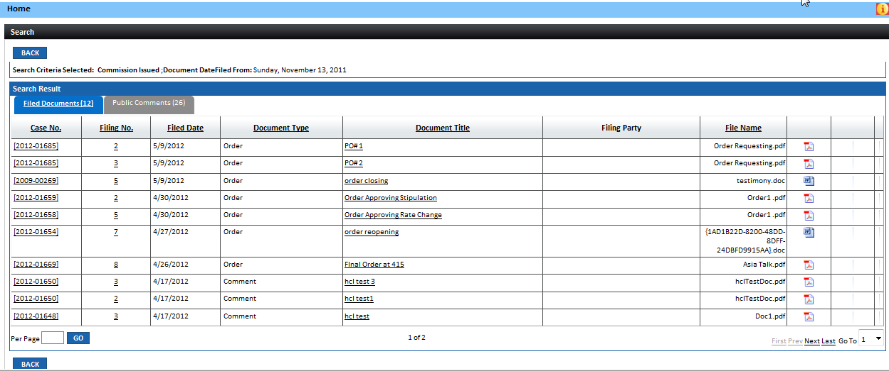

- Click on the Case No. hyperlink to be navigated to the Case File for the selected case

- Click on Document Title hyperlink to view Issuance
- Click on Filing No. hyperlink to view pop-up window containing filing information will be displayed
- In Attachments section, click on Document Title hyperlink to view issuance

- Case Lookup – If you know the Maine Public Utilities Commission Case Number, enter the number in the text box to view the Case File. If you do not know the Case Number, go to the Access Menu and click on Case File link then from the Submenu select View/Search link.
Step | Action
From the External Registered User Home Page, enter Case Number and click on View Button
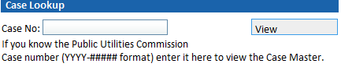
 | The Case File Screen will be displayed

- My Favorite Searches – External Registered Users will be able to set up personalized favorite searches. After a Favorite Search has been set up, by clicking on the respective View Button from the Home Page result will be displayed in pop-up window.
Step | Action
From the External Registered User Home Page, click on one of the View Button for a My Favorites Search
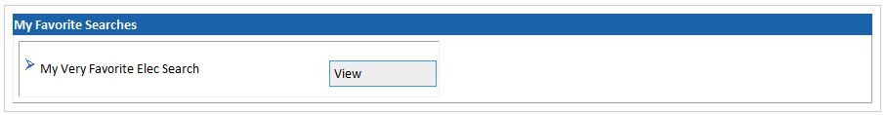

Depending on the Favorite Search Type, corresponding grid will be displayed with the results.
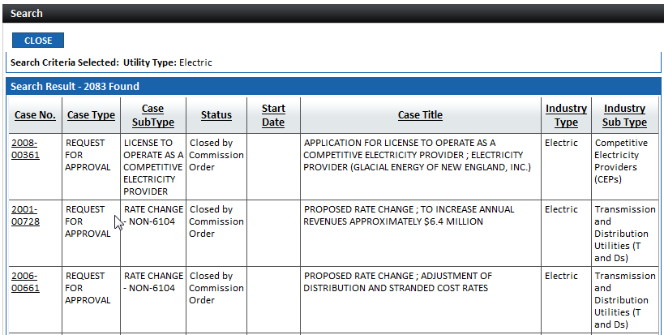

For assistance, please contact Help Desk @ 207-287-3831

