How to Training
For
Annual Report Submission
The External Registered User or the Internal Staff can submit Annual Reports. All Utilities are required to file Annual Reports with the MPUC. On an assigned date, a list of utilities is extracted. Using this list, the utilities are notified of their Annual Report obligation. To access the Annual Report Submission Screen, authorized users should click on the Annual Report File link on the Access Menu.

The user should enter the information for submitting the Annual Report. Some of the fields on this screen are mandatory entry fields as denoted by the red (*) asterisk; others fields are optional.

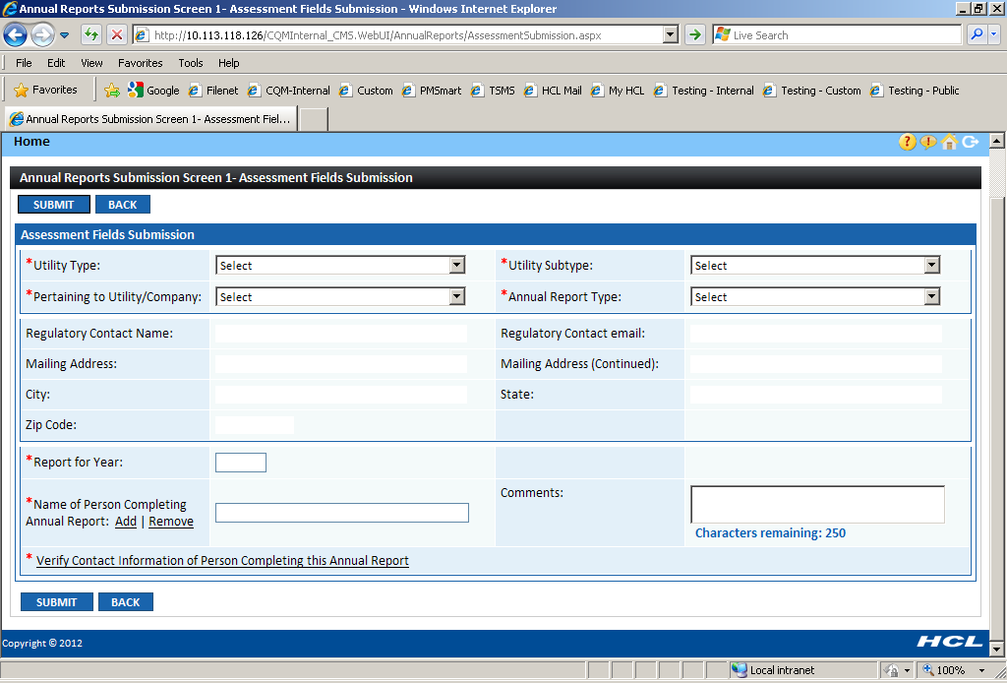
Objective:

- Submit a New Annual Report
Step | Action
 | From the Home Page Access Menu, click on Annual Report File Submit Annual Report
In the Assessment Fields Submission Section

- For the Internal Staff, select mandatory Utility Type from drop down list

- For the Internal Staff, select mandatory Utility Subtype from drop down list

- Select mandatory Pertaining to Utility/Company from drop down list.

- Select mandatory Annual Report Type from drop down list

- Based on the above selection, the Company details will be populated in the below section:

If the above fields do not get populated, then enter the following mandatory information:
- Billing Contact Name
- Billing Address
- Billing City
- Billing State
- Billing Zip Code

- Enter mandatory Report for Year in textbox

- Enter mandatory Annual Revenue Subject to Assessment in textbox

- When an Internal Staff files on behalf of some external user, enter mandatory Name of Person Completing Annual Report in textbox
- Click on Add hyperlink
- Enter known search criteria
- If contact matching entered search criteria is displayed, select Radio Button associated with the Name
- Click on Include Contact Button
- When the Annual Report Type is ARCP, then following things are mandatory:
- Enter mandatory Docket Number granting license in textbox
- Select Is Company by clicking on the Radio Button

- Click on mandatory Verify Contact Information of Person Completing this Annual Report
- If the information satisfies, click on Confirm
- Else, update the information and click on Update Button

Click on Submit Button
 | Annual Report Submission Confirmation Message will be displayed
How to Submit Analysis Key Fields

- After submitting the Annual Report, the analysis can be done by clicking on the Here hyperlink

- The Analysis Fields Submission Screen depends on the Utility Type and Subtype of the Pertaining to Utility Company

- Enter the required information for the Analysis Fields.

For Attaching Documents

- Select the security type as Public or Confidential
- For Public document, click on Attach Document Button
- Click on Browse and select the document you wish to attach
- Click on Open
- Click on Attach
- Selected document should be displayed in the Attached Documents grid
- By clicking on Red X associated with attached document, the document can be deleted prior to submitting the case

- For Confidential document, Click on Attach Confidential Document Button
- Click on Browse and select the Confidential Document you wish to attach
- Click on Browse and select the Redacted Version Document you wish to attach

- Associate Protective Order by clicking on the hyperlink
- Search for protective order and attach
- Selected document should be displayed in the Attached Documents grid
- By clicking on Red X associated with attached document, the document can be deleted prior to submitting the case

- Click on Submit Button

 | To submit another annual report, click on Back Button and follow Step 2; otherwise, click on Home hyperlink to return to the Home Page

