How To Training
For
Manage Subscriptions
External Registered Users will be able to Manage Subscriptions to New Cases and Notification Lists for Cases before the Commission. Subscriptions can be added, updated and removed as needed by the logged in user.

Manage Subscriptions

Objective:

- Manage Subscriptions

Step | Action
From the Home Page , Click on Manage Subscriptions on the access menu list. Manage Subscriptions Screen will be displayed with two sections
New Cases Section with the following

- Statement is posted above the grid which reads:

When you subscribe to New Cases, email notifications will be sent to your registered email address when the Commission opens a new case meeting your selected criteria.

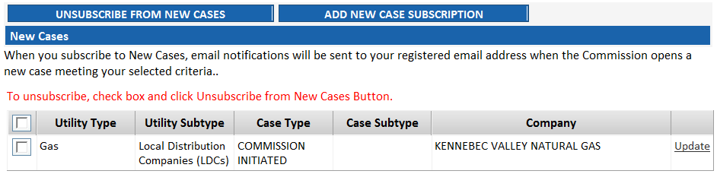

Grid includes the following

- Checkbox – when selected user can click on Unsubscribe from New Case Button to cease getting an email notification for New Case specified by subscription

- Utility Type
- Utility Subtype
- Case Type
- Case Subtype
- Company
- Update hyperlink

Notification Lists Section
- Statement is posted above the grid which reads:
** To be included on a Notification List is not the same as requesting Active Party Status. The standards for Active Party Status are set forth in Rule 4.3(c) of the Commission's Rules of Procedure.
When you subscribe to a Notification List for a case, an email notification will be sent to you when a filing or Commission issuance is entered in the case. Subscribers can receive various types of documents, i.e., Commission Issuances (usually Orders), Filings, and/or Data Requests.

Grid will contain the following

- Checkbox – To unsubscribe, select checkbox and click Unsubscribe from Notification Lists Button

- Case Number
- Case Title
- Commission Issuances Only
- Filings Only
- Data Requests Only
- Company
- Update hyperlink

Add New Case Subscription

Objective:

- Add New Case Subscription

Step | Action
From the Manage Subscriptions Screen
- Click on Subscribe to New Case Button
- Enter criteria for subscription and click on Subscribe Button

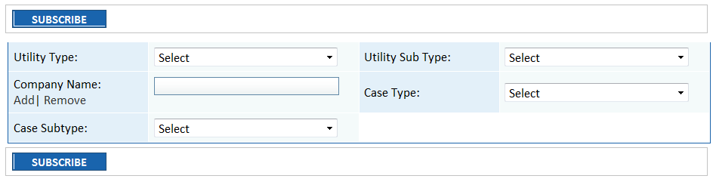

Update New Case Subscriptions

Objective:

- Update New Case Subscriptions

Step | Action
From the Manage Subscriptions Screen
- Click on Update hyperlink to edit New Case Subscription details
- Click Update Button to save changes

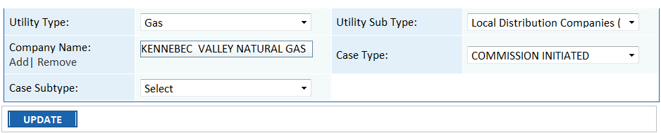

Unsubscribe from New Cases

Objective:

- Unsubscribe from New Cases

Step | Action
From the Manage Subscription Screen
- Select Checkbox for the New Case you want to discontinue
- Click on Unsubscribe from New Cases Button
- Subscription will be removed from grid

Add Case Notification List Subscription

Objective:

- Add Case Notification List Subscription

Step | Action
From the Manage Subscriptions Screen
- Click on Subscribe to Case Notification List Button
- Enter Case Number and click GO Button – Case Title will be displayed on Subscribe Screen

- Select applicable Checkboxes for subscription
  - Commission Issuances Only
  - Filings Only
  - Data Requests Only
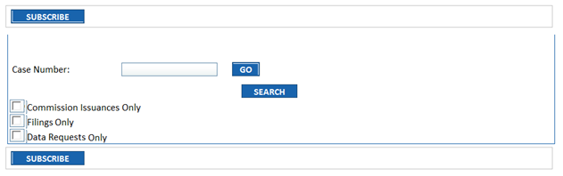

- Click on Subscribe Button to save

Update Case Notification List Subscription

Objective:

- Update Case Notification List Subscription

Step | Action
From the Manage Subscriptions Screen
- Click on Update hyperlink for one of the displayed subscriptions
- Details will be displayed in editable format. Enter changes and click on Update Button

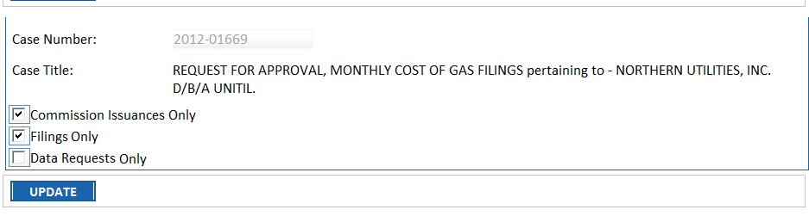

Unsubscribe from Case Notification List

Objective:

- Unsubscribe from Case Notification List

Step | Action
From the Manage Subscription Screen
- Select Checkbox for the subscription you want to discontinue
- Click on Unsubscribe from Notification List Button
- Subscription will be removed from grid

