iGOVERN™ Complaint and Quality Management System

Deliverable Name: Public User Training Manual

Date- May 21, 2012

Introduction

Overview
Case Management System (CMS) enables the Public Users to search the CQM Application, view case related public information, tariffs, annual reports, deliberations, submit comments in a case and submit complaints to the Consumer Assistance Division.

Purpose
The purpose of this document is to provide general information and instruction to public users regarding use of the Commission’s CMS system.

Conventions
Following table presents list of icons and its purpose that are used throughout the application for performing various actions.
ICON | Name | Convention
 | Button | Click on a button to perform an action. The button text describes the action that will occur upon clicking the button.  Submit button enables the user to submit information, which is stored in a repository.
 | Button | User can select this button to attach documents. On clicking this button, a new window will be opened for the user to browse and attach the document.
 | Button | User can select this button to reload page. All data previously captured on the page and not saved by user is cleared from all fields.
 | Button | User can select this button to go back to the previous page.  Note: Do not use the back button on your browser window. If you want to go back to the previous screen, use the Back button in the application itself.
 | Button | User can select this button to search for any information.
 | Button | User can select this button to clear all the information entered by the user for extraction of information from the application.
 | Button | After entering specific criteria (e.g., Case Number) upon clicking on this button, user will be navigated as per entered criteria (e.g., Case File).
 | Button | User can select this button to delete information.
 | Check Box / Checklist | Users can select one or more items from a list by checking the checkboxes.
 | Drop Down List Box | Control that displays a current setting, but can be opened to display a list of choices.
Add | Link | Click/select hyperlink to invoke a new page or a process. The text of the hyperlink will describe the action that will be invoked, e.g., Add, Remove etc.
 | Page Size | User will be able to change screen to display a specific number of rows by entering a number up to 100 in the text box.
 | Paging | Select number from list box to navigate to the page number chosen.
 | Paging Links | Click on hyperlinks to navigate to First, Last, Next or Last page of information being displayed.
 | Calendar | Click on icon to view the calendar look-up and select a date.
 | Radio Button | Select one of the radio buttons in a group to designate the desired option, e.g., view Notification List or Active Party List, Check-In/Out selected Document, etc.
 | Text Box | The purpose of text box is to allow the user to input text information to be used by the program. Enter data in a defined area on the page by typing in the text box.
 | Help | Click on the icon to display online help document in a pop-up window.
 | About | Click on the icon to display information about the application
 | Home | Click on the icon to navigate to the Home Page
 | Logout | Click on the icon to logout of the application
 | Mandatory Fields | All the mandatory (required) entry fields are prefixed with a red asterisk.
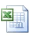 | Software Designator | Microsoft Excel Software
 | Software Designator | Microsoft Word Software and Rich Text Format (RTF)
 | Software Designator | Adobe Portable Document Format (PDF)
 | Security Icon | Image to designate a confidential document
 | Error | Error in the application.
 | Info | Displays information.
 | Expand | By clicking on plus (+) sign to the left of a Section Title, contents of the section will be expanded for viewing additional details.
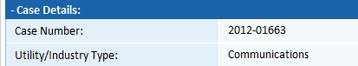 | Collapse | To collapse details displayed in a section, click on minus (-) sign to hide the contents of the section.

Acronyms
Abbreviations/ Acronym | Description
CQM | Complaint and Quality Management
CMS | Case Management System

System Features

Home Page Layout – Public User (Not Registered)
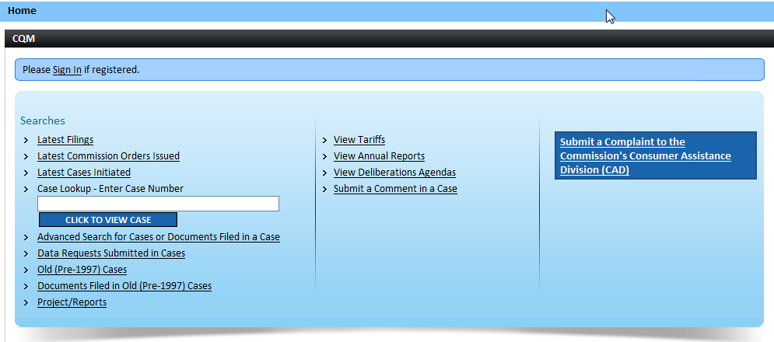

Public User Home Page

The Public User Home Page in CQM displays the following information:
- To Register and/or Sign In, click on the Please Sign in or Register as New User hyperlink. When clicked user will be navigated to Login Screen.
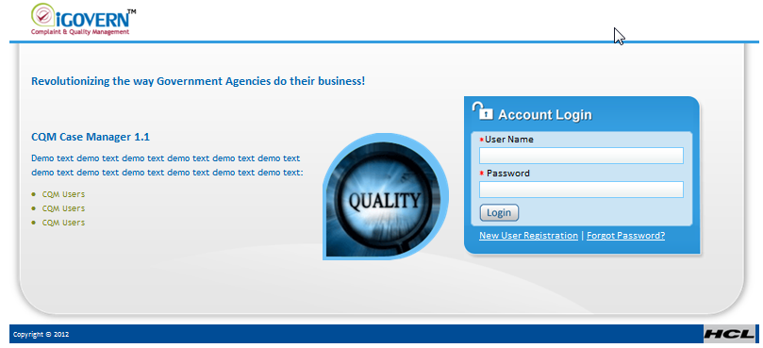
Login Page
- Common Buttons are displayed under the Application Header.
Icon | Icon Name | Description
 | Help | Click on the icon to display online help document in a pop-up window.
 | About | Click on the icon to display information about the application.
 | Home | Click on the icon to navigate to the Home Page.
 | Logout | Click on the icon to logout of the application.
Public User Home Page

Public User Functionality (Not Registered)
Application Level Access Menu lists links to the various modules in the application for which Public User has Access Rights. By clicking on a Search hyperlink, user will be navigated to the corresponding module.
Searches:
- Latest Filings – will display in a pop-up window, the filings submitted within the last 30 days. The filings will not include any Confidential or Secured Case filings.
Step | Action
From the Public User Home Page, click on Latest Filings hyperlink
- When clicked, the Latest Filings pop-up window will display filings submitted within the last 30 days.

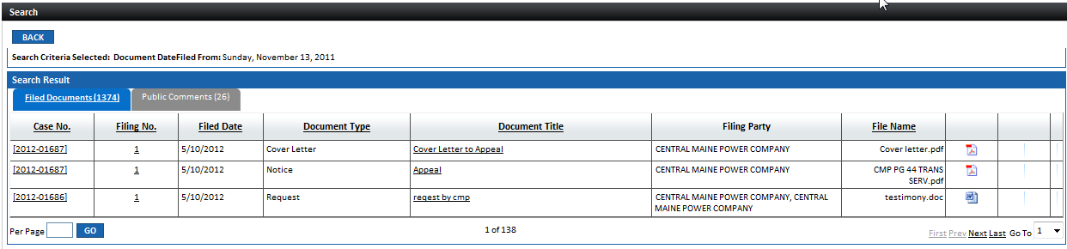

- Click on the Case No. hyperlink to be navigated to the Case File for the selected case
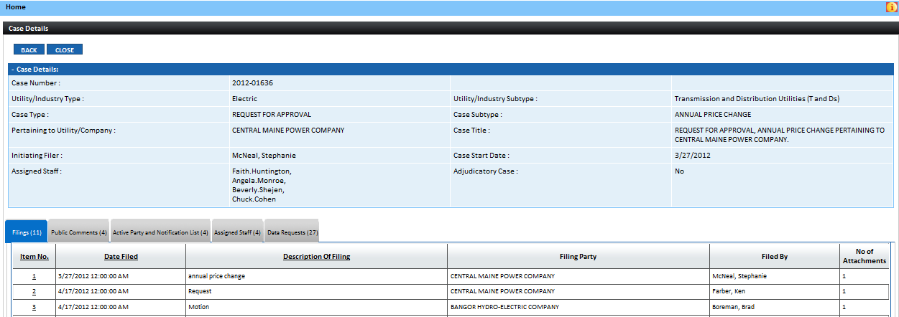
- Click on Document Title hyperlink to view filing

- Click on Filing No. hyperlink to view pop-up window containing filing information will be displayed
- In Attachments section, click on Document Title hyperlink to view filing.
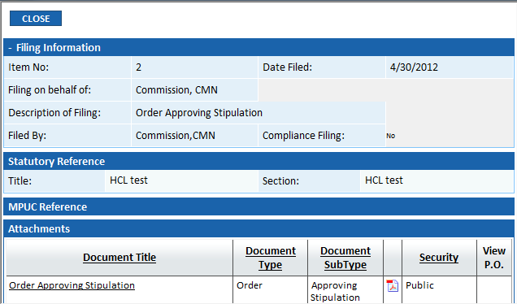

- Latest Commission Orders Issued:
Step | Action
From the Public User Home Page, click on Latest Commission Orders Issued hyperlink
- When clicked, the Latest Commission Orders Issued pop-up window will display in descending Issued Date order, the Commission issuances for the last 30 days.
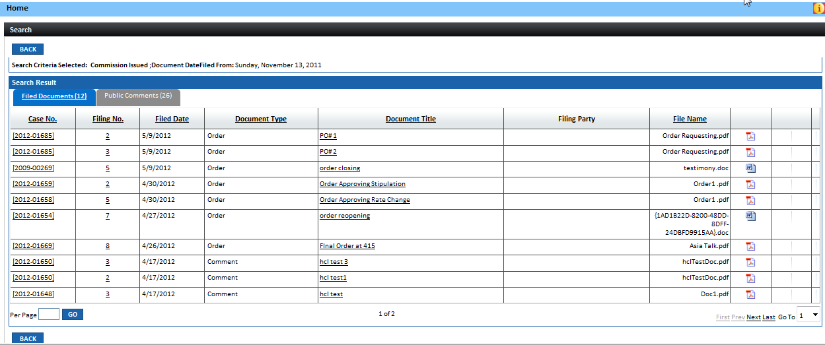

- Click on the Case No. hyperlink to be navigated to the Case File for the selected case
- Click on Document Title hyperlink to view Issuance
- Click on Filing No. hyperlink to view pop-up window containing filing information will be displayed
- In Attachments section, click on Document Title hyperlink to view issuance

- Latest Cases Initiated:
Step | Action
From the Public User Home Page, click on Latest Cases Initiated hyperlink
- When clicked, the Latest Cases Initiated pop-up window will display filings submitted within the last 30 days.

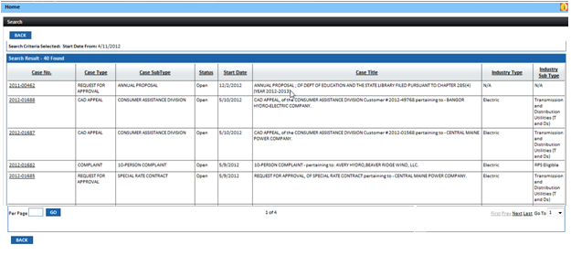

 | Click on the Case No. hyperlink to be navigated to the Case File for the selected case

- Case Lookup:
Step | Action
From the Public User Home Page, enter Case Number in text box and CLICK TO VIEW CASE BUTTON
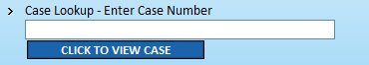
 | The Case File Screen will be displayed

- Advanced Search for Cases or Documents Filed in a Case:
Step | Action
From the Public User Home Page, click on Advanced Search for Cases or Documents Filed in a Case hyperlink
- When clicked, the Search Screen will be displayed
- User can search by Case or Document. For this exercise, select Document Radio Button
- Enter known search criteria. For example, enter Case Number in text box and select from Document Type drop down list and click on Search Button

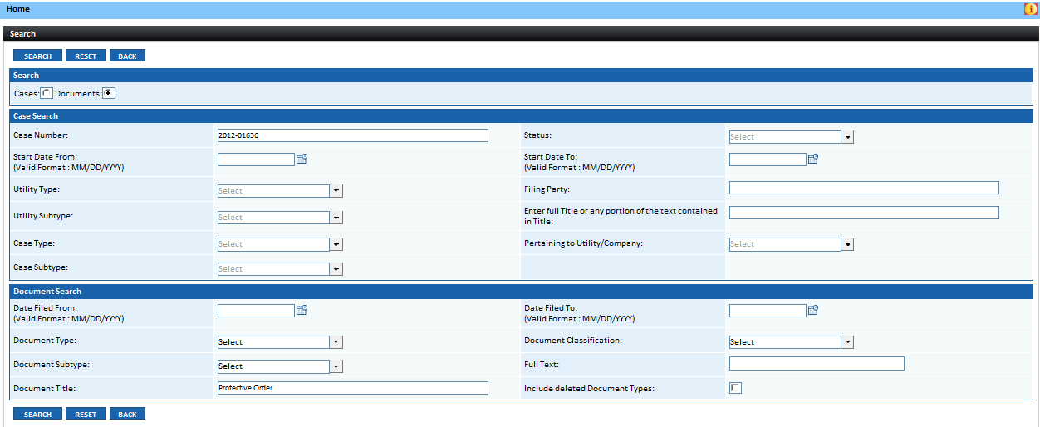

Displayed Search Result will match the entered search criteria. If no results are found in the application, “No Records Found” should be displayed.
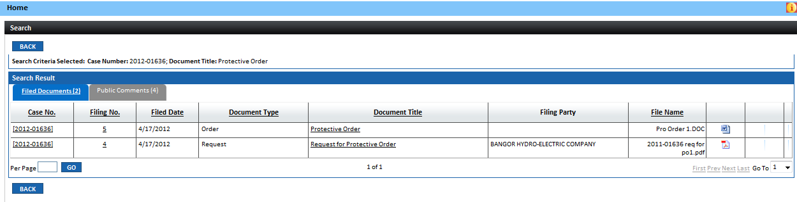

- Data Requests Submitted in Cases
Step | Action
From the Public User Home Page, click on Data Requests Submitted in Cases hyperlink
- When clicked, the Data Request Search Screen will be displayed
- User can search by Case or Document. For this exercise, select Document Radio Button
- Enter known search criteria and click on Search Button

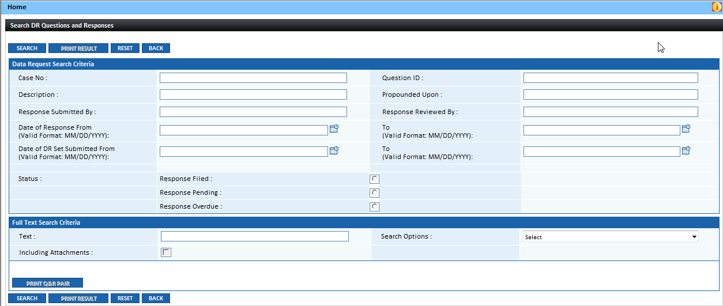

Results matching the entered search criteria will be displayed in the results grid. If no results are found in the application, “No Records Found” will be displayed
- User can select Radio Button and click on either Print Result to print displayed screen or Print Q&R Pair to print the question and response set
- User can click on View hyperlink to display Questions and/or Reponses
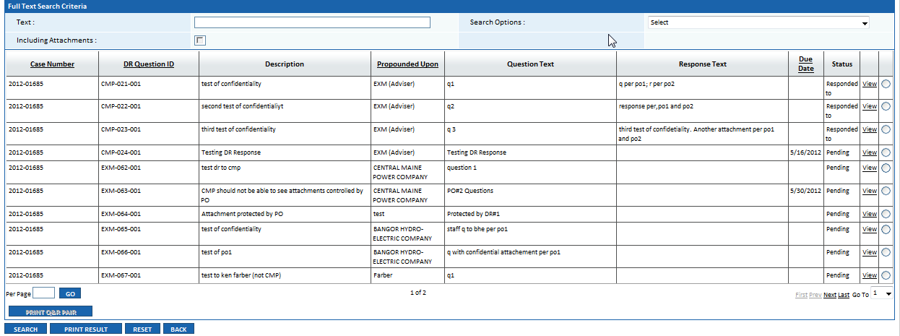

- Old (Pre-1997) Cases
Step | Action
From the Public User Home Page, click on Old (Pre-1997) Cases hyperlink
- When clicked, the Search Screen will be displayed
- Enter known search criteria and click on Search Button

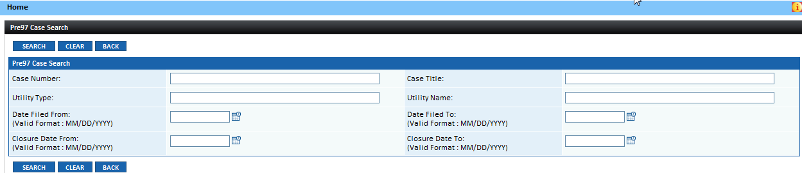

Results matching the entered search criteria will be displayed in the results grid. If no results are found in the application, “No Records Found” should be displayed.
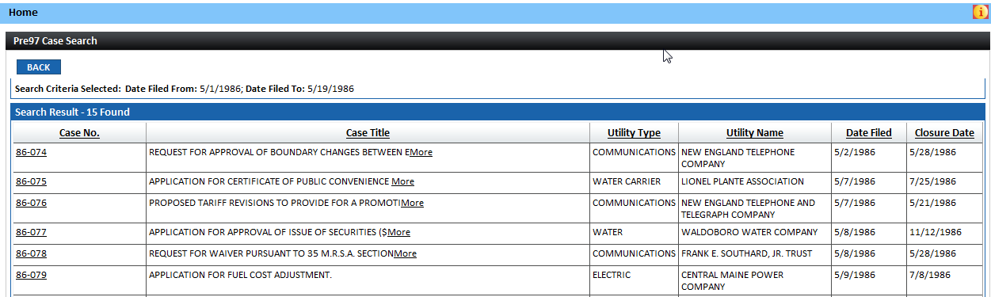
- Click on Case No. hyperlink to view case details
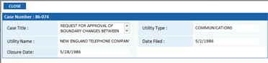

- Documents Filed in Old (Pre-1997 Cases)
Step | Action
From the Public User Home Page, click on Documents Filed in Old (Pre-1997) Cases hyperlink
- When clicked, the Search Screen will be displayed
- Enter known search criteria and click on Search Button (For this exercise, enter Case Number obtained from previous case search)

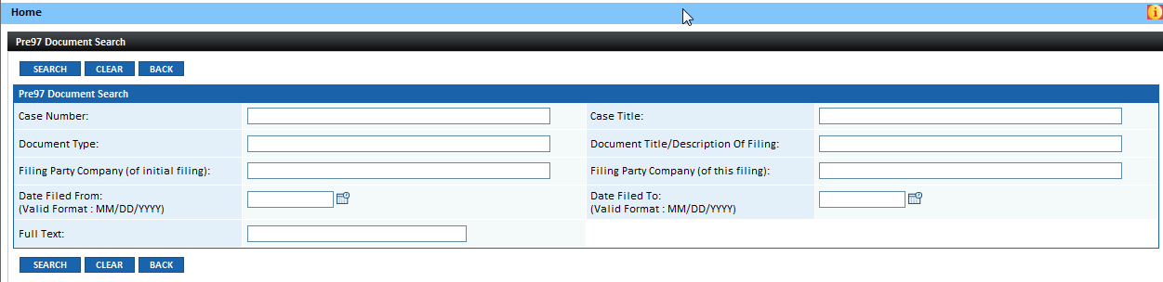

Results matching the entered search criteria will be displayed in the results grid. If no results are found in the application, “No Records Found” should be displayed.
- Click on Case Number hyperlink to view Case File

- Click on Document Title hyperlink to view filed document

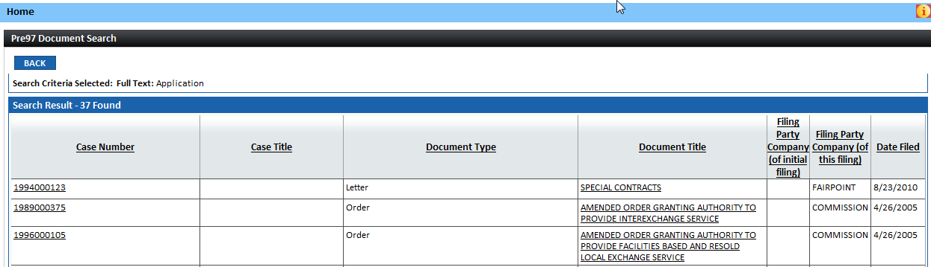

- Projects/Reports
Step | Action
From the Public User Home Page, click on Projects/Reports hyperlink
- When clicked, the Search Screen will be displayed
- Enter known search criteria (For this exercise select Project/Report Type from the drop down list for the Report/Project Year 2012) and click on Search Button

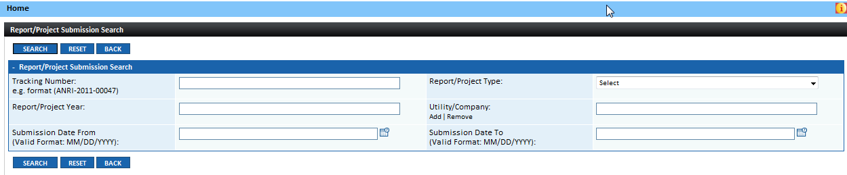

Results matching the entered search criteria will be displayed in the results grid. If no results are found in the application, “No Records Found” should be displayed.
- Click on Tracking Number hyperlink to view Case File
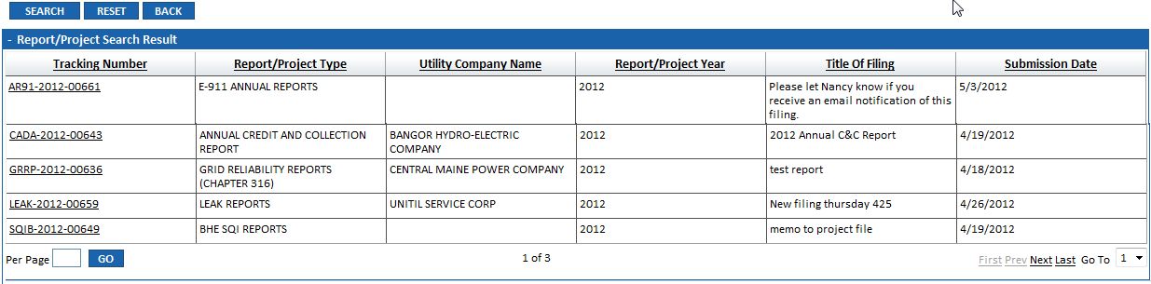
Top sections of the pop-up window will display Report/Project details.
- In the Attached Document Detail Section click on the Filename hyperlink to view the document that was attached to the Report/Project Submission
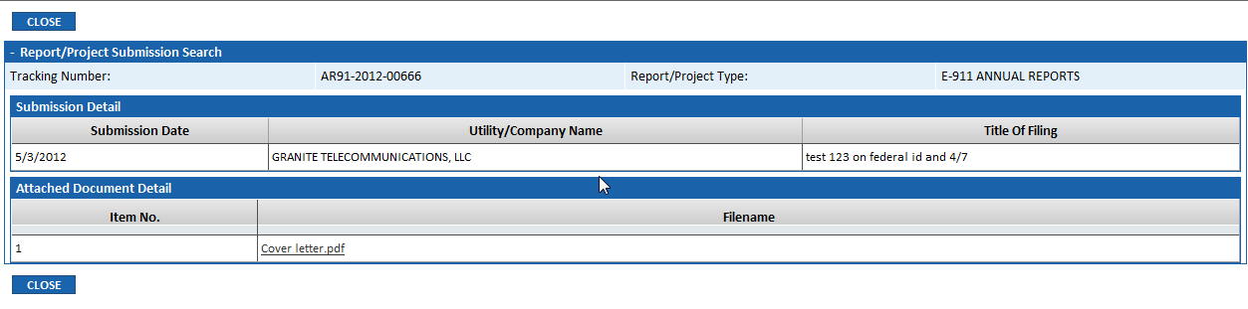

- View Tariffs:
Step | Action
From the Public User Home Page, click on View Tariffs hyperlink
- When clicked, the View Tariff Screen will be displayed
- The Utility Radio Button will be selected by default; to search by Rate/Section select associated Radio button

- Enter known search criteria. At a minimum, user is required to select Pertaining to Utility from the drop down list when searching by Utility or Rate/Section Name/Number when searching by Rate/Section.
- After entering search criteria, click on View Button
Tariff matching entered search criteria should be displayed in the grid posted at the bottom of the screen.
- To View Tariff, click on Rate/Section Name/Number hyperlink
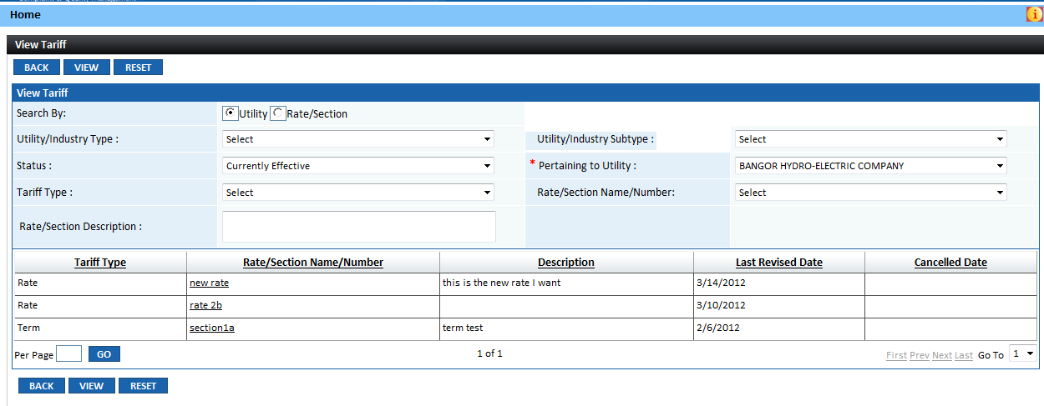

- Tariff will be displayed in pop-up window

- View Annual Reports:
Step | Action
From the Public User Home Page, click on View Annual Reports hyperlink
- When clicked, the Search Screen will be displayed
- Enter known search criteria. For this exercise, enter in the Report for Year text box 2012 and click on Search Button

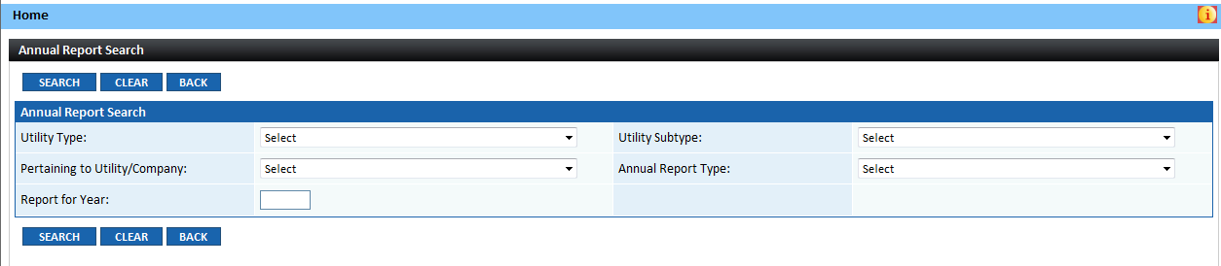

Results matching the entered search criteria will be displayed in the results grid displayed at the bottom of the Search Screen. If no results are found in the application, “No Records Found” should be displayed.
- Click on Tracking Number hyperlink
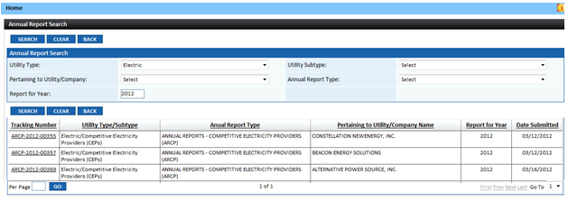
The Annual Report Details pop-up window will be displayed.
- Click on File Name hyperlink to view non-confidential Annual Report
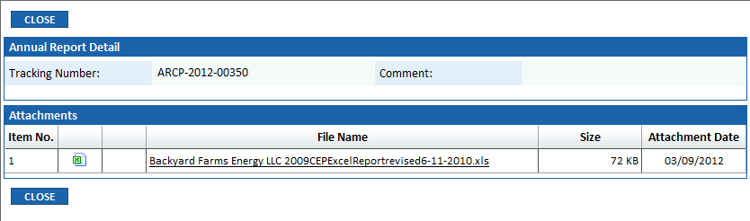

- View Deliberations Agenda
Step | Action
From the Public User Home Page, click on View Deliberations Agenda hyperlink
- When clicked, the Deliberations Agendas (Regular, Special and Supplemental) will be listed by Session Date
- To view Agenda for a specific Agenda Date, click on the associated View hyperlink
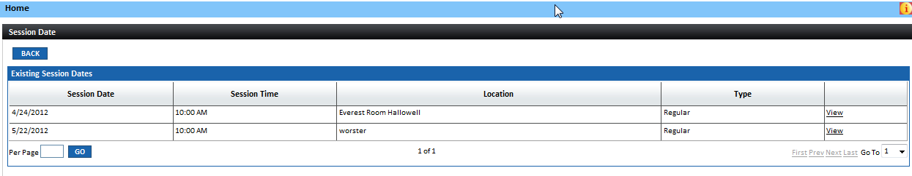

- Pop-up window will display selected Deliberations Agenda

- Submit a Comment in a Case
Step | Action
From the Public User Home Page, click on Submit a Comment in a Case hyperlink
- When clicked, the Public Case Search Screen will be displayed
- Enter valid Case Number in text box and click on GO Button

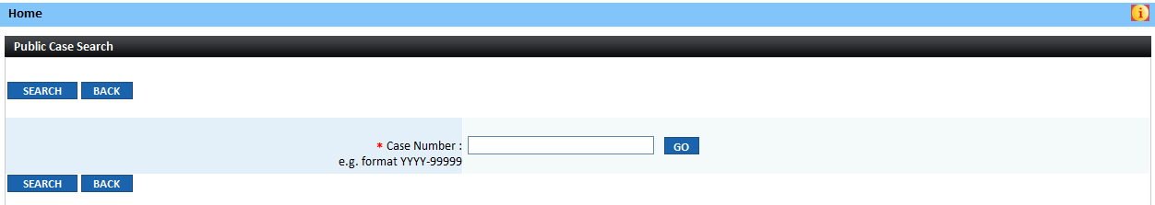

- Comment form will be displayed

Case Details will be displayed in the top sections of the screen

- Enter all required information indicated by a red asterisk ( * )
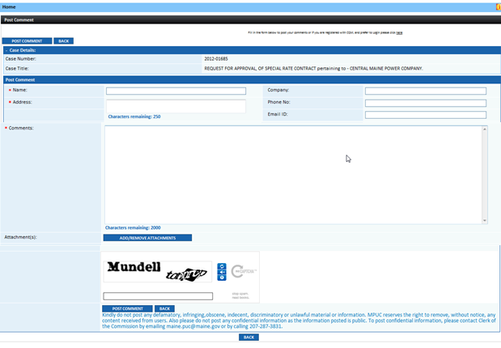
- Enter characters in text box for challenge-response test
- If you cannot clearly distinguish characters, click on to display new set of characters.
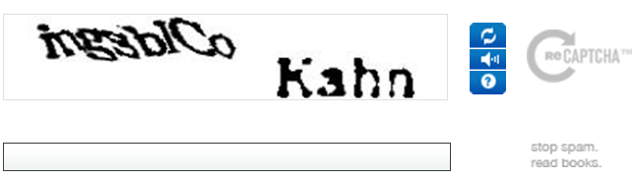
 | - Click on Post Comment Button
 | - Public Comments will be posted on the Case File Screen for the specified case.

- Submit Complaints to the Consumer Assistance Division (CAD) – Residential
Step | Action
From the Public User Home Page, click on Submit Complaints to the Consumer Assistance Division (CAD) hyperlink
- When clicked, the CAD Web Submission For Residential Screen will be displayed by default
- For this exercise, we are displaying the Residential Screen
- Enter required data all required (*) fields, add attachment if required and click on Submit Button

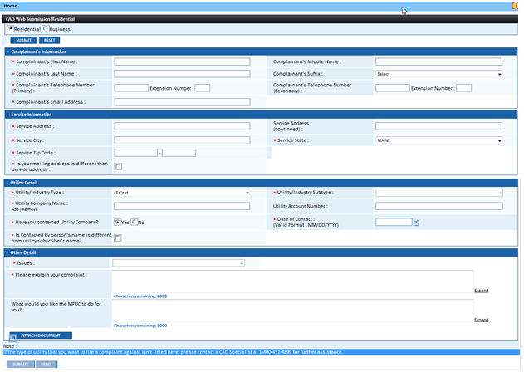

- Submit Complaints to the Consumer Assistance Division (CAD) - Business
Step | Action
From the Public User Home Page, click on Submit Complaints to the Consumer Assistance Division (CAD) hyperlink
- When clicked, the CAD Web Submission For Residential Screen will be displayed by default
- Click on Business Radio Button
- For this exercise, we are displaying the Business Screen
- Enter required data all required (*) fields, add attachment if required and click on Submit Button

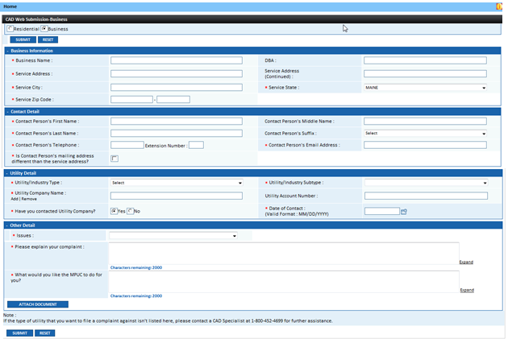

For assistance, please contact Help Desk @ 207-287-3831

