Please share your comments about this award.

Place your library information here

SAMPLE LANGUAGE FOR A CONTEST: Please return your completed booklet to the Circulation Desk no later than September 1. One lucky booklet will be drawn and the winner will receive a $_____ gift certificate to a local bookstore. Happy reading!

http://www.mainereaderschoiceaward.org

Maine Readers’ Choice Award

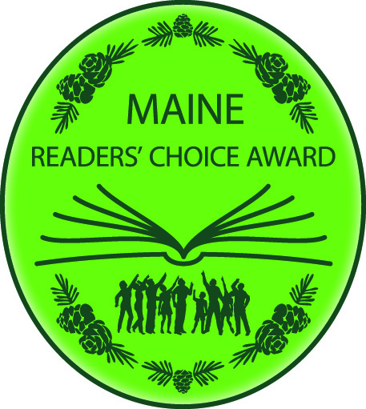

Book Journal

Name: ___________________________

Phone Number: __________________

Library: ___________________________

