01 DEPARTMENT OF AGRICULTURE, CONSERVATION AND FORESTRY

669 BUREAU OF FORESTRY (MAINE FOREST SERVICE)

Chapter 21: STATEWIDE STANDARDS FOR TIMBER HARVESTING AND RELATED ACTIVITIES IN SHORELAND AREAS

TABLE OF CONTENTS

SECTION 1. PURPOSES pg. 1

SECTION 2. (REPEALED) pg. 1

SECTION 3. SCOPE & APPLICABILITY pg. 1

SECTION 4. DEFINITIONS pg. 2

SECTION 5. SHORELAND AREA INTEGRITY AND SEDIMENTATION pg. 6

SECTION 6. SLASH TREATMENT pg. 7

SECTION 7. STANDARDS FOR TIMBER HARVESTING AND RELATED
activities in shoreland areas REQUIRING A
250-FOOT ZONE pg. 7

SECTION 8. STANDARDS FOR TIMBER HARVESTING AND RELATED
ACTIVITIES IN SHORELAND AREAS REQUIRING A
75-FOOT ZONE pg. 9

SECTION 9. SKID TRAILS, YARDS, AND EQUIPMENT OPERATION pg. 10

SECTION 10. LAND MANAGEMENT ROAD CONSTRUCTION AND
MAINTENANCE STANDARDS pg. 11

SECTION 11. CROSSINGS OF WATER BODIES pg. 14

SECTION 12. SLOPE TABLE pg. 22

SECTION 13. RESPONSIBILITY pg. 22

SECTION 14. VARIANCE pg. 22

SECTION 15. VIOLATIONS pg. 22

SECTION 16. EFFECTIVE DATE pg. 22

APPENDIX 1. DIAGRAMS OF APPLICATION OF THIS RULE pg. 24

01 DEPARTMENT OF AGRICULTURE, CONSERVATION AND FORESTRY

669 BUREAU OF FORESTRY

Chapter 21: STATEWIDE STANDARDS FOR TIMBER HARVESTING AND RELATED ACTIVITIES IN SHORELAND AREAS

AUTHORITY: 12 M.R.S., chapter 805, subchapter 3-A; Public Laws 2003, chapter 335; Public Laws 2013, chapter 570

Summary: This rule establishes statewide standards for timber harvesting and related activities in shoreland areas. In general, timber harvesting activities in shoreland areas must protect shoreline integrity and not expose mineral soil that can be washed into water bodies, including nonforested freshwater and coastal wetlands and tidal waters. Timber harvesting and related activities in shoreland areas below the 300 acre drainage point must leave windfirm stands of trees that provide adequate shade. If located in shoreland areas, roads used primarily for timber harvesting and related activities must be constructed and maintained to standards designed to minimize the chance of exposed soil washing into water bodies, including wetlands. Stream crossings must not disrupt the natural flow of water and must not allow sediment into water bodies.

SECTION 1. PURPOSES

The purposes of this rule include the following: to establish statewide standards for timber harvesting and related activities in shoreland areas; to resolve inconsistencies among existing standards; to provide maximum opportunity for flexibility; to protect public resources while minimizing impacts on private resources; to further the maintenance of safe and healthful conditions; prevent and control water pollution from various agents, including sediment, temperature, toxic materials, and excessive nutrient inputs; to maintain shoreline stability; to protect fish spawning grounds, aquatic life, bird and other wildlife habitat; to protect freshwater and coastal wetlands; and to conserve natural beauty, open space, and public recreational values.

SECTION 2. AMENDMENTS TO MAINE FOREST SERVICE CHAPTER 20 RULE (FOREST REGENERATION AND CLEARCUTTING STANDARDS)

(Repealed)

SECTION 3. SCOPE AND APPLICABILITY

- SCOPE. This rule governs all timber harvesting and related activities conducted in, over, or near water bodies, including rivers, streams, brooks, ponds, lakes, Great Ponds, freshwater and coastal wetlands, throughout the state, unless exempted in Section 3.C. of this rule.

- EXCLUSIONS. The activities described in this subsection are not considered timber harvesting and must comply with the requirements for clearing or removal of vegetation for activities other than timber harvesting under rules promulgated by the Department of Environmental Protection, Municipal Shoreland Zoning Ordinance or the Land Use Planning Commission, depending on which entity has jurisdiction.

- Removal of vegetation in proximity to an existing developed area. For purposes of this provision, “developed area” means a footprint encompassing structures, access roads (other than land management roads), and maintained non-forested areas, on a lot with shore frontage on any great pond, stream, pond, river, or freshwater or coastal wetland. “In proximity to” describes an envelope around a developed area, and includes all areas that:

- are within 50 feet of the developed area,

- are between the developed area and the water body,

- occupy an area whose width in parallel with the shoreline extends 50 feet beyond each end of the footprint of the developed area at its widest point.

In no case shall the envelope in proximity to a developed area be less than 20,000 square feet or less than 100 feet along the shoreline.

- Removal of vegetation in the shoreland area from parcels less than two acres in size.

- Removal of vegetation for the primary purpose of converting the land to a use other than forestland. If a change of land use occurs on the parcel or on any portion thereof within five years of the expiration of the Forest Operations Notification or the cessation of timber harvesting and related activities, whichever is later, the residual stand must comply with the requirements for clearing or removal of vegetation for activities other than timber harvesting under rules promulgated by the Department of Environmental Protection, Municipal Shoreland Zoning Ordinance or the Land Use Planning Commission, depending on which entity has jurisdiction. If the residual stand does not comply with these requirements after the change of land use, it constitutes prima facie evidence that a violation of the MFS Chapter 21 rule has occurred.

C. EXEMPTION. This rule does not govern timber harvesting and related activities in forested wetlands, unless the forested wetlands lie within a shoreland area.

D. RELATIONSHIP TO OTHER LEGAL REQUIREMENTS. Whenever provisions of this rule are less stringent than corresponding provisions of applicable federal, state, or municipal legal requirements, the more stringent provisions shall apply.

SECTION 4. DEFINITIONS

Unless otherwise provided herein, this rule incorporates by reference the definitions contained in MFS Rule Chapter 20 (Forest Regeneration and Clearcutting Standards). For the purpose of 12 M.R.S., chapter 805, subchapter 3-A and this rule, the following terms are defined as follows.

A. Brook: See “Stream Channel.”

B. Coastal Wetland is defined by 38 M.R.S. §480-B (2) (Supp. 2013).

C. Change of Land Use means that following timber harvesting the subsequent primary use for a particular area is not growing forest products. Change of land use may include, but is not limited to, conversion to farm pasture, site for growing agricultural crops, residential dwelling unit, development site, or gravel pit. The division of forest land into smaller units does not by itself automatically constitute a change of land use.

D. Cross-sectional area of a stream channel is determined by multiplying the stream channel width by the average stream channel depth. The stream channel width is the straight line distance from the normal high water line on one side of the channel to the normal high water line on the opposite side of the channel. The average stream channel depth is the average of the vertical distances from a straight line between the normal high water lines of the stream channel to the bottom of the channel.

E. Crossing means any timber harvesting and related activity involving the passage of ground-based equipment from one side to the opposite side of a water body, or to an island or upland within a water body. Such activities include, but are not limited to construction of roads, fords, bridges, and culverts, as well as maintenance work on these crossings.

F. Designated Agent means a person, company or other entity that is authorized by the landowner to act on the landowner's behalf for timber harvesting and related activities on the landowner's property.

G. Disruption of shoreline integrity means the alteration of the physical shape, properties, or condition of a shoreline at any location by timber harvesting and related activities. A shoreline where shoreline integrity has been disrupted is recognized by compacted, scarified and/or rutted soil, an abnormal channel or shoreline cross-section, and in the case of flowing waters, a profile and character altered from natural conditions.

H. Essential Wildlife Habitat means areas identified by the Commissioner, Maine Department of Inland Fisheries and Wildlife in accordance with the provisions of 12 M.R.S., §§12801 et seq.(2005 and Supp. 2013) and any Department of Inland Fisheries and Wildlife rules implementing that subchapter.

I. Forested Wetland means a freshwater wetland dominated by woody vegetation that is at least 20 feet tall.

J. Forest Stand means a contiguous group of trees sufficiently uniform in age class distribution, composition, and structure, and growing on a site of sufficiently uniform quality, to be a distinguishable unit.

K. Freshwater Wetland means ponds, freshwater swamps, marshes, bogs and similar areas that are:

1. Inundated or saturated by surface or groundwater at a frequency and for a duration sufficient to support, and which under normal circumstances do support, a prevalence of wetland vegetation typically adapted for life in saturated soils; and,

2. Not part of a Great Pond, coastal wetland, stream, or river.

L. Great Pond means any inland body of water which in a natural state has a surface area in excess of 10 acres, and any inland body of water artificially formed or increased which has a surface area in excess of 30 acres.

M. Harvest Area means the area where timber harvesting and related activities, including the cutting of trees, skidding, yarding, and associated road construction take place. The area affected by a harvest encompasses the area within the outer boundaries of these activities, excepting unharvested areas greater than 10 acres within the area affected by a harvest.

N. Landowner means a person, company, or other legal entity which holds title to land, including as a joint ownership or as tenants in common. Where the ownership of the timber located on the land is different than the fee ownership of the land itself, the owners of the timber are deemed a landowner and are jointly and severally responsible with the fee landowner to comply with this rule. Where a corporate landowner is a wholly owned subsidiary of another corporation, both parent and subsidiary are deemed the same landowner.

O. Land Management Road means a route or track consisting of a bed of exposed mineral soil, gravel, or other surfacing materials constructed for, or created by, the passage of motorized vehicles and used primarily for timber harvesting and related activities, including associated log yards, but not including skid trails or skid roads.

P. Licensed Forester means a forester licensed under 32 M.R.S. §5501(3) (Supp. 2013).

Q. Normal High Water Line means that line which is apparent from visible markings, changes in the character of soils due to prolonged action of the water or changes in vegetation, and which distinguishes between predominantly aquatic and predominantly terrestrial land. In the case of nonforested freshwater wetlands adjacent to streams and other water bodies, the normal high water line is the upland edge of the freshwater wetland, not the edge of the open water.

R. Permanent crossing means any structure constructed or erected with a fixed location, in, on, or over a water body for a period exceeding 7 months in any 12 month period, including, but not limited to, culverts and bridges.

S. Pond means any inland body of water which in a natural state has a surface area between 4,300 square feet and 10 acres.

T. Responsible party means all of the following persons or entities, jointly and severally:

1. The landowner, or landowners, who owned the property at the time a timber harvest subject to this rule was conducted;

2. The landowner’s designated agent at the time a timber harvest subject to this rule was conducted;

3. The Licensed Forester and/or the employer of the Licensed Forester who supervised a timber harvest subject to this rule; and

4. The timber harvester who conducted a timber harvest subject to this rule.

U. Residual Stand means a stand of trees remaining in the forest following timber harvesting and related activities.

V. River means a free-flowing body of water, including its associated flood plain wetlands, from that point at which it provides drainage for a watershed of:

1. fifty square miles to its mouth in the jurisdiction of the Land Use Planning Commission; and,

2. twenty-five square miles to its mouth in municipalities not subject to the jurisdiction of the Land Use Planning Commission.

W. Shoreland area means all land areas within:

1. 250 feet, horizontal distance, of the normal high water line of:

a. Rivers below the 50 square mile drainage point in the jurisdiction of the Land Use Planning Commission;

b. Rivers below the 25 square mile drainage point in municipalities not subject to the jurisdiction of the Land Use Planning Commission;

c. Great Ponds and nonforested freshwater wetlands 10 acres or larger;

d. Any coastal wetland;

e. Any size pond or freshwater wetland identified by the Department of Inland Fisheries and Wildlife as significant wildlife habitat or essential wildlife habitat;

2. 75 feet, horizontal distance, of the normal high water line of:

a. Streams between the 300 acre drainage point and the 50 square mile drainage point in the jurisdiction of the Land Use Planning Commission;

b. Streams between the 300 acre drainage point and the 25 square mile drainage point in municipalities not subject to the jurisdiction of the Land Use Planning Commission;

3. Adjacent to:

a. The normal high water line of streams above the 300 acre drainage point; and,

b. Ponds or freshwater wetlands larger than 4,300 square feet but less than 10 acres that are not identified by the Department of Inland Fisheries and Wildlife as significant wildlife habitat or essential wildlife habitat.

X. Shoreline: See “Normal High Water Line” and “Coastal Wetland.”

Y. Significant wildlife habitat is defined by 38 M.R.S §480-B (10) (Pamph. 2013).

Z. Skid Road or Skid Trail means a route repeatedly used by forwarding machinery or animal to haul or drag forest products from the stump to the yard or landing, the construction of which requires minimal excavation.

AA. Slash means the residue, e.g., treetops and branches, left on the ground after a timber harvest.

BB. Stand: see "Forest Stand."

CC. Stream: means a stream channel upstream from the point at which it becomes a river.

DD. Stream channel means a channel between defined banks created by the action of surface water, which is characterized by the lack of terrestrial vegetation or by the presence of a bed, devoid of topsoil, containing waterborne deposits or exposed soil parent material or bedrock; and which is connected hydrologically with other water bodies. “Stream channel” does not include rills or gullies forming because of accelerated erosion in disturbed soils where the natural vegetative cover has been removed by human activity.

EE. Timber harvesting means the cutting or removing of timber for the primary purpose of selling or processing forest products.

FF. Timber harvesting and related activities means timber harvesting, the construction and maintenance of roads used primarily for timber harvesting, and other activities conducted to facilitate timber harvesting.

GG. Used for navigation means those rivers, streams or brooks used by motorized watercraft.

HH. Water body means any river, stream, stream channel, brook, freshwater wetland, coastal wetland, pond, lake, Great Pond, or any other hydrological feature regulated by this rule.

II. Woody Vegetation means live trees or woody, non-herbaceous shrubs.

JJ. Windfirm means the ability of a forest stand to withstand strong winds and resist windthrow, wind rocking, and major breakage.

NOTE: In the context of this definition, an assessment of windfirmness will include assessment of soil conditions, depth to bedrock, and live crown ratios and height/diameter ratios on residual trees. Trees with live crown ratios of 30 percent or greater and/or trees with height/diameter ratios of 90 or less could be considered indicators of windfirmness.

SECTION 5. SHORELINE INTEGRITY AND SEDIMENTATION

A. APPLICABILITY. The requirements of Section 5 apply to all timber harvesting and related activities conducted in all shoreland areas as defined in this rule.

B. STANDARDS. Persons conducting timber harvesting and related activities in shoreland areas must take reasonable measures to avoid the disruption of shoreline integrity, the occurrence of sedimentation of water, and the disturbance of stream banks, stream channels, shorelines, and soil lying within ponds and wetlands. If, despite such precautions, the disruption of shoreline integrity, sedimentation of water, or the disturbance of stream banks, stream channels, shorelines, and soil lying within ponds and wetlands occurs, such conditions must be corrected. This section does not apply to crossings of water bodies conducted in compliance with Section 11 of this rule.

NOTE: For guidance on reasonable measures, consult the Bureau publication, “Best Management Practices for Forestry: Protecting Maine’s Water Quality” (2004). This publication is available from the Bureau and on the Bureau’s website, www.maineforestservice.gov.

SECTION 6. SLASH TREATMENT

A. Timber harvesting and related activities shall be conducted such that slash or debris is not left below the normal high water line of any water body. This section does not apply to minor, incidental amounts of slash that result from timber harvesting and related activities otherwise conducted in compliance with this section.

B. No accumulation of slash shall be left within 50 feet of:

1. the normal high water line of Great Ponds, rivers, non-forested wetlands larger than 10 acres, and tidal waters in the jurisdiction of the Land Use Planning Commission; and,

2. the normal high water line of Great Ponds, rivers, non-forested wetlands larger than 10 acres, and tidal waters in municipalities not subject to the jurisdiction of the Land Use Planning Commission.

Slash actively used to protect soil from disturbance by equipment or to stabilize exposed soil may be left in place, provided no part thereof extends more than 4 feet above the ground.

C. Between 50 feet and 250 feet of the normal high water line of a water body identified in subsection 6.B. above, all slash larger than 3 inches in diameter must be disposed of in such a manner that no part thereof extends more than 4 feet above the ground.

SECTION 7. STANDARDS FOR TIMBER HARVESTING AND RELATED ACTIVITIES IN SHORELAND AREAS REQUIRING A 250-FOOT ZONE

A. APPLICABILITY. The requirements of Section 7 apply to all timber harvesting and related activities in shoreland areas within 250 feet, horizontal distance, of the normal high water line of:

1. Rivers below the 50 square mile drainage point in the jurisdiction of the Land Use Planning Commission

2. Rivers below the 25 square mile drainage point in municipalities not subject to the jurisdiction of the Land Use Planning Commission;

3. Great Ponds and nonforested freshwater wetlands 10 acres or larger;

4. Any coastal wetland; and,

5. Any size pond or freshwater wetland identified by the Department of Inland Fisheries and Wildlife as significant wildlife habitat or essential wildlife habitat.

B. SHADE AND TREE RETENTION STANDARDS

Timber harvesting and related activities in shoreland areas subject to the requirements of Section 7 must leave adequate tree cover and shall be conducted so that a well-distributed stand of trees is retained. The requirements of this section may be satisfied by following one of the following three options:

1. Option 1 (40% volume removal), which requires:

a. Harvesting of no more than 40 percent of the total volume on each acre involved of trees 4.5 inches DBH or greater in any 10 year period is permitted. For the purposes of these standards volume may be considered to be equivalent to basal area;

b. A well-distributed stand of trees which is windfirm, and other vegetation including existing ground cover, must be maintained; and,

c. Within 75 feet, horizontal distance, of the normal high water line of shoreland areas regulated under this section, there must be no cleared openings. At distances greater than 75 feet, horizontal distance, of the normal high water line, timber harvesting and related activities must not create single cleared openings greater than 14,000 square feet in the forest canopy. Where such openings exceed 10,000 square feet, they must be at least 100 feet apart. Such cleared openings will be included in the calculation of total volume removal. For the purposes of these standards, volume may be considered equivalent to basal area.

2. Option 2 (60 square foot basal area retention), which requires:

a. The residual stand must contain an average basal area of at least 60 square feet per acre of woody vegetation greater than or equal to 1.0 inch DBH, of which 40 square feet per acre must be greater than or equal to 4.5 inches DBH;

b. A well-distributed stand of trees which is windfirm, and other vegetation including existing ground cover, must be maintained; and,

c. Within 75 feet, horizontal distance, of the normal high water line of shoreland areas regulated under this section, there must be no cleared openings. At distances greater than 75 feet, horizontal distance, of the normal high water line, timber harvesting and related activities must not create single cleared openings greater than 14,000 square feet in the forest canopy. Where such openings exceed 10,000 square feet, they must be at least 100 feet apart. Such cleared openings will be included in the calculation of total volume removal. For the purposes of these standards, volume may be considered equivalent to basal area.

3. Option 3 (outcome based), which requires: An alternative method proposed in an application, signed by a Licensed Forester or certified wildlife professional, submitted by the landowner or designated agent to the Bureau and approved by the Bureau, which provides equal or better protection of the shoreland area than this rule.

Landowners must designate on the Forest Operations Notification form required by 12 M.R.S. §§8881 et seq. (Supp. 2013) which option they choose to use. If landowners choose Option 1 or Option 2, compliance with this section will be determined solely on the criteria for the option chosen. If landowners choose Option 3, timber harvesting and related activities may not begin until the Bureau has approved the required application.

The Bureau may verify that adequate tree cover and a well-distributed stand of trees is retained through a field procedure that uses sample plots that are located randomly or systematically to provide a fair representation of the harvest area.

SECTION 8. STANDARDS FOR TIMBER HARVESTING AND RELATED ACTIVITIES IN SHORELAND AREAS REQUIRING A 75-FOOT ZONE

A. APPLICABILITY. The requirements of Section 8 apply to all timber harvesting and related activities in shoreland areas within 75 feet, horizontal distance, of the normal high water line of:

1. Streams between the 300 acre drainage point and the 50 square mile drainage point in the jurisdiction of the Land Use Planning Commission; and,

2. Between the 300 acre drainage point and the 25 square mile drainage point in municipalities not subject to the jurisdiction of the Land Use Planning Commission.

B. SHADE AND TREE RETENTION STANDARDS

Timber harvesting and related activities in shoreland areas subject to the requirements of Section 8 must leave adequate tree cover and shall be conducted so that a well-distributed stand of trees is retained. The requirements of this section may be satisfied by following one of the following three options:

1. Option 1 (40% volume removal), which requires:

a. Harvesting of no more than 40 percent of the total volume on each acre involved of trees 4.5 inches DBH or greater in any 10 year period is permitted. For the purposes of these standards volume may be considered to be equivalent to basal area;

b. A well-distributed stand of trees which is windfirm, and other vegetation including existing ground cover, must be maintained; and,

c. There must be no cleared openings.

2. Option 2 (60 square foot basal area retention), which requires:

a. The residual stand must contain an average basal area of at least 60 square feet per acre of woody vegetation greater than or equal to 1.0 inch DBH, of which 40 square feet per acre must be greater than or equal to 4.5 inches DBH;

b. A well-distributed stand of trees which is windfirm, and other vegetation including existing ground cover, must be maintained; and,

c. There must be no cleared openings.

3. Option 3 (outcome based), which requires: An alternative method proposed in an application, signed by a Licensed Forester or certified wildlife professional, submitted by the landowner or designated agent to the Bureau and approved by the Bureau, which provides equal or better protection of the shoreland area than this rule.

Landowners must designate on the Forest Operations Notification form required by 12 M.R.S. §§8881 et seq. (Supp. 2013) which option they choose to use. If landowners choose Option 1 or Option 2, compliance with this section will be determined solely on the criteria for the option chosen. If landowners choose Option 3, timber harvesting and related activities may not begin until the Bureau has approved the required application.

The Bureau may verify that adequate tree cover and a well-distributed stand of trees is retained through a field procedure that uses sample plots that are located randomly or systematically to provide a fair representation of the harvest area.

- Exception. Timber harvesting and related activities conducted in the jurisdiction of the Land Use Planning Commission between the 300 acre drainage point and the 25 square mile drainage point are not subject to the requirements of Section 8.B. of this rule, but must be conducted to retain sufficient vegetation to maintain shading of surface waters.

SECTION 9. SKID TRAILS, YARDS, AND EQUIPMENT OPERATION

A. APPLICABILITY. The requirements of Section 9 apply to the construction, maintenance, and use of skid trails and yards in shoreland areas. This section does not apply to crossings of water bodies conducted in compliance with Section 11 of this rule.

B. STREAM CHANNELS. Equipment used in timber harvesting and related activities shall not use stream channels as travel routes except when:

1. surface waters are frozen and snow covered; and,

2. the activity will not result in any ground disturbance.

C. DESIGN, CONSTRUCTION, AND CLOSEOUT. Skid trails and yards must be designed and constructed to prevent sediment and concentrated water runoff from entering a water body. Upon termination of their use, skid trails and yards must be stabilized.

D. SETBACKS

1. Except for crossings of stream channels or freshwater wetlands, equipment used in timber harvesting and related activities, including but not limited to the use of skid trails and yards, must be operated to avoid the exposure of mineral soil within 25 feet of any water body or wetland regulated by this rule. On slopes of 10 percent or greater, the setback for equipment operation must be increased by 20 feet, plus an additional 10 feet for each 5 percent increase in slope above 10 percent. These requirements are presented in an alternative format in the slope table in Section 12 of this rule.

2. The provisions of this subsection apply only to a face sloping toward the water body or freshwater or coastal wetland, provided, however, that no portion of such exposed mineral soil on a back face is closer than 25 feet from the normal high water line of a water body or upland edge of a freshwater or coastal wetland. The setback requirements of this subsection shall not apply to skid trail approaches to crossings of stream channels or freshwater wetlands.

3. Where such setbacks are impracticable, appropriate techniques shall be used to avoid sedimentation of the water body or wetland. Such techniques may include the installation of sump holes or settling basins, and/or the effective use of additional ditch relief culverts and ditch water turnouts placed to avoid sedimentation of the water body or wetland. If, despite such precautions, sedimentation or the disruption of shoreline integrity occurs, such conditions must be corrected.

- Exception. Timber harvesting and related activities in shoreland areas of streams draining less than 300 acres and wetlands adjacent to such streams may be conducted in a manner not in conformity with the setback requirements of the foregoing subsections provided persons conducting such activities take reasonable measures to avoid the disruption of shoreline integrity, the occurrence of sedimentation of water, and the disturbance of stream banks, stream channels, shorelines, and soil lying within ponds and wetlands. If, despite such precautions, the disruption of shoreline integrity, sedimentation of water, or the disturbance of stream banks, stream channels, shorelines, and soil lying within ponds and wetlands occurs, such conditions must be corrected.

NOTE: For guidance on reasonable measures, consult the Bureau publication, “Best Management Practices for Forestry: Protecting Maine’s Water Quality” (2004). This publication is available from the Bureau and on the Bureau’s website, www.maineforestservice.gov.

SECTION 10. LAND MANAGEMENT ROAD CONSTRUCTION AND MAINTENANCE STANDARDS

A. APPLICABILITY. The requirements of Section 10 apply to the construction, maintenance, and use of land management roads in shoreland areas. This section does not apply to crossings of water bodies conducted in compliance with Section 11 of this rule.

B. ROAD DESIGN, CONSTRUCTION, AND MAINTENANCE. Land management roads, including approaches to crossings of stream channels and freshwater wetlands, ditches and other related structures, must be designed, constructed, and maintained to prevent sediment and concentrated water runoff from directly entering the water body. Surface water on or adjacent to crossing approaches must be diverted through vegetative filter strips to avoid sedimentation of the watercourse. Because roadside ditches may not extend to the resource being crossed, filter strips must be established in accordance with the slope table in Section 12 of this rule.

C. SETBACKS. Land management roads and associated ditches, excavation, and fill must be set back at least:

1. 100 feet from the normal high-water line of a Great Pond or a river that flows to a Great Pond, rivers draining more than 50 square miles in the jurisdiction of the Land Use Planning Commission, rivers draining more than 25 square miles in municipalities not subject to the jurisdiction of the Land Use Planning Commission, nonforested freshwater wetlands 10 acres or larger, any coastal wetland, and any pond or freshwater wetland identified by the Department of Inland Fisheries and Wildlife as significant wildlife habitat or essential wildlife habitat;

2. 50 feet from the normal high water line of streams draining more than 300 acres but less than 50 square miles in the jurisdiction of the Land Use Planning Commission and streams below the 300 acre drainage but above the 25 square mile drainage point in municipalities not subject to the jurisdiction of the Land Use Planning Commission; and,

3. 25 feet from the normal high water line of streams draining less than 300 acres and ponds or freshwater wetlands larger than 4,300 square feet but less than 10 acres that are not identified by the Department of Inland Fisheries and Wildlife as significant wildlife habitat or essential wildlife habitat.

4. Exceptions

a. The minimum 100 foot setback specified in subsection 1 above may be reduced to no less than 50 feet, if, prior to construction, the landowner or the landowner’s designated agent demonstrates to the Bureau’s satisfaction that no reasonable alternative exists and that appropriate techniques will be used to prevent sedimentation of the water body. Such techniques may include, but are not limited to, the installation of settling basins, and/or the effective use of additional ditch relief culverts and turnouts placed to avoid sedimentation of the water body. If, despite such precautions, sedimentation or the disruption of shoreline integrity occurs, such conditions must be corrected.

b. The minimum 50 foot setback specified in subsection 2 above may be reduced to no less than 25 feet, if, prior to construction, the landowner or the landowner’s designated agent demonstrates to the Bureau’s satisfaction that no reasonable alternative exists and that appropriate techniques will be used to prevent sedimentation of the water body. Such techniques may include, but are not limited to, the installation of settling basins, and/or the effective use of additional ditch relief culverts and turnouts placed to avoid sedimentation of the water body or the disruption of shoreline integrity. If, despite such precautions, sedimentation or the disruption of shoreline integrity occurs, such conditions must be corrected.

5. On slopes of 10 percent or greater, the land management road setback must be increased by at least 20 feet, plus an additional 10 feet for each 5 percent increase in slope above 10 percent, but in no case may the land management road setback be less than that indicated in the slope table presented in Section 12 of this rule.

6. New land management roads are not permitted within the shoreland area along Significant River Segments as identified in 38 M.R.S. §437 (Supp. 2013), nor in Resource Protection Districts as identified in municipal shoreland zoning ordinances nor in Recreation Protection Subdistricts (P-RR) as identified by the Land Use Planning Commission, unless, prior to construction, the landowner or the landowner’s designated agent makes a clear demonstration to the Bureau’s satisfaction that no reasonable alternative route exists outside the shoreland zone, and that the new road must be set back as far as practicable from the normal high water line and screened from the river by existing vegetation.

D. MAINTENANCE. Ditches, culverts, bridges, dips, water turnouts and other water control installations associated with roads must be maintained on a regular basis to assure effective functioning. Drainage structures shall deliver a dispersed flow of water into an unscarified filter strip no less than the width indicated in the slope table set forth in Section 12 of this rule. Where such filter strip is impracticable, appropriate techniques shall be used to avoid sedimentation of the water body or wetland. Such techniques may include the installation of sump holes or settling basins, and/or the effective use of additional ditch relief culverts and ditch water turnouts placed to avoid sedimentation of the water body or wetland. If, despite such precautions, sedimentation or the disruption of shoreline integrity occurs, such conditions must be corrected.

E. ROAD CLOSEOUT AND DISCONTINUANCE. Maintenance of the water control installations required above must continue until use of the road is discontinued and the road is put to bed by effective installation of water bars or other adequate road drainage structures at appropriate intervals, constructed to avoid surface water flowing over or under the water bar, and extending sufficient distance beyond the traveled way so that water does not reenter the road surface.

F. UPGRADING EXISTING ROADS. Extension or enlargement of presently existing roads must conform to the provisions of this section. Any nonconforming existing road may continue to exist and to be maintained, as long as the nonconforming conditions are not made more nonconforming.

Exception. Extension or enlargement of presently existing roads need not conform to the setback requirements of Section 10.C if, prior to extension or enlargement, the landowner or the landowner’s designated agent demonstrates to the Bureau’s satisfaction that no reasonable alternative exists and that appropriate techniques will be used to prevent sedimentation of the water body. Such techniques may include, but are not limited to, the installation of settling basins, and/or the effective use of additional ditch relief culverts and turnouts placed to avoid sedimentation of the water body. If, despite such precautions, sedimentation or the disruption of shoreline integrity occurs, such conditions must be corrected.

G. ADDITIONAL MEASURES. In addition to the foregoing minimum requirements, persons undertaking construction and maintenance of roads and stream crossings must take reasonable measures to avoid sedimentation of surface waters.

NOTE: For guidance on reasonable measures, consult the Bureau publication, “Best Management Practices for Forestry: Protecting Maine’s Water Quality” (2004). This publication is available from the Bureau and on the Bureau’s website, www.maineforestservice.gov.

SECTION 11. CROSSINGS OF WATER BODIES

A. APPLICABILITY. The requirements of Section 11 apply to all crossings of stream channels, rivers, ponds, lakes, Great Ponds, nonforested freshwater wetlands, coastal wetlands, and freshwater wetlands identified by the Department of Inland Fisheries and Wildlife as significant wildlife habitat or essential wildlife habitat.

B. ALL CROSSINGS

1. Crossings must allow for fish passage at all times of the year, must not impound water, and must allow for the maintenance of normal stream flows.

2. Determination of flow. Provided they are properly applied and used for the circumstances for which they are designed, methods including but not limited to the following are acceptable to the Bureau as means of calculating the 10 year and 25 year frequency water flows and thereby determining crossing sizes as required in this section: The United States Geological Survey (USGS) Methods; specifically: Hodgkins, G. 1999. Estimating the Magnitude of Peak Flows for Streams in Maine for Selected Recurrence Intervals. U.S. Geological Survey. Water Resources Investigations Report 99-4008. 45 pp.

3. Upgrading existing crossings. Extension or enlargement of presently existing crossings must conform to the provisions of this section. Any nonconforming existing crossing may continue to exist and be maintained, as long as the nonconforming conditions are not made more nonconforming; however, any maintenance or repair work done below the normal high water line must conform to the provisions of this section.

4. Bureau Permits and Permit by Rule

      - Permits. An application for a permit must be submitted to the Bureau at least 60 days prior to the construction of any new permanent crossing or the replacement of a permanent crossing of any waterbody subject to a 250’ shoreland area as defined by §(4)(W)(1) of this rule, non-forested freshwater wetlands larger than 4,300 square feet and any crossing that will not conform to permit by rule standards. An individual permit application is required for each crossing. The permit application must contain all information required by the Bureau, including a description of how negative impacts to the resource will be avoided and minimized to the extent practicable. When granting a permit the Bureau may impose such reasonable terms and conditions as the Bureau considers appropriate in order to satisfy the purpose set forth in its governing statutes and rules.
      - Permit by Rule. Crossings must conform to standards of this section to qualify for permit by rule. If a crossing does not conform to these standards an application for a full permit must be submitted per §(11)(B)(4)(a) above. A permit by rule must be submitted to the Bureau prior to construction, maintenance, alteration, and replacement of permanent crossings of waterbodies subject to a 75’ shoreland area or adjacent shoreland area as defined by §(4)(W)(2) and (3) of this rule except all non-forested freshwater wetlands greater than 4,300 square feet which require a permit as described in §(11)(B)(4)(a). Multiple crossings within one township or municipality may be submitted on one permit by rule form. The permit by rule must contain all information required by the Bureau, including:
        - a map showing the location of all proposed permanent crossings. Maps must be of sufficient quality and scale for a person unfamiliar with the area to locate the crossing;
        - for any temporary or permanent crossing that requires a permit from state or federal agencies, a copy of the approved permit or permits; and,
        - a statement signed by the permit applicant that all temporary and permanent crossings will be constructed, maintained, and closed out in accordance with the requirements of this chapter.
c. Exception A permit or permit by rule is not required for the repair and maintenance of an existing crossing or for the replacement of an existing crossing, including ancillary crossing installation activities such as excavation and filling, in any protected natural resource area, as long as:
i. Erosion control measures are taken to prevent sedimentation of the water;
ii. The crossing does not block passage for fish in the protected natural resource area;
iii. For replacement crossings of a river, stream or brook:
a. The replacement crossing is designed, installed and maintained to match the natural stream grade to avoid drops or perching; and
b. As site conditions allow, crossing structures that are not open bottomed are embedded in the stream bottom at least 25% of the culvert or other structure's diameter, except that a crossing structure does not have to be embedded more than 2 feet.
iv. The Bureau is notified prior to the activity in accordance with §(11)(B)(6) of this rule.

For purposes of this subsection, "repair and maintenance" includes but is not limited to the riprapping of side slopes or culvert ends; removing debris and blockages within the crossing structure and at its inlet and outlet; and installing or replacing culvert ends if less than 50% of the crossing structure is being replaced.

5. Other Agency Permits

a. Any timber harvesting and related activities involving the design, construction, and maintenance of crossings on water bodies other than a stream channel or river, including crossings of Significant River Segments and freshwater wetlands identified by the Department of Inland Fisheries and Wildlife as significant wildlife habitat or essential wildlife habitat, may require a permit from the US Army Corps of Engineers. When a permit is required, the crossing is not required to meet the standards of this section provided it conforms with all applicable state and federal requirements and any permit conditions.

b. Any timber harvesting and related activities involving the design, construction, and maintenance of crossings of freshwater wetlands identified by the Department of Inland Fisheries and Wildlife as essential wildlife habitat require prior consultation with the Department of Inland Fisheries and Wildlife.

6. Notice to Bureau. Notification to the Bureau is required prior to construction, maintenance, alteration, and replacement of crossings. Written notice of all temporary and permanent water body crossing construction, maintenance, alteration, and replacement activities in shoreland areas regulated by this rule must be given to the Bureau prior to the commencement of such activities. Multiple crossings within one township or municipality may be submitted on one notification form. Such notice must contain all information required by the Bureau, including:

a. a map showing the location of all proposed permanent crossings. Maps must be of sufficient quality and scale for a person unfamiliar with the area to locate the crossing;

b. for any temporary or permanent crossing that requires a permit from state or federal agencies, a copy of the approved permit or permits; and,

c. a statement signed by the responsible party that all temporary and permanent crossings will be constructed, maintained, and closed out in accordance with the requirements of this chapter.

C. SKID TRAIL CROSSINGS

1. Design and Construction

a. All skid trail crossings of streams and rivers below the 25 square mile drainage point require a bridge or culvert sized according to the requirements of subsection 2 below.

b. Streams above the 25 square mile drainage point may be crossed using temporary structures that are not bridges or culverts but which meet the requirements of the following subsection c; or

i. when stream channels are frozen and snow-covered; or

ii. when stream channels are composed of a hard surface which will not be eroded or otherwise damaged.

c. All skid trail crossings of streams must be designed, constructed, and maintained, such that:

i. sedimentation of surface waters is reasonably avoided;

ii. there is no substantial disturbance of the bank or stream channel;

iii. fish passage is not impeded; and,

iv. water flow is not unreasonably impeded.

NOTE: For guidance on reasonable measures, consult the Bureau publication, “Best Management Practices for Forestry: Protecting Maine’s Water Quality” (2004). This publication is available from the Bureau and on the Bureau’s website, www.maineforestservice.gov.

2. Bridge and Culvert Sizing. The following requirements apply to skid trail crossings of stream channels when surface waters are unfrozen:

a. Bridges and culverts must be installed and maintained to provide an opening sufficient in size and structure to accommodate 25 year frequency water flows or with a cross-sectional area at least equal to 3times the cross-sectional area of the stream channel.

b. Temporary bridge and culvert sizes may be smaller than provided in subsection a above if techniques are effectively employed such that in the event of culvert or bridge failure, the natural course of water flow is maintained and sedimentation of the water body is avoided. Such crossing structures must be at least as wide as the channel and, if not culverts, placed above the normal high water line. Techniques may include, but are not limited to, the effective use of any, a combination of, or all of the following:

i. use of temporary skidder bridges;

ii. removing culverts prior to the onset of frozen ground conditions;

iii. using water bars in conjunction with culverts;

iv. using road dips in conjunction with culverts.

c. Culverts utilized in stream crossings must:

i. be installed at or below stream bed elevation;

ii. be seated on firm ground;

iii. have soil compacted at least halfway up the side of the culvert;

iv. be covered by soil to a minimum depth of 1 foot or according to the culvert manufacturer's specifications, whichever is greater; and

v. have a headwall at the inlet end which is adequately stabilized by rip-rap or other suitable means to reasonably avoid erosion of material around the culvert.

NOTE: For guidance on reasonable measures, consult the Bureau publication, “Best Management Practices for Forestry: Protecting Maine’s Water Quality” (2004). This publication is available from the Bureau and on the Bureau’s website, www.maineforestservice.gov.

d. Stream crossings allowed under this section, but located in flood hazard areas (i.e. A zones) as identified on a community's Flood Insurance Rate Maps (FIRM) or Flood Hazard Boundary Maps (FHBM), must be designed and constructed under the stricter standards contained in that community's National Flood Insurance Program (NFIP). For example, a crossing may be required to pass a 100-year flood event.

3. Closeout. Upon completion of timber harvesting and related activities, or upon the expiration of a Forest Operations Notification, whichever is earlier, the following requirements apply:

a. Bridges and culverts installed for stream crossings by skid trails must either:

i. comply with the standards for stream channel crossings by land management roads as set forth in this rule, or

ii. be removed and areas of exposed soil stabilized.

b. Crossing structures that are not bridges or culverts must either:

i. be removed immediately following timber harvesting and related activities, or,

ii. if frozen into the stream bed or bank, as soon as practical after snowmelt.

c. Stream channels, banks and approaches to crossings of water bodies must be immediately stabilized on completion of harvest, or if the ground is frozen and/or snow-covered, as soon as practical after snowmelt. If, despite such precautions, sedimentation or the disruption of shoreline integrity occurs, such conditions must be corrected.

4. Freshwater wetlands. Skid trail crossings, other than those areas below the normal high water line of water bodies, must avoid freshwater wetlands and must maintain the existing hydrology of such wetlands, unless there are no reasonable alternatives, as determined by the Bureau in a written decision prior to construction.

5. Exception. Timber harvesting and related activities in shoreland areas of streams draining less than 300 acres and wetlands adjacent to such streams may be conducted in a manner not in conformity with the requirements of the foregoing subsections provided persons conducting such activities take reasonable measures to avoid the disruption of shoreline integrity, the occurrence of sedimentation of water, and the disturbance of stream banks, stream channels, shorelines, and soil lying within ponds and wetlands. If, despite such precautions, the disruption of shoreline integrity, sedimentation of water, or the disturbance of stream banks, stream channels, shorelines, and soil lying within ponds and wetlands occurs, such conditions must be corrected

NOTE: For guidance on reasonable measures, consult the Bureau publication, “Best Management Practices for Forestry: Protecting Maine’s Water Quality” (2004). This publication is available from the Bureau and on the Bureau’s website, www.maineforestservice.gov.

D. LAND MANAGEMENT ROAD STREAM CROSSINGS

1. Design, construction, and maintenance. Land management road stream channel crossings, including approaches to stream channel crossings, ditches and other related structures, must be designed, constructed, and maintained such that:

a. concentrated water runoff does not enter the water body or tributary stream;

b. sedimentation of surface waters is reasonably avoided;

c. there is no substantial disturbance of the stream bank or stream channel not directly associated with culvert or bridge installation;

d. fish passage is not impeded; and,

e. water flow is not unreasonably impeded.

NOTE: For guidance on reasonable measures, consult the Bureau publication, “Best Management Practices for Forestry: Protecting Maine’s Water Quality” (2004). This publication is available from the Bureau and on the Bureau’s website, www.maineforestservice.gov.

2. Bridge and culvert sizing. The following requirements apply to land management road crossings of stream channels when surface waters are unfrozen:

a. Bridges and culverts must be installed and maintained to provide an opening sufficient in size and structure to accommodate 25 year frequency water flows or with a cross-sectional area at least equal to 3times the cross-sectional area of the stream channel.

b. Culverts utilized in stream crossings must:

i. be installed at or below stream bed elevation;

ii. be seated on firm ground;

iii. have soil compacted at least halfway up the side of the culvert;

iv. be covered by soil to a minimum depth of 1 foot or according to the culvert manufacturer's specifications, whichever is greater; and

v. have a headwall at the inlet end which is adequately stabilized by rip-rap or other suitable means to reasonably avoid erosion of material around the culvert.
c. If a perennial water course to be crossed is to be used for navigation, the crossing must consist of a bridge span or pipe arch with at least 4 feet of clearance during normal high water for boat traffic.
d. If the stream being crossed is a perennial watercourse and has a slope of more than 2%, a bridge or pipe arch must be used to maintain the natural streambed.
e. Fill sideslopes in a stream or floodplain wetland must be maintained at a slope no shallower than 3 horizontal to 1 vertical and no steeper than 1.5 horizontal to 1 vertical. Fill side slopes must be stabilized at the completion of the activity.

NOTE: For guidance on reasonable measures, consult the Bureau publication, “Best Management Practices for Forestry: Protecting Maine’s Water Quality” (2004). This publication is available from the Bureau and on the Bureau’s website, www.maineforestservice.gov.

f. Temporary bridge and culvert sizes may be smaller than provided in subsection a above if techniques are effectively employed such that in the event of culvert or bridge failure, the natural course of water flow is maintained and sedimentation of the water body is avoided. Such crossing structures must be at least as wide as the channel and, if not culverts, placed above the normal high water line. Techniques may include, but are not limited to, the effective use of any, a combination of, or all of the following:

i. use of temporary skidder bridges;

ii. removing culverts prior to the onset of frozen ground conditions;

iii. using water bars in conjunction with culverts; and/or,

iv. using road dips in conjunction with culverts.

3. Stream crossings allowed under this section, but located in flood hazard areas (i.e. A zones) as identified on a community's Flood Insurance Rate Maps (FIRM) or Flood Hazard Boundary Maps (FHBM), must be designed and constructed under the stricter standards contained in that community's National Flood Insurance Program (NFIP). For example, a crossing may be required to pass a 100-year flood event.

4. Road closeout and discontinuance. Maintenance of the water control installations required above must continue until use of the road is discontinued and the road is put to bed by taking the following actions:

a. Effective installation of water bars or other adequate road drainage structures at appropriate intervals, constructed to reasonably avoid surface water flowing over or under the water bar, and extending sufficient distance beyond the traveled way so that water does not reenter the road surface.

b. Crossing structures must be appropriately sized or dismantled and removed in a manner that reasonably avoids sedimentation of the water body.

c. Any bridge or water crossing culvert in roads to be discontinued shall satisfy one of the following requirements:

i. it shall be designed to provide an opening sufficient in size and structure to accommodate 25 year frequency water flows;

ii. it shall be designed to provide an opening with a cross-sectional area at least 3 1/2 times the cross-sectional area of the stream channel; or

iii. it shall be dismantled and removed in a fashion to reasonably avoid sedimentation of the water body.

If, despite such precautions, sedimentation or the disruption of shoreline integrity occurs, such conditions must be corrected.

NOTE: For guidance on reasonable measures, consult the Bureau publication, “Best Management Practices for Forestry: Protecting Maine’s Water Quality” (2004). This publication is available from the Bureau and on the Bureau’s website, www.maineforestservice.gov.

5. Freshwater wetlands. Land management road crossings, other than those areas below the normal high water line of water bodies, must avoid freshwater wetlands and must maintain the existing hydrology of such wetlands, unless there are no reasonable alternatives, as determined by the Bureau in a written decision.

SECTION 12. SLOPE TABLE

Filter strips, skid trail setbacks, and land management road setbacks must be maintained as specified in the rule, but in no case shall be less than shown in the following table.

Average slope of land between Width of strip between exposed mineral soil
exposed mineral soil and and normal high water line
normal high water line (percent) (feet along surface of the ground)
0 25
10 45
20 65
30 85
40 105
50 125
60 145
70 165

Section 13. RESPONSIBILTY
All responsible parties as set forth in §(4)(T)(1)-(4) of this rule may be jointly and severally responsible for compliance with this rule, and liable for violations of this rule.

SECTION 14. VARIANCE

A variance to the strict application of this rule may be granted as specified in MFS Rule Chapter 20 (“Forest Regeneration and Clearcutting Standards”, Section 6).

SECTION 15. VIOLATIONS

Any responsible party, including but not limited to a landowner, a landowner's agent or a contractor, who orders, contracts for, or conducts any activity in violation of this rule commits a civil violation, and shall be penalized in accordance with 12 M.R.S., chapter 809.

SECTION 16. EFFECTIVE DATE

- The effective date of this rule in organized municipalities that have either accepted the statewide standards in accordance with 38 M.R.S. §438-B, sub-§2 or have adopted an ordinance identical to the statewide standards in accordance with 38 M.R.S. §438-B, sub-§3 is January 1, 2016.

- The effective date of this rule in a municipality that either accepts the statewide standards in accordance with 38 M.R.S. §438-B, sub-§2 or adopts an ordinance identical to the statewide standards in accordance with 38 M.R.S. §438-B, sub-§3 after the effective date specified in subsection A is the date the municipality’s shoreland zoning ordinance is certified by the Commissioner of the Department of Environmental Protection.

- The effective date of this rule in the jurisdiction of the Land Use Planning Commission is the first day of January of the second year following the year in which the Commissioner of Conservation Agriculture, Conservation and Forestry determines that at least 252 of the 336 municipalities identified by the Commissioner of Conservation as the municipalities with the highest acreage of timber harvesting activity on an annual basis for the period 1999-2003 have either accepted the statewide standards in accordance with 38 MRSA M.R.S. §438-B, sub-§2 or have adopted an ordinance identical to the statewide standards in accordance with 38 MRSA M.R.S. §438-B, sub-§3. Within 30 days of making the determination that the 252-municipality threshold has been met, the Commissioner of Conservation shall notify the Secretary of State in writing and advise the secretary of the effective date for the statewide standards.

Timber harvesting and related activities are not subject to this rule if, prior to the effective date of the rule, (1) notification has been filed with and accepted by the Bureau, and (2) timber harvesting has begun. Timber harvesting and related activities not subject to this rule are subject to the rules of the proper authority that were in effect at the time notification was filed and accepted by the Bureau and timber harvesting began.

STATUTORY AUTHORITY: 12 M.R.S. ch. 805 sub-ch. 3-A; P.L. 2003 ch. 335; P.L. 2013, ch. 570

Received June 16, 2005 – filing 2005-235

corrections:
February, 2014 – agency names, formatting

AMENDED:
August 30, 2015 – filing 2015-139 (Final adoption, major substantive)

Appendix 1. Diagrams of Application of This Rule

Figure 1. Application of this rule in the jurisdiction of the Land Use Planning Commission

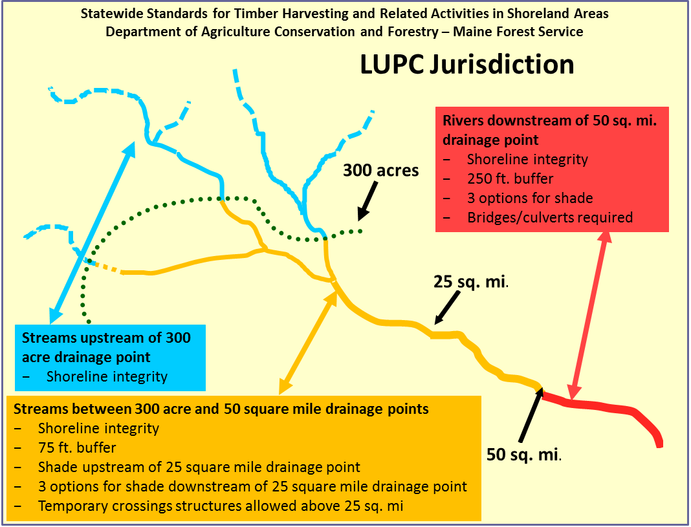

NOTE: This diagram is for informational purposes only. In the case of discrepancies, the written rule shall govern.

Figure 2. Application of this rule in municipalities not subject to the jurisdiction of the Land Use Planning Commission

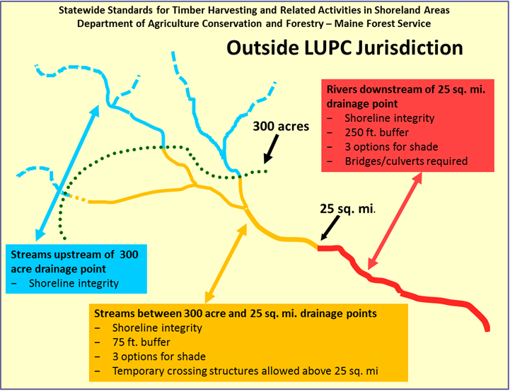
Note: This diagram is for informational purposes only. In the case of discrepancies, the written rule shall govern.

Figure 3. Application of this rule to wetlands statewide

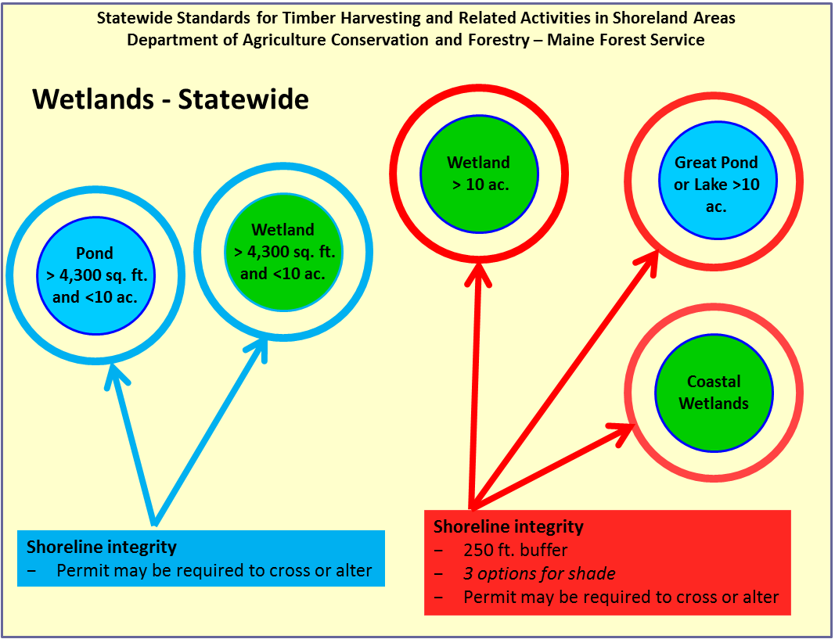

Note: This diagram is for informational purposes only. In the case of discrepancies, the written rule shall govern.

