13-188 DEPARTMENT OF MARINE RESOURCES

Chapter 36: ATLANTIC HERRING

36.01 Herring Management Plan

A. Definitions

(1) Herring

Herring means Atlantic Sea Herring, particularly the Clupea Harengus harengus.

(2) ICNAF gonad stages

ICNAF gonad stages are the official stages adopted by the International Commission for the Northwest Atlantic Fisheries in 1964.

Excerpt from ICNAF, 1964, Table 2 definitions:
Stage V. Gonads fill body cavity. Eggs large, round; some transparent. Ovaries yellowish; testes milkwhite. Eggs and sperm do not flow, but sperm can be extruded by pressure.
Stage VI. Ripe gonads. Eggs transparent; testes white; eggs and sperm flow freely.

(3) Spawn herring

Spawn herring is a sexually mature herring (male or female) in ICNAF gonad stages V or VI.

(4) Herring harvester

Any person or vessel operator in command of any type of gear used to harvest herring.

(5) Management Area 1

Management Area 1 is all U.S. waters of the Gulf of Maine encompassed by the shoreline and an imaginary line beginning at the intersection of the 41º 35' N parallel with the eastern shore of Monomoy Island; thence along a straight line in a northeast direction to its intersection with the U.S.-Canada boundary at the point 42º 53' 14" N parallel of latitude and 67º 44' 35" W meridian of longitude; thence in a northerly direction along the U.S.-Canada boundary.

Management Area 1 is subdivided into Area 1A (inshore) and Area 1B (offshore). The line dividing these areas is described by the following coordinates:

Beginning at 70º 00' W Longitude on the Cape Cod shoreline; thence due north to
42º 38.4' N Latitude, 70º 00' W Longitude; thence due northeasterly to
42º 53.0' N Latitude, 69º 40' W Longitude; thence due northeasterly to
43º 12.0’ N Latitude, 69º 00' W Longitude; thence due northeasterly to
43º 40.0’ N Latitude, 68º 00' W Longitude; thence due northeasterly to
43º 58.0’ N Latitude, 67º 22' W Longitude at the U.S.-Canada boundary; thence northerly along the irregular U.S.-Canada boundary.

- Management Area 2

South Coastal Area: All waters west of 70 º 00' W Longitude and south of 41 º 35' N Latitude, to include state and Federal waters adjacent to the states of Massachusetts, Rhode Island, Connecticut, New York, New Jersey, Delaware, Maryland, Virginia and North Carolina.

(7) Management Area 3

Georges Bank: All U.S. waters east of 70º 00' W Longitude and southeast of the line that runs from a point at 70º 00' W Longitude and 41º 35' N Latitude, northeasterly to the Hague Line at 67º 44' 35” W Longitude and 42º53' 14” N Latitude.

(8) Herring Dealer

Any person who purchases herring directly from a herring harvester for other than their own use and then sells the herring as a wholesale or retail product.

(9) “GSI” means the gonadosomatic index calculated by the following formula:

(Gonad Weight/ Total Body Weight – Gonad Weight) X 100 percent.

(10) Spawning Sample

Sample means a batch of 100 adult herring taken randomly from commercial catch or fish surveys.

(11) Landing

To come to shore, float or a dock and offload herring; or to transfer herring at sea to a vessel utilizing the herring for bait.

Exception: Fixed gears may transfer at sea to a vessel utilizing the herring as bait.

B. Permits and reporting

(1) Dealer Permit

All herring dealers shall obtain a herring dealers permit as part of the Wholesale Seafood License issued by the Department of Marine Resources. There will be no additional charge for this permit. The Commissioner may require that dealer permit holders report volumes of herring bought and sold and other information as required.

(2) Herring Harvester Permit

All herring harvesters must possess a Herring Harvester Permit on their Commercial Pelagic and Anadromous Fishing License issued by the Department of Marine Resources.

(3) Reporting of catch

All harvesters must submit trip level catch reports by 11:59 p.m. daily through an approved electronic option.

Harvesters: See Chapter 8.20(Q) and 8.20(R).

Dealers: See Chapter 8.10 Landings Program.

C. Gear and vessel restrictions

(1) Gear Type Prohibition

It shall be unlawful to use otter trawls, beam trawls, pair trawls, or midwater trawls to fish for herring within the territorial waters of Maine.

(2) Vessel Size and Shaft Horsepower

It shall be unlawful for any vessel that exceeds 165 feet length overall (LOA) or no more than 750 gross registered tonnage (GRT) to fish for or take herring within Maine territorial waters or to land herring in any Maine port. It shall be unlawful for any vessel possessing more than 3000 shaft horsepower to fish for or take herring within Maine territorial waters or to land herring in any Maine port.

This rule does not prohibit the landing of herring that are lawfully imported from other countries, territories or states provided the origin of fish is documented.

D. Catch restrictions

License holders shall be informed by public notice in a newspaper circulated in the area affected of any restrictions herein.

(1) Spawning herring protection

It shall be unlawful to fish for, take, possess, transfer or land in any State of Maine port or facility, or to transfer at sea from any Maine registered vessel, any catch of herring harvested from the following described areas within Management Area 1A during a spawning area closure:

(a) Spawning Area Boundaries:

Eastern Maine Spawning Area means:

All waters bounded by the following coordinates:
Maine coast 68° 20.0' W,
43° 48.0' N 68° 20.0' W,
44° 25.0' N 67° 03.0' W,
North along the U.S./Canada border.

Western Maine Spawning Area means:

All waters bounded by the following coordinates:
43° 30.0' N Maine coast,
43° 30.0' N 68° 54.5' W,
43° 48.0' N 68° 20.0' W,
North to Maine coast at 68° 20.0' W.

Massachusetts/New Hampshire Spawning Area means:

All waters bounded by the Massachusetts, New Hampshire and Maine coasts, and 43° 30.0' N70° 00.0' W.

(b) Closure Timing. To protect spawning sea herring, the commissioner shall close the Eastern Maine, Western Maine, or Massachusetts/New Hampshire Spawning Areas to directed Atlantic herring fishing effort when it is determined that Atlantic herring are in later stages of maturity just prior to spawning. A closure date will be projected based on a formula and process set forth in the Atlantic States Marine Fisheries Commission’s Amendment 3 (Section 4.2.6) Interstate Fishery Management Plan for Atlantic Herring.

    - Closure Duration. Once the closure is enacted, it shall remain in effect for 42 days.
    - Closure Extension. Sampling of Atlantic herring taken from Eastern Maine, Western Maine, or Massachusetts/New Hampshire Spawning Areas shall begin during the last week of the initial closure period or at the end of the initial closure period. If one sample taken from the Eastern Maine or Western Maine Spawning Areas is comprised of 20% or more spawn herring then the closure may be extended for an additional 14 days.
    - Closure Prohibitions. During the Eastern Maine, Western Maine, or Massachusetts/New Hampshire Spawning Area Closure or an extension thereof, it shall be unlawful for any vessel to possess or land more than 2,000 pounds of sea herring caught within the Eastern Maine, Western Maine, or Massachusetts/New Hampshire Spawning Area.
    - Closure Procedure. The initial closure date shall be announced 5-days prior to the closure being enacted and any closure extension shall be announced immediately to be enacted the day following the announcement.
    - Default Closure Dates: If sufficient samples are not available, spawning area closures will begin on area specific dates as follows: Eastern Maine (August 28), Western Maine (September 23), Massachusetts/New Hampshire (September 23)

(c) Exemptions

- Transport. Any herring vessel having onboard herring, which were caught outside of a management area that is under a herring spawning closure, may transit the closed or restricted area and land at a Maine port, only if all of its fishing gear has been stowed.
- Fixed gear. The fixed gear (stop seines and weirs) fishery east of Cutler is exempt from spawning area restrictions.

(2) Catch quota

Fishing for herring in Management Areas 1A, 1B, 2 and 3 is subject to the sub-annual catch limit (ACL) and fishing effort restrictions specified by the ASMFC Atlantic Herring Board and the NEFMC in accordance with their respective Fisheries Management Plans (FMP). The ACL is established annually by July 1 for the following year by ASMFC and NEFMC. Any reduction in the harvest will be determined in consultation with the ASMFC and NEFMC. No person shall land herring taken from a management area when 92% of the area’s seasonal or sub- annual catch limit will be exceeded or if 95% of the coastwide annual catch limit will be exceeded.

(a) Exception. Up to 30 mt of the Area 1A sub-ACL is allocated for the fixed gear fisheries in Area 1A (fish weirs and stop seines) west of Cutler. This Fixed Gear Set Aside (FGSA) is available for harvest by fish weirs and stop seines only within the fishing year until the FGSA is fully utilized. The FGSA is exempt from Days Out Program measures. No person shall land herring taken from Area 1A with fish weirs and stop seines when 92% of the fixed gear set-aside portion of the Management Area 1A sub-ACL will be exceeded.

(3) Effort Restrictions

    - Management Area 1A, January 1 – May 31

For the period of January 1 through May 31, 0% of the sub-ACL is allocated annually. Herring may only be landed from Management Area 1A on days that have been designated landing days by the Atlantic States Marine Fisheries Commission (ASMFC). ASMFC designates zero landing days between January 1 and May 31, annually.

    - Management Area 1A, June 1 – December 31

For this period, 100% of the sub-ACL is allocated annually and further sub-divided into two seasonal periods. Season 1 is June 1 through September 30 and is allocated 72.8% of the sub-ACL. Season 2 is October 1 through December 31 and is allocated 27.2% of the sub-ACL. Atlantic herring may only be landed from Management Area 1A on days that have been designated landing days by the ASMFC. All vessels landing herring caught in Season 1 of Management Area 1A in any Maine port will be limited to fishing for and landing herring on days that have been designated landings days by the ASMFC. All vessels landing herring caught in Season 2 of Management Area 1A in any Maine port will be limited to landing herring on days that have been designated landings days by the ASMFC.

All vessels landing herring caught in Management Area 1A in any Maine port are limited to one landing per 24 hour period (6 p.m. to 6 p.m.).

- For the purpose of this subsection, the following terms shall be defined as follows:

“At-Sea Transfer”: to transfer herring from a vessel to another vessel before the harvester vessel has landed.
“Harvester vessel”: a purse seine vessel that is required to report the catch it has aboard (along with effort data under a gear code other than CAR) as the harvesting vessel on its Federal Vessel Trip Report.
“Carrier vessel”: a vessel that has received herring from another vessel and is not required to report that catch as its own on its Federal Vessel Trip Report; and, not rigged as a purse seine vessel.
“Purse seine vessel”: a vessel currently rigged and capable of harvesting fish with an encircling net with floats on the top edge, weights and a purse line on the bottom edge, and associated gear to set, purse and haul such a net, which may include, but not limited to, a hydraulically-driven block, roller gear, and/or skiff.
“Truck”: a truck, as a unit of measurement, is equal to 40,000 lbs.

- Harvester vessels

There are zero landing days designated from June 1, 2023 through July 6, 2023 at 6:00 p.m. Harvest begins on July 16, 2023 at 6:00 p.m. and herring may be landed five consecutive days a week, starting on Sundays at 6:00 p.m. and concluding on Fridays at 6:00 p.m. It is unlawful for a harvester vessel that does not meet the definition of a purse seine vessel to receive fish while at-sea. It is unlawful for a purse saine harvester vessel to transfer at-sea to a carrier vessel. Vessels are prohibited from fishing for or landing herring caught in Area 1A during a day out of the fishery.

(A) For all harvesters issued a state Commercial Pelagic and Anadromous license with a Herring Harvester Permit that do not possess a Federal Limited Access Herring Permit:

All harvester vessels may possess and land Atlantic herring five days a week, beginning at 6:00 p.m. Sunday to 6:00 p.m. Friday. No vessel may land, take or possess more than 25,000 lbs. per week. No permit holder may land, take or possess more than 25,000 lbs. per week.

Exception: Harvesters using fixed gears (fishing weirs, stop seines) and pound nets are not subject to the harvest schedule detailed above. Weekly landing limits apply.

(B) For all vessels issued a Federal Limited Access Atlantic Herring Permit Category A:

The permit holder must have declared into the Atlantic Herring fishery by April 15th, annually, to be eligible to harvest.

The weekly landing limit is up to 320,000 pounds (8 trucks) per vessel.

(C) For all vessels issued a Federal Limited Access Atlantic Herring Permit Category C:

Daily trip limit shall not exceed 55,000 lbs. per day.

(D) For all vessels issued a Federal Limited Access Atlantic Herring Permit Category D:

Daily trip limit shall not exceed 6,600 lbs. per day.

- Carrier Vessels

Carrier vessels shall not operate as a harvester vessel on the same trip when operating as a carrier vessel.

Carrier vessels may not receive at-sea transfers from a harvester vessel.

(c) Exceptions

Any vessel may possess herring as an incidental catch and land herring caught in Management Area 1A, 1B, 2 or 3, in any Maine port, as long as such herring do not comprise more than 10% of the total weight of the catch and not to exceed 2000 lbs. per trip.

An individual may fish or take by hook and line up to 100 Atlantic herring per day for personal use only.

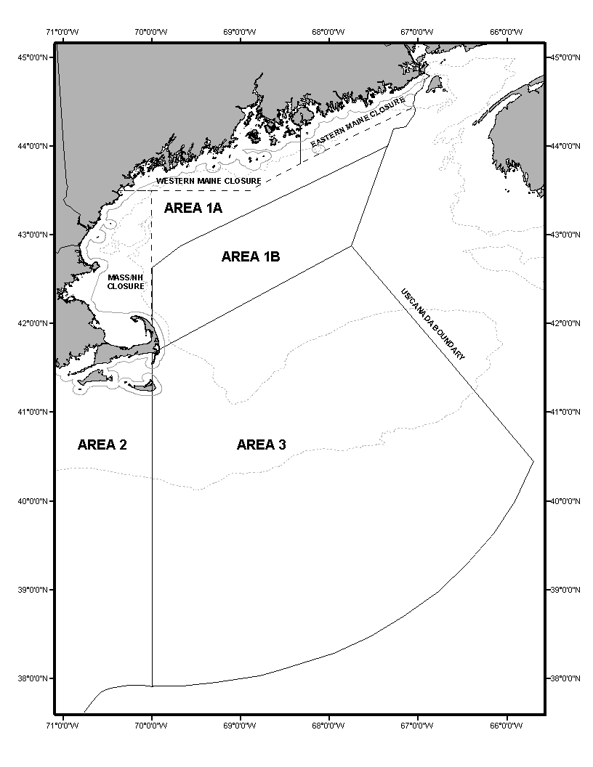

HISTORY

STATUTORY AUTHORITY:
12 M.R.S. §6171

EFFECTIVE DATE:
July 27, 1979

AMENDED:
October 1, 1979 - Artificial lights exception
June 30, 1980
June 30, 1981
July 4, 1981 - Section 36.01
October 26, 1981 - closure until November 30, 1981
November 23, 1981 - Section 36.15
September 3, 1982 - Section 36.50 (EMERGENCY)
April 28, 1983 - Section 36.011
September 15, 1983 - Section 36.16 (EMERGENCY)
October 1, 1983 - Section 36.01 (EMERGENCY)
August 13, 1984 - Section 36.01
September 21, 1995 - Sec. 36.01(B) (EMERGENCY)
September 21, 1996

EFFECTIVE DATE (ELECTRONIC CONVERSION):
February 24, 1997

AMENDED:
August 19, 1997
September 16, 1997 - Section 36.01(B), chart
November 19, 1997 - Section 36.01(C), renumbering
August 25, 1998 - Section 36.01, chart
August 28, 1999

NON-SUBSTANTIVE CORRECTIONS:
November 16, 1999 - removal of a comma

AMENDED:
July 29, 2000
August 15, 2001 - Sec. 36.01(D)(1)(a), chart (EMERGENCY)
November 25, 2001
December 17, 2003 - Section 36.01(B)(3), filing 2003-467

NON-SUBSTANTIVE CORRECTIONS:
April 28, 2004 - removed "." after headings

AMENDED:
January 1, 2005 – Section 36.01(D)(2)(a), filing 2004-571

NON-SUBSTANTIVE CORRECTION:
April 13, 2005 – minor formatting
April 29, 2005 – punctuation in Section 36.01(D)(2)(a)

AMENDED:
August 15, 2006 – Section 36.01(D)(1), filing 2006-281
January 1, 2007 – Section 36.01(A)(5), (6), (7), filing 2006-280
September 24, 2007 – Section 36.01(D)(1)&(3), filing 2007-410
June 21, 2010 – Section 36.01(D)(2), filing 2010-250 (EMERGENCY)
August 23, 2010 – Section 36.01(D)(2), filing 2010-368
October 26, 2010 – Section 36.01(B), filing 2010-509
June 22, 2016 – Section 36.01(D)(2), filing 2016-107 (EMERGENCY)
July 2, 2016 – Section 36.01, filing 2016-115 (EMERGENCY)
July 9, 2016 – Section 36.01(D)(3), filing 2016-116 (EMERGENCY)
September 25, 2016 – Section 36.01, filing 2016-152
June 4, 2017 – Section 36.01, filing 2017-083 (EMERGENCY)
July 1, 2017 – Section 36.01, filing 2017-101 (EMERGENCY)
July 29, 2017 – Section 36.01, filing 2017-115 (EMERGENCY)
August 7, 2017 – Section 36.01, filing 2017-118
September 17, 2017 – Section 36.01, filing 2017-149 (EMERGENCY)
December 18, 2017 – Section 36.01(D)(3)(c), filing 2017-205 (EMERGENCY)
June 2, 2018 – Section 36.01(D), filing 2018-093 (EMERGENCY)
July 21, 2018 – Section 36.01(D), filing 2018-143 (EMERGENCY)
September 12, 2018 – Section 36.01(D), filing 2018-186 (EMERGENCY)
September 29, 2018 – Section 36.01(D), filing 2018-219 (EMERGENCY)
November 16, 2018 – Section 36.01(D)(3)(c), filing 2018-255 (EMERGENCY)
March 13, 2019 – filing 2019-049
July 17, 2019 – filing 2019-120
August 17, 2019 – Section 36.01(D)(3)(b)(ii), filing 2019-151 (EMERGENCY)
September 14, 2019 – Section 36.01(D)(3)(b)(ii), filing 2019-166 (EMERGENCY)
October 31, 2019 – Section 36.01(D)(3)(b)(ii), filing 2019-191 (EMERGENCY)
November 13, 2019 – Section 36.01(B), filing 2019-196
November 30, 2019 – Section 36.01(D)(3)(b)(ii), filing 2019-218 (EMERGENCY)
March 15, 2020 – filing 2020-043
May 30, 2020 – filing 2020-133 (EMERGENCY)
August 22, 2020 – filing 2020-189 (EMERGENCY)
October 6, 2020 – filing 2020-216 (EMERGENCY)
November 3, 2020 -filing 2020-230 (EMERGENCY)
June 1, 2021 – filing 2021-116 (EMERGENCY)
October 1, 2021 – filing 2021-200 (EMERGENCY)
November 6, 2021 - filing 2021-228 (EMERGENCY)
May 31, 2022 – filing 2022-105 (EMERGENCY)
September 29, 2022 – filing 2022-195 (EMERGENCY)
March 13, 2023 – filing 2023-047
May 31, 2023 – filing 2023-078 (EMERGENCY)

