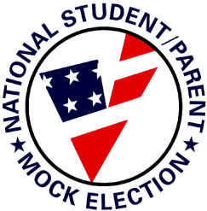
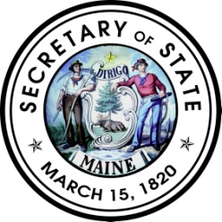
STATE OF MAINE
OFFICIAL MOCK ELECTION BALLOT

October 30, 2012

Instructions to Voters
♦ To vote for the candidate of your choice, fill in the oval to the left, like this:
♦ To vote for a write-in candidate, fill in the oval to the left of the write-in space and write in the
person’s name.
♦ To have your vote count, do not erase or cross out your choice.
♦ If you make a mistake, ask for a new ballot.

President and Vice President
Vote for ONE

Johnson, Gary E. and Gray, James P.
(Libertarian)

Obama, Barack and Biden, Joe
(Democrat)

Romney, Mitt and Ryan, Paul
(Republican)

Stein, Jill and Honkala, Cheri
(Green Independent)

Write-in:

Representative to Congress
District 2
Vote for ONE

Michaud, Michael H.
East Millinocket (Democrat)

Raye, Kevin L.
Perry (Republican)

Write-in:

United States Senator
Vote for ONE

Dalton, Danny Francis
Brunswick (Non-Party)

Dill, Cynthia Ann
Cape Elizabeth (Democrat)

Dodge, Andrew Ian
Harpswell (Independent for Liberty)

King, Angus
Brunswick (Independent for Maine)

Summers, Charles E., Jr.
Scarborough (Republican)

Woods, Stephen M.
Yarmouth (Independent)

Write-in:

