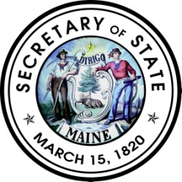
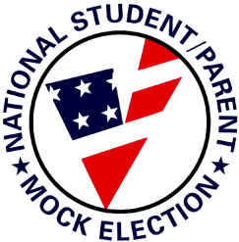

Instructions to Voters
♦ Fill in the oval next to your choice, like this:
♦ To vote for a question, fill in the YES oval. To vote against a question, fill in the NO oval.
♦ To have your vote count, do not erase or cross out your choice.
♦ If you make a mistake, ask for a new ballot.

STATE OF MAINE
OFFICIAL MOCK ELECTION BALLOT

October 30, 2012 Referendum Election

Question 1: Citizen Initiative
Vote Yes or No
Do you want to allow the State of Maine to issue marriage licenses to same-sex couples?

YES
NO
Question 2: Bond Issue
Vote Yes or No
Do you favor an $11,300,000 bond issue to provide funds for capital to build a diagnostic facility for the University of Maine System; for capital improvements and equipment, including machine tool technology, for the Maine Community College System; and for capital improvements and equipment at the Maine Maritime Academy?

YES
NO
Question 3: Bond Issue
Vote Yes or No
Do you favor a $5,000,000 bond issue to purchase land and conservation easements statewide from willing sellers for public land and water access, conservation, wildlife or fish habitat and outdoor recreation, including hunting and fishing and deer wintering areas, and to preserve working farmland and working waterfronts to be matched by at least $5,000,000 in private and public contributions?
YES
NO

Question 4: Bond Issue
Vote Yes or No
Do you favor a $51,500,000 bond issue for improvements to highways and bridges, local roads, airports and port facilities, as well as for funds for rail access, transit buses and the LifeFlight Foundation, which will make the State eligible for at least $105,600,000 in federal and other matching funds?

YES
NO
Question 5: Bond Issue
Vote Yes or No
Do you favor a $7,925,000 bond issue to be expended over 2 years for revolving loan funds for drinking water systems and for wastewater treatment facilities, which will make the State eligible to secure $39,625,000 in federal grants?

YES
NO

